REPREGISTRY
Udaybir Singh

Contents
Contents 2
1. Analysis 4
1.1 Background/identification of the problem 4
1.1.1 The user 4
1.1.2 Area to be computerised 4
1.1.3 Problem Statement 4
1.1.4 Possible Project Objectives 4
1.2 Research 5
1.2.1 Interviews 5
1.2.1.1 Interview before the development of the project 5
1.2.1.2 Interview after the development of the save and load system and UI 6
1.2.1.3 Interview after the implementation of Sqlite3 and bcrypt 6
1.2.1.4 Interview after the development of workout management 7
1.2.1.5 Interview after the development of the workout logging system 8
1.2.1.6 Interview after completing the entire system 9
1.2.2 Direct Observation 10
1.2.3 Internet Search 11
1.2.3.1 Existing Gym applications 11
1.2.3.2 JSON 11
1.2.3.3 Sqlite3 and Bcrypt 12
1.2.5 Research conclusion 12
1.3 Initial Modelling 13
1.3.1 List of major variables 13
1.3.2 Files 16
1.3.2 Formulae and calculations 16
1.3.3 Object Analysis Diagrams 18
1.3.4 Menu hierarchy/ initial screen layout 19
1.3.5 Data flow diagrams 21
1.3.6 ER diagrams 22
1.4 Objectives 22
2.Documented Design 25
2.1 Overall System Design 25
2.1.1 Project Overview 25
2.1.2 Function hierarchy 25
2.2 Classes 35
2.3 Data Dictionary 36
2.3.1 ER Diagrams 36
2.3.2 database tables 37
2.3.3 Files 39
2.4 in-depth explanation of the 5 most important objectives 43
2.4.1 Basic Workout Logging 43
2.4.1.1 User interface and explanation of user journey throughout program 43
2.4.1.2 Pseudocode 50
2.4.1.3 Data Structures 64
2.4.1.4 Calculations 66
2.4.1.5 SQL Queries 66
2.4.1.6 Validation 67
2.4.2 User Authentication (Login and Signuup) 68
2.4.2.1 User interface and explanation of user journey throughout program 68
2.4.2.2 pseudocode 72
2.4.2.3 Data Structures 78
2.4.2.4 Queries 79
2.4.2.5 Validation 79
2.4.3 workout history and attendance 80
2.4.3.1 User interface and explanation of user journey throughout program 80
2.4.3.2 Pseudocode 83
2.4.3.3 Validation 86
2.4.3.3 SQL Queries 86
2.4.3.4 Calculations 87
2.4.3.5 Extra 87
2.4.4 Muscles analysis, streak, and warnings 87
2.4.4.1 User interface and explanation of user journey throughout program 88
2.4.4.2 Pseudocode 90
2.4.4.3 Data Structures 93
2.4.4.4 Data Structures 94
2.4.5 Exercise management 94
2.4.5.1 User interface and explanation of user journey throughout program 94
2.4.5.2 Pseudocode 97
2.4.5.2 SQL queries 102
2.4.5.3 Codes used/invented 102
2.4.5.3 Validation 103
3. Technical solution 104
3.1 Main.py 104
3.2 Database.py 162

1. Analysis

1.1 Background/identification of the problem

1.1.1 The user
The client is Prabhveer, an A-level student and regular gym-goer who follows a hypertrophy training program. He currently tracks his workouts manually using the notes application on his phone, which is disorganised and inefficient. The client is easily accessible for interviews and feedback throughout the development of this program

1.1.2 Area to be computerised
The area to be computerised is a desktop gym tracking program titled Rep Registry. The system will allow the user to log workouts, create exercises and workout days, save and load data, add new exercises and get useful information on workouts. The scope of this project is limited to workout tracking functionality only. Other features like tracking macros, water intake are outside the scope of this project. Other potential users include other gym-goers who require a free and accessible alternative to existing paid applications

1.1.3 Problem Statement
Current gym tracking applications are too expensive for daily gym-goers, requiring costly monthly subscriptions. Furthermore, some applications can be confusing to users, having too many features when all they require is a simple workout log. The client currently uses the notes app, which is messy, inefficient and does not provide useful information based on current and past workouts. A new system will be developed that is free to use, intuitive, and provides workout logging, progress tracking and meaningful statistics to help the user monitor their performance over time.

1.1.4 Possible Project Objectives
- Log workouts, tracking sets, reps, and weight for each exercise.
- Create, modify, and delete workout days containing chosen exercises.
- Add and remove exercises from workout days and adjust sets and rest times.
- View workout history and filter sessions by date.
- Track and display personal records for weight, reps, and volume per exercise.
- Display progress graphs for weight, reps, and volume over time.
- Detect and notify the user of plateaus in their training.
- Recommend weight increases when the user consistently hits 12 or more reps.
- Track workout streak and display sessions completed per week and month.
- Detect overtraining by monitoring the number of sessions completed in a single day.
- Analyse muscle group training balance and display percentage trained per group.
- Provide a searchable exercise database with descriptions and muscle group data.
- Allow users to add and delete custom exercises with muscle targeting information.
- Export workout results as a PDF file.
- Secure login and sign-up system with password hashing and data persistence per user.
- Intuitive and consistent UI using reusable interface components throughout the program.

1.2 Research

1.2.1 Interviews

1.2.1.1 Interview before the development of the project
(09,02,2026,11:30 – 11:39)
1.How do you track your current workouts(notepads, phone app, memory)?
Currently I use the notes app on my phone to track the weight and reps I had done for a specific exercise.
2.How much time do you spend logging or recording your workouts now?
Currently, I don’t have to spend much time. All I have to do is find the notes page with my workout data and update it.
3.What problems have you experienced with tracking your progress?
Sometimes I forget to track my reps on the notes app, and it gets a bit confusing.
4.Have you used any gym apps before? If yes, what did you like or dislike about them?
I have used an app called Iron notes, but it just didn’t have all the features I wanted. And the UI was very overwhelming for me
5.What features do you think are missing in the apps you have used?
The features that are missing are good UI, the data it gives me is not enough, I want information on my personal records and more.
6.Which data do you want to record for each workout?
For each workout I want to be able to set the exercise I am currently doing and when I finish a set it gives me a reminder to do another set after the rest period. I want to be able to change the reps based on what I did and the weight if I have changed it from the previous session.
7.Do you want the system to give you reminders based on your workouts?
Yes, I really like this idea because it can help me stay on track. Like maybe it reminds me to drink water and reminds that my rest period has ended. Or even tells me that I have a muscle group I am not training.
8.How important is it for the app to have an intuitive UI system?
This is very important personally because I find my biggest issue with gym tracking apps is that the UI is very confusing. Even after using it for a while it’s very complicated.
9.Would you like preset workouts, or would you like to create your own?
I would like to create my own to support my bodybuilding goals.
10.Would you want to see your progress displayed visually?
Yes, I think this would be great for staying focused and motivated.
Interview Conclusion
Overall, the client wants a lightweight application to store important data about his workouts. With clean UI and something easy to use making his progress more visual and organised.

1.2.1.2 Interview after the development of the save and load system and UI
(18,02,2026,1:50-2:00)
1.2.1.2 Interview after the development of the save and load system and UI (18,02,2026, 1:50-2:00)
1. What do you think about the UI design of the save and load file?
The client likes the UI design of the save and load system, saying it is simplistic and easy to use. He also likes how the UI indicates when data is incorrect via a popup screen error.
2. What do you think about the save and load file?
The client says the save and load system works perfectly, storing and loading data correctly.
3. What do you think about the popup screen when incorrect data is inputted?
The client likes the popup screen as it clearly shows when the data he inputted is wrong.
4. Is it easy to navigate between screens?
The client says the buttons make it easy to navigate, with back buttons available on each screen.
5. Are the input boxes easy to use for the save and load file?
The client likes the input boxes as it is clear where to input what data.
6. What do you think about how data is stored?
The client is not satisfied with storing data in multiple text files using JSON. Furthermore, the client would like more security such as password hashing.
Interview Conclusion
Overall, the client likes the current system as it is designed in a simplistic way, which he mentioned he preferred in the initial interview. The popups work perfectly for the client, and he can navigate easily between screens. However, the client is not satisfied with how data is stored in text files and requested password hashing for improved security. As a result of this interview, the save and load system was changed to store data using SQLite3 and bcrypt password hashing.

1.2.1.3 Interview after the implementation of Sqlite3 and bcrypt
(22,02,2026,10:20-10:25)
1.What do you think about the new database storage?
The client likes the new system as it feels more secure and organised compared to saving data in separate text files.
2.What do you think about the bcrypt implementation?
The client likes the bcrypt implementation as it encrypts passwords, making users' saved data more secure.
3.Are the login and sign-up process still easy to use?
The client says it works exactly like before, which is how he preferred it.
4.Has the speed or performance of the app changed with the new database?
The client says there are no significant changes to speed or performance. However, storage is reduced as all user data is now stored in one database instead of separate text files.
5.Are there any other security features you would like to see added?
The client states he could not think of any additional security features he would like added at this stage.
Interview Conclusion
The client is satisfied with the implementation of SQLite3 as it reduces storage and improves organisation. Furthermore, the client is satisfied with the bcrypt password hashing as it improves the security of user data.

1.2.1.4 Interview after the development of workout management
(3,03,2026,11:30-11:40)
1.What do you think about the display of the workout management?
The client stated that the display works perfectly for him and it is easy for him to edit, change and add to his workout.
2.What do you think about setting a rest time for each exercise?
The client says setting rest times for each exercise is very effective and organised as for different exercises he needs either more or less rest time.
3.Is adding exercises from the database easy to use?
The client says adding exercises is very easy as he can navigate to the exercise search and type the exercise he wants. Exercises matching the letters typed will appear in a list, making it easy to find and select the desired exercise.
4.Is removing an exercise straightforward?
The client says it is easy to remove exercises by pressing the remove button next to the corresponding exercise.
5.What do you think about being able to add, rename and delete workout days?
The client states it works exactly how he wanted, being able to configure everything and add new workout days.
6.Is there anything you would like to change or improve about the workout editing system?
The client could not think of any changes as the current system works as intended.
Interview Conclusion
Overall, the client is satisfied with the current workout management system. All editing features including rest time configuration, exercise search, adding and removing exercises, set management, and workout day configuration meet his requirements. Therefore, no changes are needed at this stage.

1.2.1.5 Interview after the development of the workout logging system
(18,03,2026, 9:30-9:40)
1.What do you think about the process of the workout?
The client likes the workout process, adding reps and weight then completing sets with rest timers in between and a total workout duration displayed.
2.What do you think about the UI of the workout logging system?
The client enjoys the UI, stating that sets turning green once completed makes it easy to track progress. He also likes the workout duration and rest timer being visible. Furthermore, the client likes the exercise images making the system more visually appealing.
3.What do you think about the workout result screen?
The client stated that the workout results screen works great, displaying all his statistics for the workout including the total duration.
4.What do you think about being able to export workout results?
The client likes being able to export his workout results as a nicely formatted PDF.
5.What do you think about the water reminder, rest time and progress popups?
The client is satisfied with the rest timer popup appearing when the rest period ends. He also likes the water reminder keeping him hydrated, and the progress popups notifying him when volume, reps or weight for an exercise has been surpassed.
6.What do you think about the PR and info button?
The client likes the info button displaying an explanation of the exercise. He is also satisfied with the PR button showing when personal records were achieved, previous session statistics, plateau detection and percentage weight increase since the last session.
7.What do you think about the graphs showing weight, reps and volume progression?
The client is very satisfied with the graphs as they allow him to visualise his progress over time.
Interview Conclusion
Overall, the client is satisfied with the workout logging system. All desired features have been implemented, and the system is easy to use. Workout logging, set completion, rest timers, and PDF export all meet the client's requirements. The popup notifications for rest periods, water reminders and personal records help the client stay on track during sessions. The PR button and info button provide useful exercise information and session statistics, while the progression graphs allow the client to monitor improvements over time.

1.2.1.6 Interview after completing the entire system
(04,04,2026, 9:35;9:45)
1.What do you think about the workout history with date search?
The client stated that the workout history works perfectly and he can efficiently find a specific workout by searching for the date.
2.What do you think about the workout frequency graph?
The client is satisfied with the workout frequency graph showing sessions in the week and the month, allowing him to see his consistency.
3.What do you think about the workout streak?
The client is satisfied with the workout streak resetting if the user has not trained after a couple of days. The client is also satisfied with how it is displayed in the main menu screen with an icon next to the streak number.
4.What do you think about the overtraining warnings?
The client stated that he likes the overtraining warning showing if he has trained too much in a day. Although the client thinks this feature will not be seen much as he is unlikely to do more than one training session in a day.
5.What do you think about the muscle analysis screen?
The client stated that the muscle analysis screen works perfectly, showing which muscles are undertrained based on his workouts. The client also likes how it shows percentages and keywords indicating which muscles are undertrained.
6.What do you think about the custom exercise creation and deletion?
The client is satisfied as he can create new exercises that are not in the original exercise database. The client also likes that he can delete his personally created exercises but cannot delete built in exercises, which avoids him making mistakes.
7.What is your overall satisfaction with the complete app?
Overall, the client stated he is very satisfied with the app as it has all the features he wants while remaining simplistic. Furthermore, the client stated the UI is consistent and easy to use, making using the application a simple process.
Interview Conclusion
Overall, the client is fully satisfied with the completed system. All features including workout history, frequency graphs, streak tracking, overtraining warnings, muscle analysis, and custom exercise management meet his requirements. The application is consistent, intuitive and easy to use, fulfilling all objectives set out at the beginning of the project.

1.2.2 Direct Observation
A direct observation of the client was carried out while he was completing one of his regular gym sessions. The purpose of the observation was to understand how the client currently records his workout data and to identify inefficiencies in his current method
Date:10/02/2026
Time:4:00PM – 5:30PM
Location: School Gym – Strodes College – Egham
During the observation, the client used the notes application on his phone to record his workout data. The client would write the exercise name and record the number of repetitions completed along with the weight used. When a set was completed, the client would unlock his phone and manually scroll through the notes page to locate the relevant exercise entry. This was done so he could check the previous weight used and decide whether to increase the weight for the next set.
After completing each set, the client would again unlock his phone and update the values in the notes application. This process was repeated after every set throughout the workout session.
Several problems were identified during this observation. Firstly, the client had difficulty locating specific exercises because all exercises and sessions were stored within a single notes page. This made the information cramped and difficult to navigate. As a result, the client had to spend time scrolling to find the correct exercise, which interrupted the flow of the workout and reduced the efficiency of his rest periods.
Secondly, the notes became increasingly disorganised as more workout sessions were added. Exercises and workout data were stored in a continuous block of text without any clear structure. This made it difficult for the client to quickly locate relevant information from previous sessions.
Another issue observed was that the current method did not provide any useful analysis of the workout data. For example, the client could not easily view personal records for an exercise or see recommended rest times between sets. Additionally, important statistics such as percentage strength increase or total training volume were not automatically calculated. There was also no visual representation of progress, such as graphs or charts. Any analysis would need to be calculated manually, which the client currently does not do.
Overall, this observation demonstrated that the client’s current method of recording workout data is inefficient and disorganised. It also lacks useful analytical features that could help the client track his progress. Therefore, a dedicated workout tracking system would improve the organisation of data, automate calculations, and provide useful visual feedback on training progress.

1.2.3 Internet Search

1.2.3.1 Existing Gym applications
RP Hypertrophy
The first gym tracking application researched was RP Hypertrophy. This is a subscription-based web application that allows users to record exercises, sets, repetitions and weight for each workout. The application also includes a wide range of additional features such as adding notes to exercises, video demonstrations showing the correct form of exercises, and information about the muscle groups being targeted.
The application also provides educational content from Renaissance Periodization related to muscle hypertrophy and training principles. In addition, users can track their progress over time and view personal records (PRs) for specific exercises.
However, the application requires a monthly subscription costing approximately £35, which makes it very expensive for many users. Furthermore, the large number of features can make the application overwhelming, particularly for users who only want a simple system for recording workout data.
This research influenced the design of the Rep Registry system. The Rep Registry application focuses on providing a free and simple workout tracking system that allows users to record sets, repetitions, weight and workout duration. The system also includes useful features such as progress graphs, plateau detection, overtraining warnings, custom exercise creation and muscle group analysis, while maintaining a simple and intuitive interface.
Strong-workout tracker

Strong is a workout tracking app for mobile used to log sets, reps and weight of a workout. Users can have up to 3 custom routines for free and there is a built-in exercise library with descriptions. However, some features are locked behind paid access. If customers are willing to pay a monthly subscription fee of £4.99, they can use all features without limits. This includes unlimited custom routines, progress charts and graphs, advanced analytics and CSV data export.
This research influenced the design of Rep Registry. Unlike Strong, Rep Registry is a free desktop application with no subscription required. Furthermore, Rep Registry includes additional features not available in Strong, such as plateau detection, overtraining warnings, muscle group analysis, and PDF export, while maintaining a simple and intuitive interface.

1.2.3.2 JSON
During the early stages of development, JSON (JavaScript Object Notation) was used to store workout data in text files. JSON is a lightweight format that stores structured data using key–value pairs, making it suitable for storing exercises, sets, repetitions, and weights. Each user’s data was saved in a separate text file to allow the program to load and update workout information.
This approach was initially chosen because it is simple to implement in Python and allows structured data to be stored without requiring a database system. However, further development revealed several limitations. Storing multiple users’ data in separate text files became inefficient and difficult to manage. The data could also become disorganised as more workouts were added, and there was no built-in security to protect sensitive information such as passwords.
Despite these limitations, JSON remained useful for storing complex data structures, such as dictionaries, within the program. Data could be converted to JSON format to store as text and then read back into Python dictionaries when needed. This demonstrated a lightweight method for storing structured data before moving to a more robust database system.

1.2.3.3 Sqlite3 and Bcrypt
After determining that JSON alone was not the most suitable solution for the save and load functionality, the system was upgraded to use SQLite3 as the primary data storage system. SQLite3 is a built-in, lightweight, file-based relational database that allows all user data to be stored in a single database file. This improves organisation and scalability, making it easier to manage multiple users. SQL queries can be used to efficiently retrieve, update, and organise data. SQLite3 was also used to create an exercise database, storing structured information for all hypertrophy exercises included in the system.
To enhance security, crypt was implemented for password hashing. In section 1.2.1.2, the user expressed concerns about the security of their data. Bcrypt encrypts passwords before storing them in the database, adding a layer of protection against unauthorized access. This ensures that all user information is stored securely while maintaining the performance and reliability of the system.
Despite switching to SQLite3, JSON is still used within the database to store complex data structures. Many parts of the program rely on Python dictionaries to store exercise details, sets, and other structured information. These dictionaries are converted into JSON strings when stored in the database and then converted back into dictionaries when loaded. This approach allows the program to handle advanced data structures efficiently while benefiting from the organisation and security provided by SQLite3 and Bcrypt.

COULD OPTIONALLY ADD THE GRAPHS AND PDF IMPORT

1.2.5 Research conclusion
The purpose of the research was to determine exactly what the user wanted implemented in the Rep Registry system and how to develop it as efficiently as possible. To achieve this, interviews were conducted throughout the development process, allowing the system to be continuously refined based on client feedback. Direct observations of the client's current workout tracking methods highlighted inefficiencies and areas for improvement, while internet-based research into existing gym applications, data storage solutions, and security methods informed the choice of technologies and features.
From the interviews, it became clear that the user wanted a simple and intuitive gym tracking application to log workouts efficiently. The initial interview revealed the client's current tracking process and specific requirements. The client stated they wanted a clear UI that allows logging of sets, repetitions, and weights, including rest timers and reminders. They also wanted to view personal records and receive useful visual information, such as progress graphs. Furthermore, the client emphasised the need for a secure save and load system with password encryption.
Observation of the client confirmed the inefficiencies in their current method. The client manually opened the notes app, navigated to the correct page, and logged sets and repetitions after each exercise. This process was time-consuming, disorganised, and inefficient. In addition, the current method did not provide useful information, such as percentage increases in weight, set volume, or visual progress graphs, which the client could not track without performing manual calculations.
Finally, internet research provided insight into existing software and potential improvements. Researching applications such as RP Hypertrophy and Strong highlighted useful features, but also revealed limitations, including high subscription costs and interfaces with an overwhelming number of features. Both applications also lock key features such as progress graphs behind paid subscriptions. Initially, the save and load system used JSON, which proved inefficient. This led to an improved solution using SQLite3 for database storage and bcrypt for password hashing. JSON was retained for storing complex data structures, such as dictionaries, within the database.
Overall, this research guided the design of Rep Registry, ensuring it is efficient, organised, secure, and tailored to the client's needs, while remaining simple and easy to use.
IF I ADD THE PDF AND GRAPH IMPORT ADD HERE

1.3 Initial Modelling

1.3.1 List of major variables
Class DataManager
Variable Name | Type | Purpose
Username | string | Stores the login or new save name
Password | string | Stores the password
workouts | dictionary | Stores all the workouts linked to the user
workout_history | dictionary | Stores completed workout sessions by date
workout_data | dictionary | Stores data on PR’s for a specific exercise

All variables related to the user’s save are stored in the DataManager class. These variables are accessed from that class. Dictionaries, such as workouts, are converted to JSON strings when saved in the database and converted back when loaded. This allows the program to store complex data structures for each user efficiently.

Class ExerciseDatabase
Variable Name | Type | Purpose
Exercise | string | Name of the exercise
image | string | File path of exercise image
Muscles_targeted | list/JSON | Muscle group targeted by that exercise
Intensity_trained | List/JSON | Intensity levels muscles are trained
Description | String | Information about the exercise
Built_in | Boolean/text | Indicates if the exercise is a built in one or a custom exercise

All exercise-related variables are stored in the ExerciseDatabase class and saved in a database. The functions in the class allow the program to retrieve, add, or delete specific exercise information efficiently.

Class Running
Variable Name | Type | Purpose
Current_screen | Object | Tracks which screen the user is currently on
Current_workout | string | Stores the day the workout the user is currently logging
datamanager | DataManager | Handles user data, saving/loading workouts
exercisedatabase | ExerciseDatabase | Stores all exercises and their details
WORKOUT_START | Boolean | Indicates if workout session has started
Screen_dictionary | dictionary | Used to easily loop though screens and update them

Class Objects
Method | Purpose | Output
Label() | Create a text label on a parent widget | CTkLabel Object
Panel() | Creates a panel frame for grouping UI elements | CTkFrame Object
Button() | Create a standard clickable button | CTkButton Object
Graphic() | Display an image on the screen | CTkLabel with image
Text_box() | Input box for user text | CTkEntry object
Workout_box() | Specialised UI for workout sets | Returns two list:  Weight_arr and reps_arr both array
Graphical_button() | Create a button with images | CTkButton with images
Scrollable_frame() | Scrollable container frame | CTkScrollableFrame object

Staticmethods use to make creating UI for the application simple and consistent. Will reduce the lines of code needed.

Variables | Type | Purpose
APP_SIZE | string | Default window size of the app f”{width}X{height}”
APP_WIDTH | int | Width of screen
APP_HEIGHT | int | Height of screen
app | CTk() Object | Main application window
TEXT_COLOR | string | Primary colour
TEXT_COLOR2 | string | Secondary colour
TEXT_COLOR3 | string | Darker grey
TEXT_COLOR4 | string | Lighter grey
POSITIVE_COLOR | string | Green
NEGATIVE_COLOR | string | Red
APP_BG | string | Background colour
PANEL_BG | string | Panel colour
PRIMARY_BLUE | string | Blue colour
BUTTON_BG_NORMAL | string | Colour state of button
BUTTON_BG_CLICKED | string | Colour state of button
BUTTON_BG_HOVER | string | Colour state of button
APP | Running() Object | Instance of the main app logic class (running)

1.3.2 Files
File Name | File type | Purpose
Users.db | SQLite3 | To store all the saves for different users
Exercises.db | SQLite3 | Store all the data for the different exercises
Graphics Folder | Folder | Store all the graphics for the program(exercise images, tick button states, edit button, add and remove sets image, logo)

HAVENT ADDED ALL THE IMAGES FOR ALL TH E EXERCISES

1.3.2 Formulae and calculations
1. Workout Volume for Each Set
This formula is used to calculate the total training volume for a set.
Volume = Weight × Reps
Where:
- Weight = weight lifted during the set
- Reps = number of repetitions completed
Purpose:
To calculate the training volume for each set, allowing the program to measure how much work the user has performed.

2. Progressive Overload Recommendation
This formula determines a new suggested weight when the user reaches a specific repetition target.
New Weight = Current Weight + 2.5
Where:
- Current Weight = weight used in the current set
- 2.5 = standard increment used for progressive overload in weight training
Purpose:
If the user performs 12 or more repetitions, the program recommends increasing the weight for the next session or set.

3. Strength Percentage Increase
This formula calculates the percentage increase in weight compared to a previous session.
Percentage Increase = (New Weight − Old Weight) / Old Weight) × 100
Where:
- New Weight = weight lifted in the most recent session
- Old Weight = weight lifted in the previous session
Purpose:
Allows the user to see important information about their strength progression between workouts.

4. Personal Record (PR) Detection
The program checks if the current value is greater than the user's previous best for an exercise.
PR = Current Value > Previous Best
Where:
- Current Value = value currently recorded (reps, weight, or volume)
- Previous Best = highest recorded value for that exercise in a previous workout
Purpose:
This calculation allows the program to determine if the user has achieved a new personal record. When a PR is detected, the previous value is replaced with the new one and the program displays a message informing the user that they have achieved a new record (for reps, weight, or volume).

1.3.3 Object Analysis Diagrams
The program’s main class, Running, interacts with all the other classes to retrieve and manage data. Currently:
- Running uses the Objects class’s static methods to handle the GUI, which is built with custom Tkinter components.
- Running also uses the DataManager class to retrieve data from the user and to save, load, and create data.
In this structure, Running serves as the central controller, coordinating between the GUI (Objects) and the data operations (DataManager).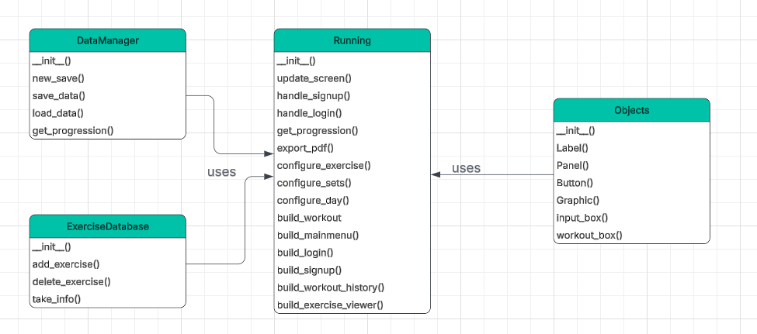

1.3.4 Menu hierarchy/ initial screen layout
Entry, Login, Signup screens
The program will start with an entry screen that allows the user to log in or sign up. Once the user successfully completes these steps, they will be taken to the main menu screen, where they can access the application’s core features.

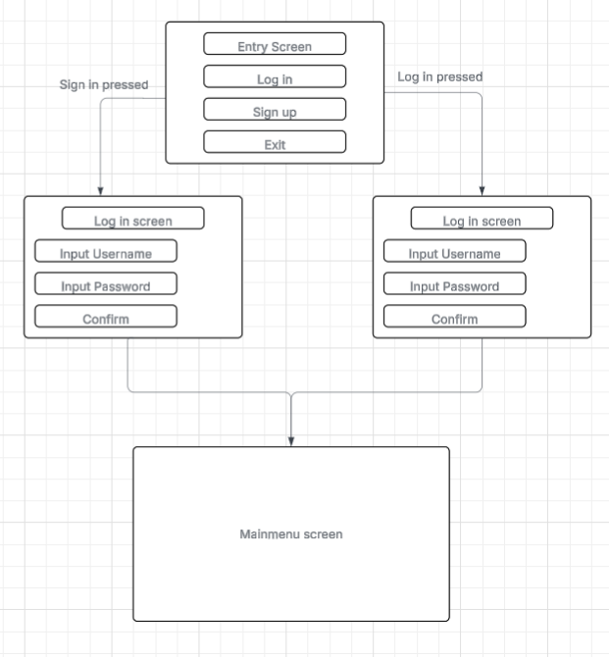

Mainmenu, Workout, workout history and exercise screen
This image illustrates the design of the main menu and the workout page. Key features include:
- Workout Page:
  - Input boxes for reps and weight
  - Buttons to configure the workout day, including exercises and sets
- Workout History: Displays all workouts based on the selected date
- Exercises Page: Provides a list of available exercises
This layout ensures users can easily navigate between creating workouts, tracking their history, and managing exercises.
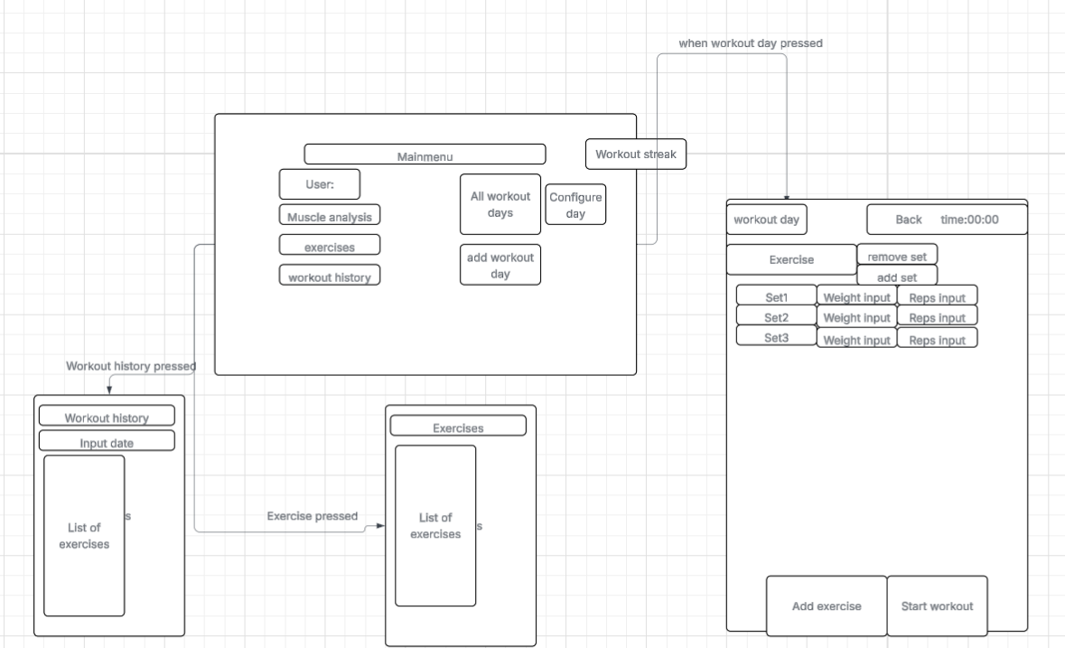

1.3.5 Data flow diagrams
This data flow diagram shows the initial user authentication process. The User sends login credentials or signup information to the system, which checks or saves the data in the User Data store. The system then returns a success or failure message to the User.
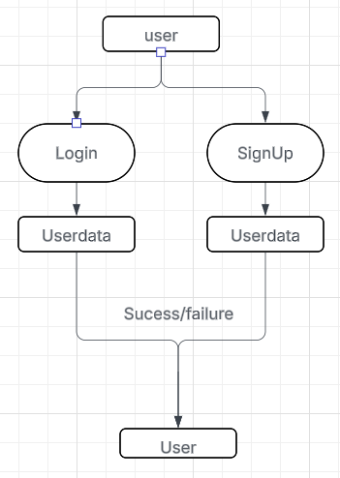

1.3.6 ER diagrams
The ER diagram illustrates the relationships between User, Workout, and Exercise entities:
- A User can have many Workouts, representing the different workout sessions they perform. This is a one-to-many relationship from User to Workout.
- Each Workout can include multiple Exercises, forming another one-to-many relationship from Workout to Exercise.
- Indirectly, a User performs Exercises through their Workouts, meaning a single user can perform multiple exercises across different workouts.
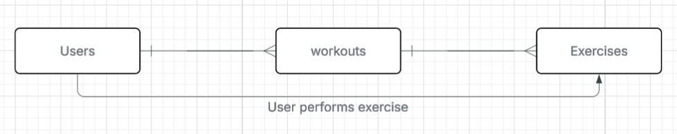

1.4 Objectives
1. Basic Workout Logging
- Record exercises, sets, reps, and weight for each workout
- Track workout duration and completion time
2. Custom Exercise Management
- Add custom exercises to personal library
- Delete exercises from personal library
- Assign muscles targeted and intensity per exercise
- Include exercise description
3. Workout Templates
- Create new workout days (templates)
- Modify existing workout days
- Delete unwanted workout days
4. Rest Time Tracking
- Rest times between sets
- Customize rest times different exercises
- Rest time finished alert
- Track total time worked out
5. Workout History
- View all completed workouts in chronological order
- Filter workouts by date
- Search workouts by date
6. Personal Records (PRs)
- Automatically calculate PRs for each exercise (weight, reps, volume)
- Display current PR for each metric
- Show when PRs were achieved
- Show PR surpassed alerts
7. Volume Tracking
- Calculate total volume for each set. (reps * weight)
- Track volume changes per exercise
- Display volume trends
8. Progress Visualization
- Generate graphs showing strength improvements
- Display charts for volume progression
- Create visual timelines of workout frequency
9. Strength Gain Analysis
- Track strength increases per exercise
- Calculate percentage improvements over time
10. Consistency Monitoring
- Track workout frequency (sessions per week/month)
- Identify workout streaks
11. Progressive Overload Tracking
- Monitor if weights are increasing appropriately
- Highlight plateaus in training
13. Overtraining Detection
- Monitor training frequency
- Alert users when training frequency is too high
- Track fatigue indicators
14. Muscle Balance Analysis
- Identify if certain muscle groups are undertrained
- Show percentage of the muscle group worked
- Display messages for muscle balance status
15. Exercise Database
- Provide library of default exercises
- Include exercise description
16. Data Export
- Export individual workout history as PDF
- Save data for external use
17. User Authentication
- Secure login with username and password
- Sign-up system for new users
18. Data Persistence
- Save all user data to account
- Maintain progress across sessions
19. User Interface
- Clean, intuitive, and simple design
- Easy navigation between features
- Responsive layout
- Reusable UI classes (Objects.panel, Objects.button, etc.)

2.Documented Design

2.1 Overall System Design

2.1.1 Project Overview
- The programming language to be used is python 3.11.9
- The database being used is SQLite3
- Standard library modules include json, datetime, and sqlite3.
- Third party packages include CustomTkinter, bcrypt, matplotlib, fpdf2, and Pillow

2.1.2 Function hierarchy
Update screen hierarchy
The functions used to update the screen. Firstly, update_screen is called, which destroys all previous widgets. It then configures the window to match the screen being changed to, before calling the relevant build function to construct the new screen. Note that build_screen() is a placeholder each screen has its own specific build function
.
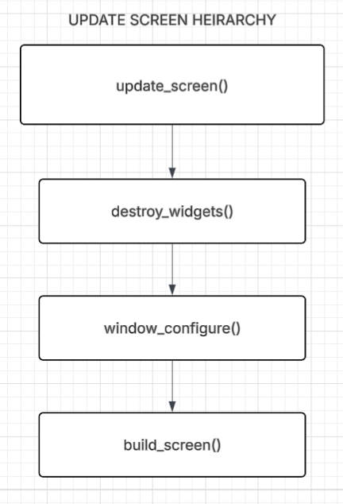

Login/Signup hierarchy
This is the hierarchy for the login and signup system. Firstly, the DataManager and ExerciseDatabase classes are initialised to load all necessary data. The screen is then updated to the entry screen, which displays three buttons: log in, sign up, and exit. Depending on which button is pressed, a different sequence of functions will be called.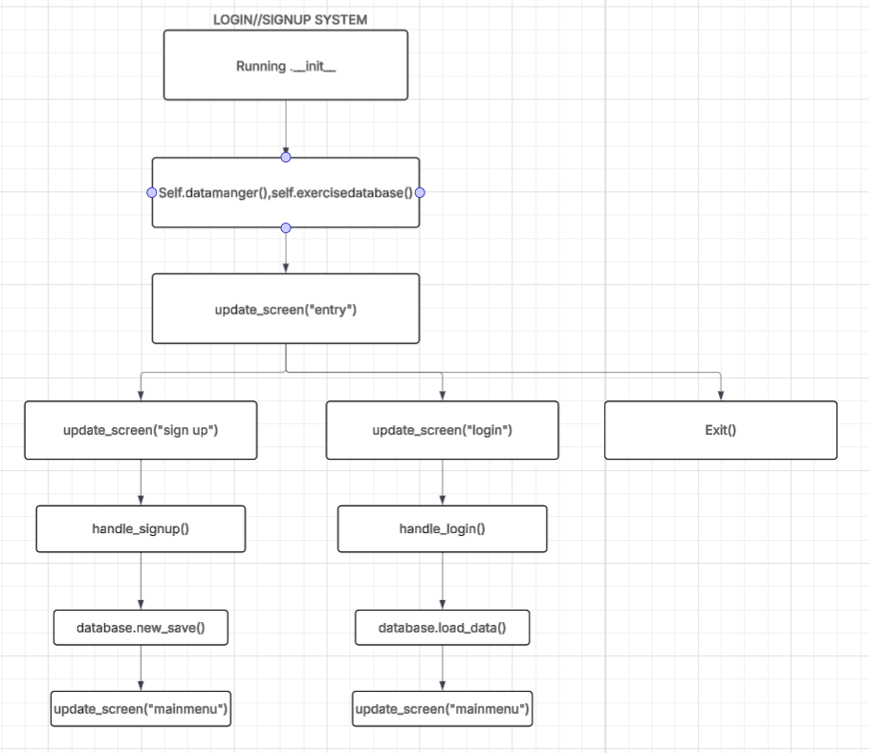

View_workout hierarchy
This hierarchy represents the view_workout function, which is called when the PR button is pressed during a workout, or when an exercise is selected from the exercise page. The exercise page is accessible via a button on the main menu. Firstly, useful information about the exercise is displayed, retrieved by calling functions from the DataManager and ExerciseDatabase classes. The function also checks for plateaus and calculates the percentage strength increase since the last session. Additionally, there are buttons available to view progression graphs for weight, reps and volume, as well as an option to delete the exercise if it was created by the user.

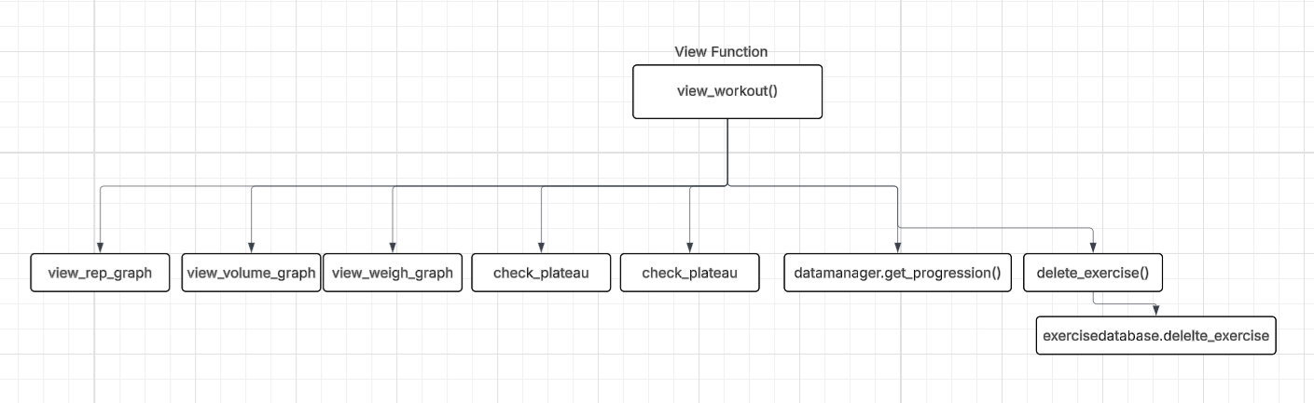
Add rest time hierarchy
Add rest time called when rest time button pressed in workouts. it will set the time to the time picked and save the data.
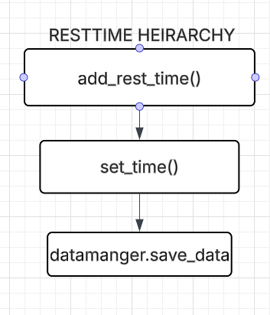

Change workout hierarchy
The change_workout function requires a command word to be passed in, either "add" or "remove", which determines which path of functions is followed. If "remove" is passed, the selected exercise is removed from the workout, the data is saved and the screen is updated. If "add" is passed, a secondary window is displayed containing a search box. The on_type function is bound to each key release, dynamically displaying exercises that match the input. Once an exercise is selected, it is added to the workout, the data is saved and the screen is updated to the workout screen.
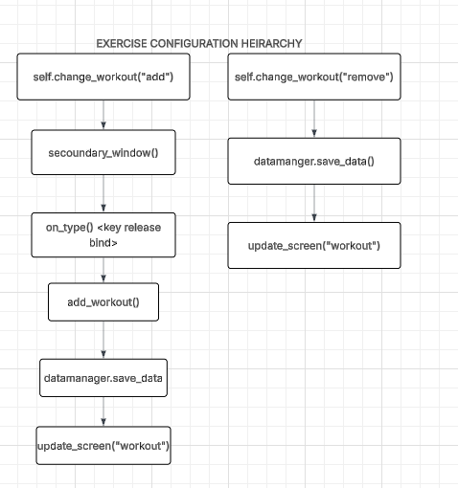

End workout hierarchy
When the end workout button is pressed, the workout results are first saved by calling save_workout_results, which calls compare_values to compare the recorded data against existing personal records before saving to workout_data. The session is then saved to workout history. After this, the screen is updated to the main menu and a secondary window is displayed showing the workout results. If the export button on the secondary window is clicked, export_pdf is called to generate and save a PDF of the workout results.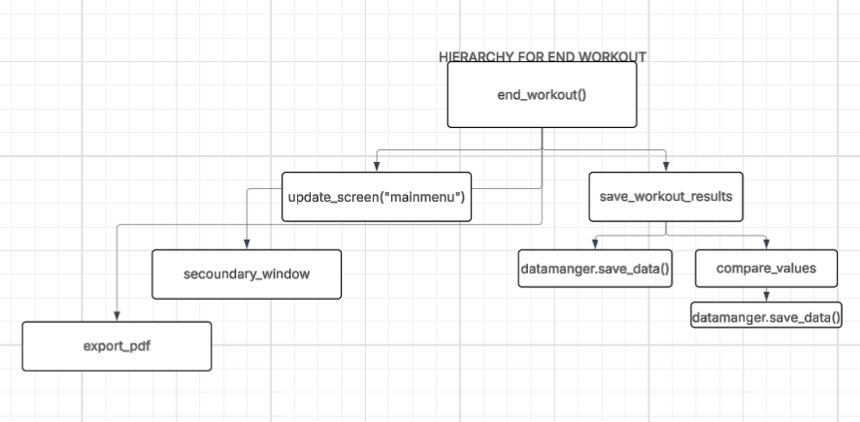

Full workout hierarchy
This is the full workout hierarchy, which references the functions documented in the previous hierarchies above. Different buttons call different functions depending on the state of the workout. Some buttons are only visible once start_workout has been called — for example, the end workout button only appears after the workout has been started, while buttons such as add exercise and remove exercise are only visible before start_workout is called.
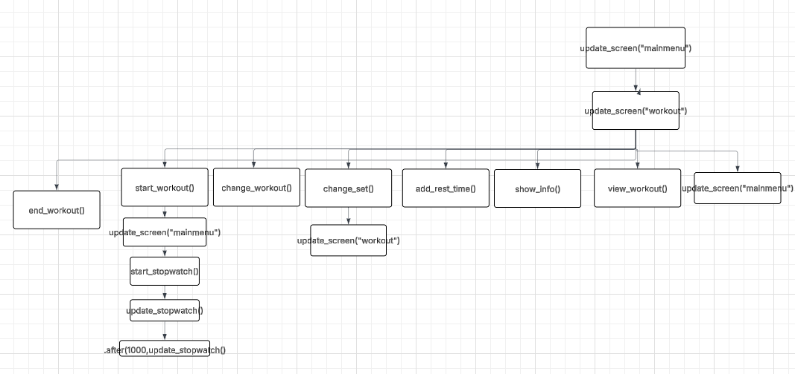

Configure day hierarchy
The configure_day function is called, which opens a secondary window displaying two buttons. If the first button is pressed, the selected day will be deleted. If the second button is pressed, the name of the selected day will be configured.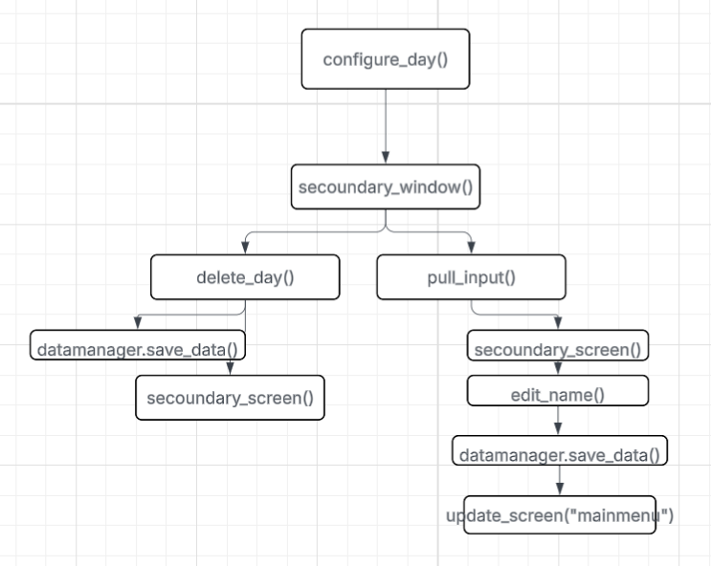

Add day hierarchy
The add_day function is called, which opens a secondary window prompting the user for an input. When the confirm button is pressed, the inputted data is validated. If the data is invalid, an error screen is displayed and the function returns. If the data is valid, it is saved and the screen is updated to the main menu.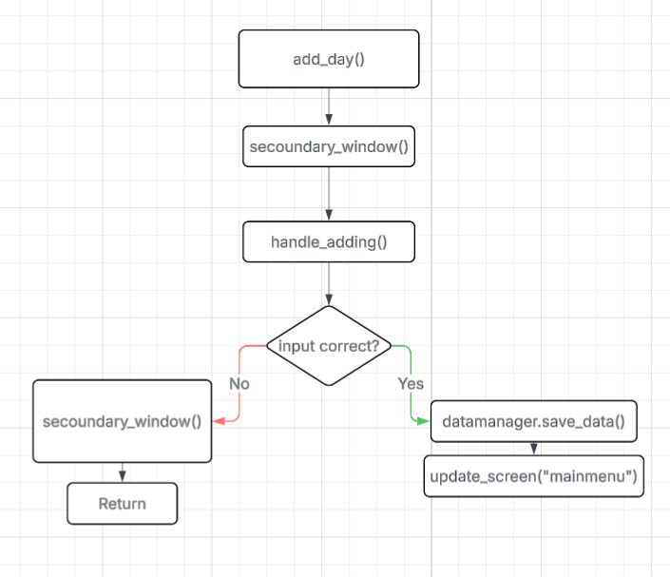

Custom exercise hierarchy
The screen is updated to the custom exercise screen, which displays two buttons: one to return to the previous screen and one to add a new exercise. When the add exercise button is pressed, a secondary window is opened prompting the user to input the exercise details. Once submitted, check_values() is called to validate the input, which then calls exercise_database.take_info() to check whether the exercise already exists in the database. If it does not exist, the new exercise is added to the database. When the user types in the search box, on_type() is called, dynamically displaying a list of exercises matching the current input.
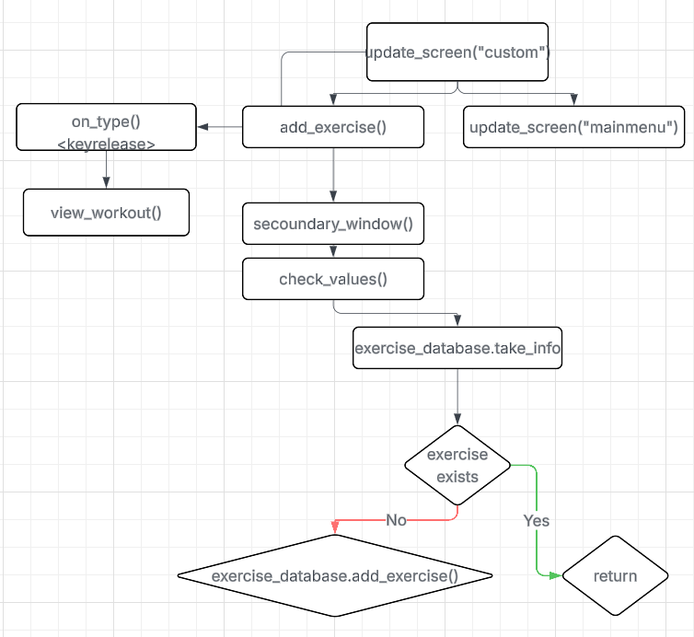

Workout history hierarchy
The screen is updated to the workout history screen. If the back button is pressed, the screen returns to the main menu. If the view attendance graph button is pressed, attendance_graph() is called, which retrieves values from workout_frequency() and displays them on the graph. When the user types in the search box, on_type() is called, dynamically displaying workouts matching the input. If a date is selected, view_workout() is called, displaying the corresponding workout. If the export button is pressed on a selected workout, the workout is converted to a PDF.######
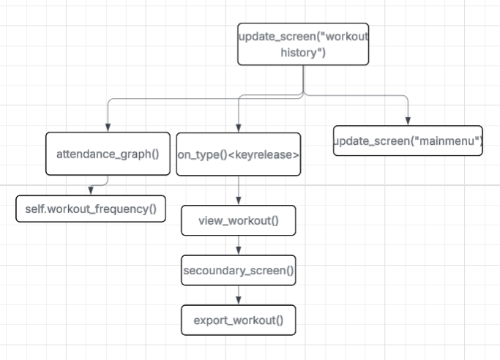

Mainmenu hierarchy
When the main menu screen is loaded, update_screen("mainmenu") is called, which also calls check_workout_fatigue() to check if the user has overworked, and workout_streak() to calculate and display the user's current streak. From the main menu, the user can navigate to several functions: update_screen("workout history"), update_screen("custom"), configure_day(), add_day(), update_screen("muscle analysis"), open_workout(day), and exit(). If update_screen("muscle analysis") is called, calculate_muscles_worked() is called to calculate the muscle groups trained, before the back button returns the user to the main menu by calling update_screen("mainmenu"). If open_workout(day) is called, the screen is updated to update_screen("workout"). The remaining functions are not detailed here as their hierarchies have been documented individually in the sections above.
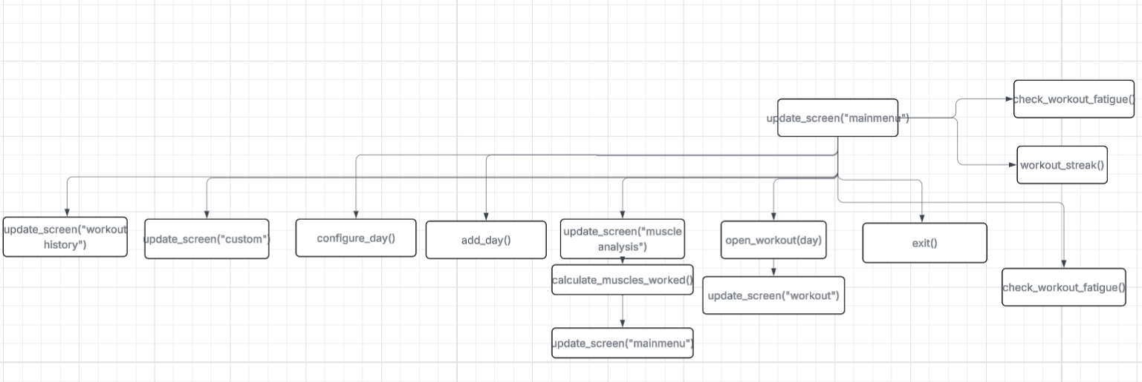

2.2 Classes
The Running class is split into two—one for functions and one for attributes—because combining them made the class diagram too large. Running is the main class and uses three helper classes to operate. Running uses the static methods from Objects to create the UI (indicated by an arrow). No diamond is needed here because Running can exist without Objects; it only helps reduce code duplication and maintain style. Running has an aggregation (unshaded diamond) relationship with ExerciseDatabase because it uses its functions to retrieve exercise information, but ExerciseDatabase can exist independently. Running also has an aggregation relationship with DataManager for the same reason: Running depends on it to store and manage data, but DataManager can exist independently.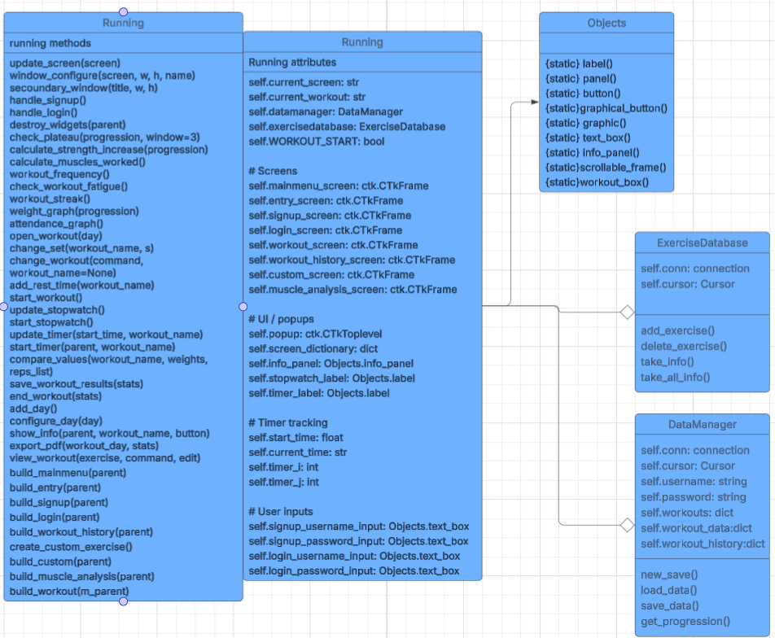

2.3 Data Dictionary

2.3.1 ER Diagrams

The database consists of two tables: Users and Exercises.
- Users table stores one record per registered user. The username field is the primary key as it uniquely identifies every user — no two accounts can share the same username. The password field stores a bcrypt-hashed version of the password for security. The workouts, workout_data and workout_history fields each store a JSON string containing the user's planned workouts, personal records and session history respectively.
- Exercises table stores one record per exercise. The exercise field is the primary key as every exercise has a unique name. muscles_targeted and intensity_trained are stored as JSON arrays because each exercise works multiple muscles at varying intensities. The built_in field indicates whether the exercise was created by the system or added by the user, which controls whether it can be deleted.
- Relationship — the two tables have a many-to-many relationship. One user can reference many exercises across their workouts and history, and one exercise can be referenced by many different users. A many-to-many relationship was chosen because it accurately reflects the real world scenario — any user can do any exercise, and any exercise can be done by any user.
- JSON design decision — in a fully normalised design, workouts, workout_data and workout_history would each be separate tables with foreign keys linking back to both Users and Exercises. However in this implementation they are stored as JSON strings within the Users table. This was a deliberate design choice to simplify development and avoid complex multi-table queries. The exercise names stored inside the JSON act as implicit references to the exercise primary key in the Exercises table, maintaining the logical link between the two tables even without a formal foreign key.

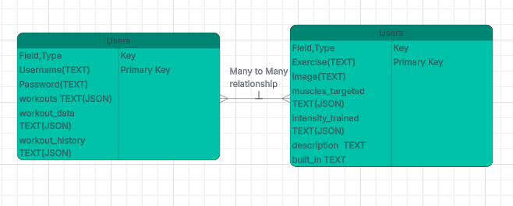

2.3.2 database tables

Table 1: Users
- Purpose: Stores all registered user accounts. Each row represents one user and contains their login credentials as well as all their personal workout data stored as JSON strings.
- Expected number of records: Small — estimated 1 to 50 users. This is a personal fitness app used by individuals rather than a large commercial platform, so the Users table will never hold a large number of records. Because of this a linear search is sufficient when looking up a username.
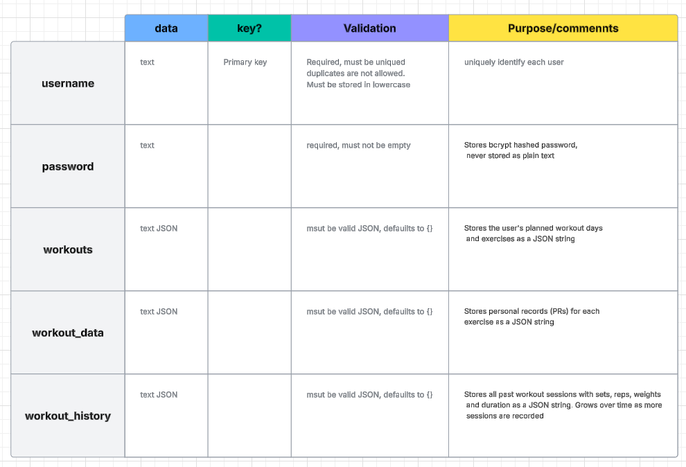

Table 2: Exercises
Purpose: Stores all available exercises in the app, both built-in exercises pre-loaded by the system and custom exercises added by the user. Each row represents one exercise and stores everything needed to display and analyse it.
Expected number of records: Medium — approximately 60 to 100 records. The database is pre-loaded with around 60 built-in exercises covering all major muscle groups. Users can add their own on top of this. Because the number of records could grow, a linear search through exercise names is used when searching, which is acceptable at this scale. If the exercise library grew to thousands of records a binary search would be more appropriate.
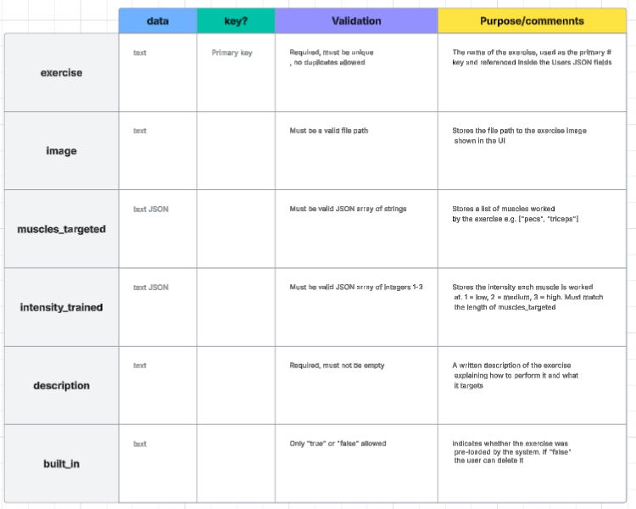

2.3.3 Files
File Name: Users.db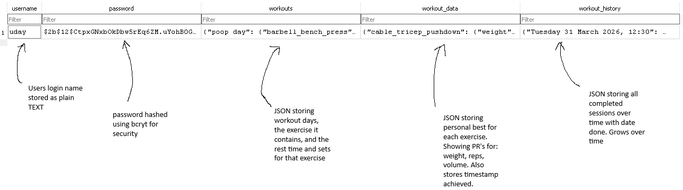
Name | Data type | Description
Username | TEXT | The users login name.
Password | TEXT (hashed) | A bcrypt password (e.g. $2b^sj).
workouts | TEXT(JSON) | JSON storing the users custom workout plans and exercises.
Workout_data | TEXT(JSON) | JSON storing personal bests for each exercise. This stores the best weight, best reps, and best volume done with timestamps.
Workout_history | TEXT(JSON) | JSON storing every completed workout sessions with date, sets, reps, weight and duration.

When it's created/updated:
- Created or accessed as soon as the program is run
- Updated when the user registers a new account
- Updated when a user completes a workout (workout_history field updated)
- Updated when the user hits a personal record (workout_data field updated)
- Updated when the user adds, configures or deletes a workout day (workouts field updated)
- Updated when the user edits exercises, sets or rest times (workouts field updated)

How data is stored:
When a workout is completed, the program does not add a new row to the database. Instead, it finds the existing row for that user and overwrites the workout_history field with the updated data

File size estimation:
One user record is roughly 2,000–3,000 bytes, however this will grow significantly over time as workout_history accumulates more sessions with every completed workout. Furthermore, multiple users each storing their own workout history will increase the file size further. Estimating 50 users with moderate usage gives approximately 50 × 2,500 = 125,000 bytes ≈ 125KB, though heavy users could push this considerably higher.

File Name: Exercises. Db
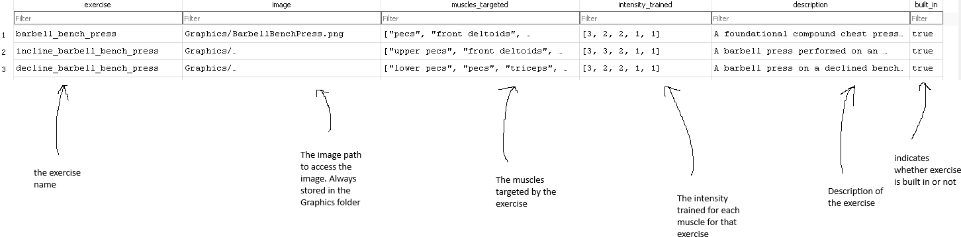

Name | Data type | Description
exercise | TEXT | The exercise name (e.g. “barbell_bench_press”)
image | TEXT | File path for the exercise image (eg. “Graphics/BarbellBenchPress.png”)
Muscles_targeted | TEXT(JSON) | JSON list of muscles worked (“triceps”,”biceps”)
Intensity_trained | TEXT(JSON) | JSON list of intensity values per muscles[1,2,3]
description | TEXT | Text description of the exercise
Built_in | TEXT | Stores text as “true” or “false” to indicated whether its built in or not.

When is created/updated
- Created or accessed as soon as the program is run
- Pre-populated with all built-in exercises when first created
- Updated when the user adds a custom exercise (new row with built_in = “false”)
- Updated when the user deletes a custom exercise (row removed)

How data is stored:
Built-in exercise rows are never modified. When a user adds a custom exercise, a new row is appended to the table. When a custom exercise is deleted that row is removed entirely.
File size estimation:
75 built-in exercises × 400 bytes ≈ 30KB baseline, grows slightly as users add custom exercises.

File Name; Graphics/ (folder)
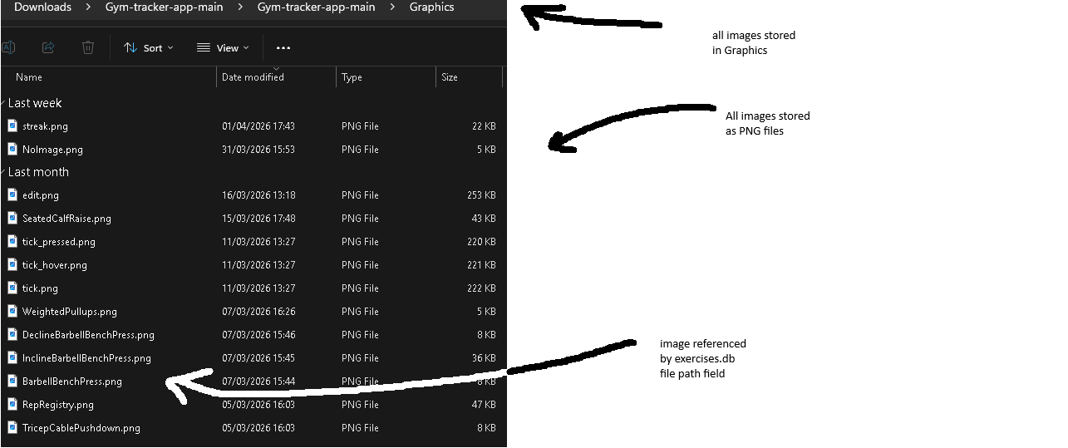
Purpose:
This folder contains all the images used by the program. All images are in PNG format and are read only. The program only reads to this folkder and never writes to it. The folders contains images on the exercise and some other UI images for the program.
Image | File size | purpose
NoImage.png | 4.44kb | When no image found for exercise displays this
Edit.png | 252kb | Image for a button
RepRegistry.png | 50kb | Image for logo of application
SeatedCalfRaise | 10kb | Image for an exercise
Tick_pressed.png | 220kb | State for tick button
Tick.png | 220kb | Tick button image
Tick_hover | 220kb | State for tick button

This folder contains images for each built-in exercise. All images follow the same naming convention — the exercise name in PascalCase followed by .png (e.g. BarbellBenchPress.png, CableTricepPushdown.png). Each image is approximately 10KB, giving a total estimated folder size of 75 × 10 = 750KB.

File Name: workout day} results.pdf (e.g. push day results.pdf).File name changes when printed from workout history. ({date} results.pdf)
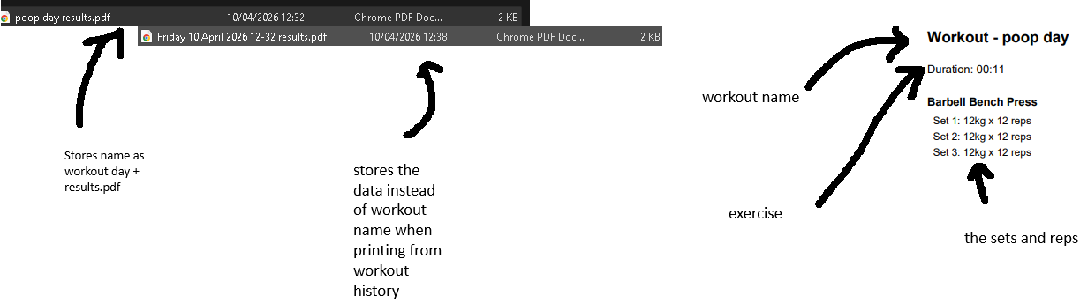

What it stores: A summary of a completed workout session including the workout day name, total duration, and for each exercise: the exercise name, and the weight and reps logged for every set.
When it's generated: It is generated when the user clicks the "Export Workout" button, which appears either immediately after ending a workout or when viewing a past session in workout history.
Where it saves: It saves to the same directory as the program files, named after the workout day (e.g. push day results.pdf).
Layout
section | content
Header | Workout day name in bold size 16
Duration | Total session time
Exercise heading | Exercise name in bold
Set rows | “set1:80kg x 10reps,”set2…..”

File size estimation. A typical workout with 5 exercises and 3sets produces roughly 30-40 lines of text. At approximately 30 bytes per line that gives around 30 x 35 = 1050 bytes ~ 1KB as PDF. However this can vary if the user has more exercises and sets. Also a new PDF is created each time a pdf for a workout day is requested. Workout days with the same date will replace previous ones.

2.4 in-depth explanation of the 5 most important objectives

2.4.1 Basic Workout Logging
This objective is the core of the gym tracking application and represents the most important feature of the program. It allows the user to configure workout days by adding and removing exercises, adjusting sets, and setting rest times before starting a session. Once the workout is started, the user can log the weight and reps for each set, with a stopwatch tracking the total session duration and a rest timer counting down between sets. When the workout is complete, the results are saved to the SQLite database, ensuring data persists across sessions, and a results screen is displayed giving the user the option to export their workout as a PDF.

2.4.1.1 User interface and explanation of user journey throughout program
Workout day configuration
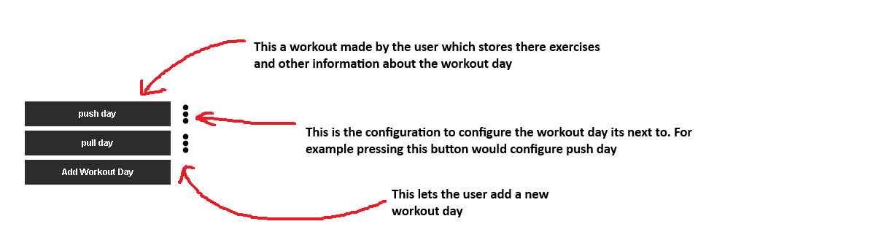
Add workout day pressed
When add workout is pressed a secoundary screen will open prompting the user for an input
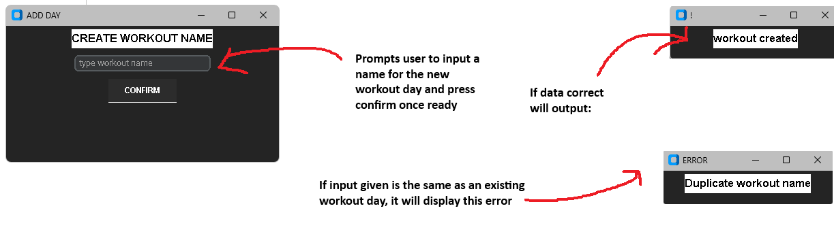
Edit button pressed
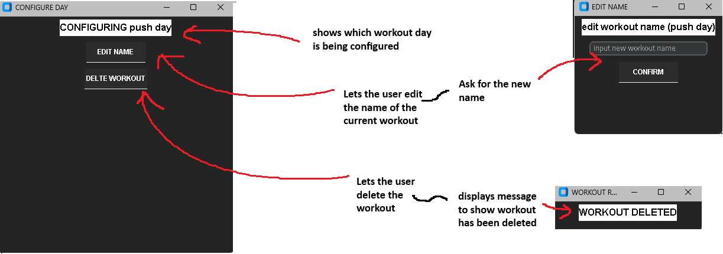

Inside of the workout day
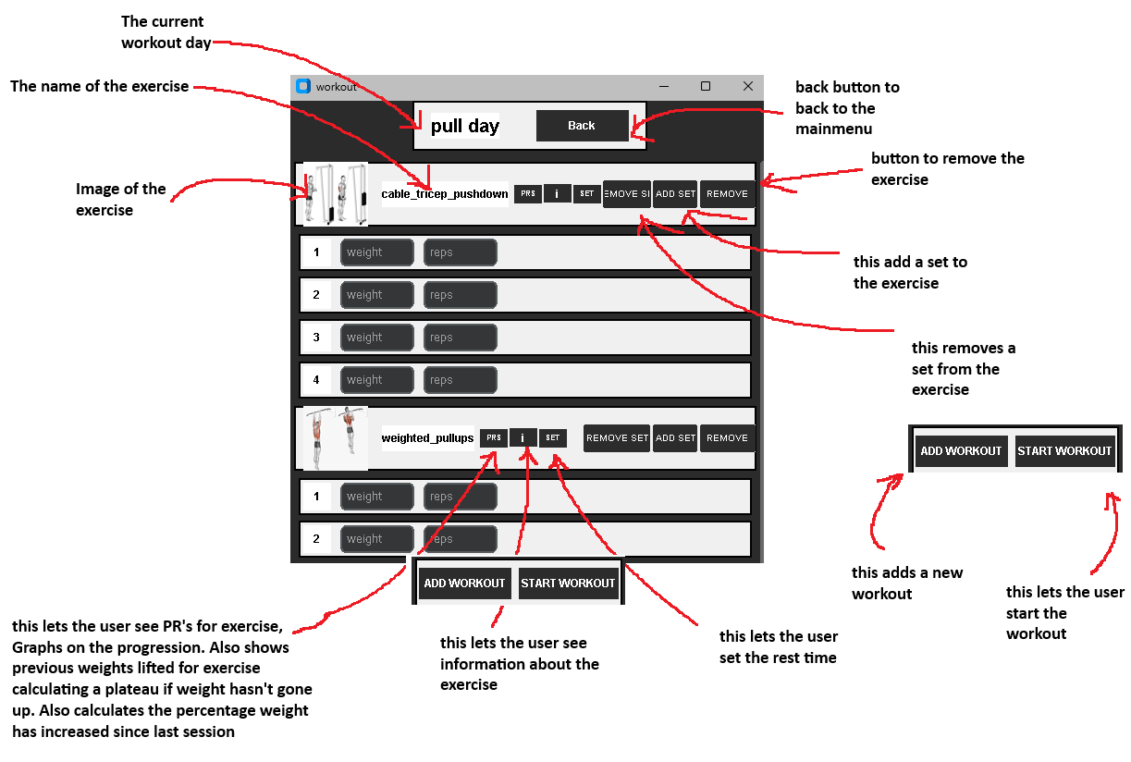
Buttons pressed outputs
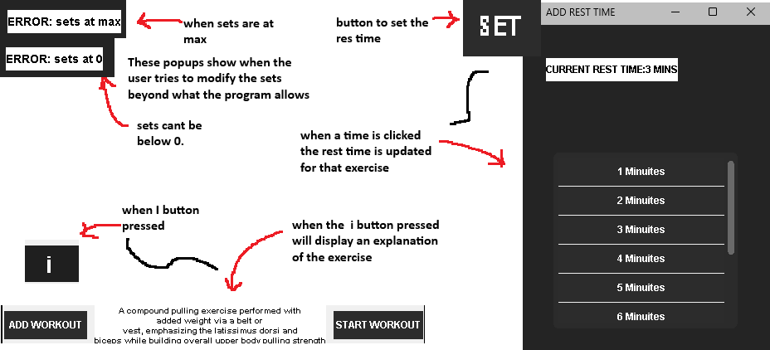
PR pressed
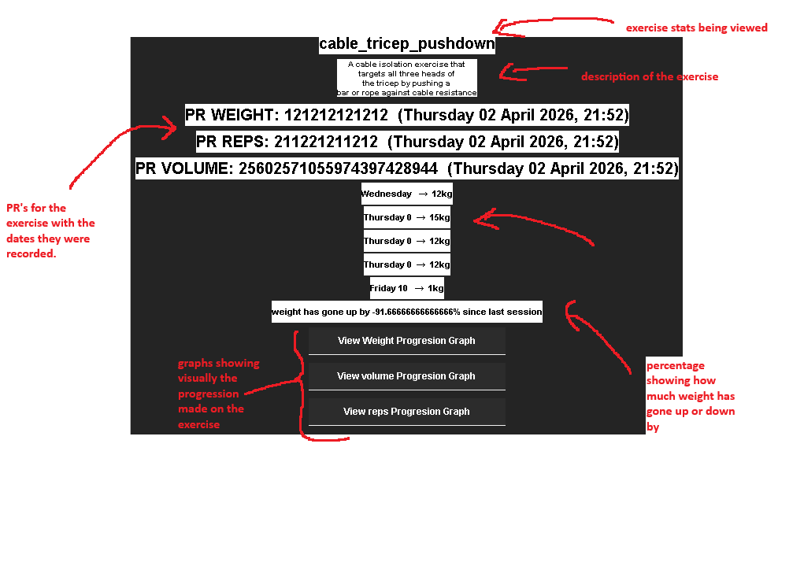

Weight progression graph
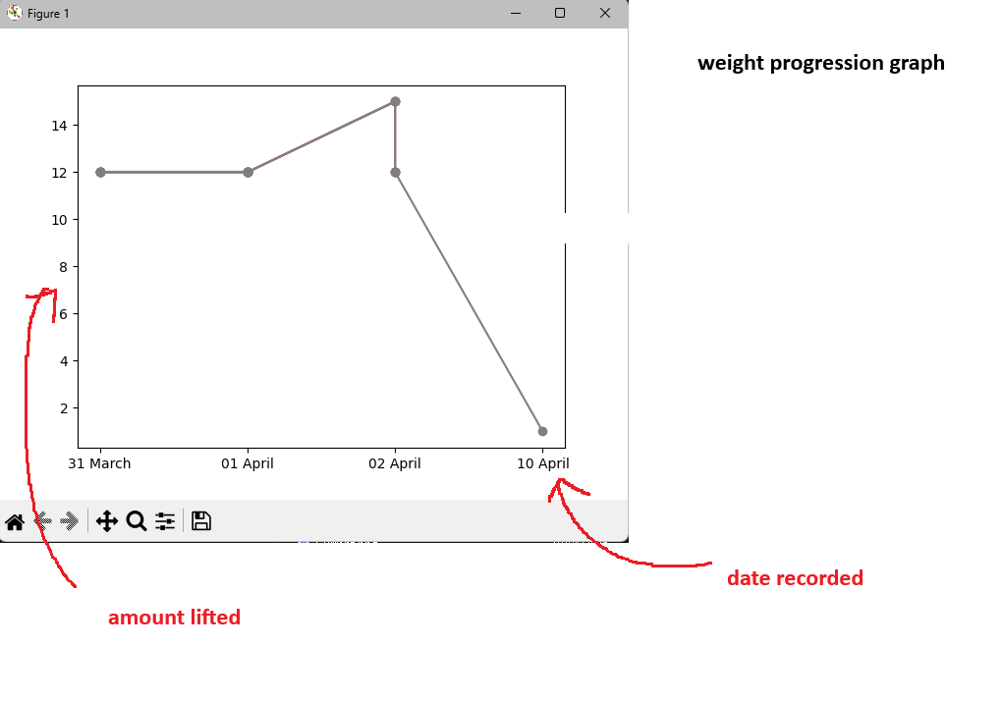
Volume progression graph
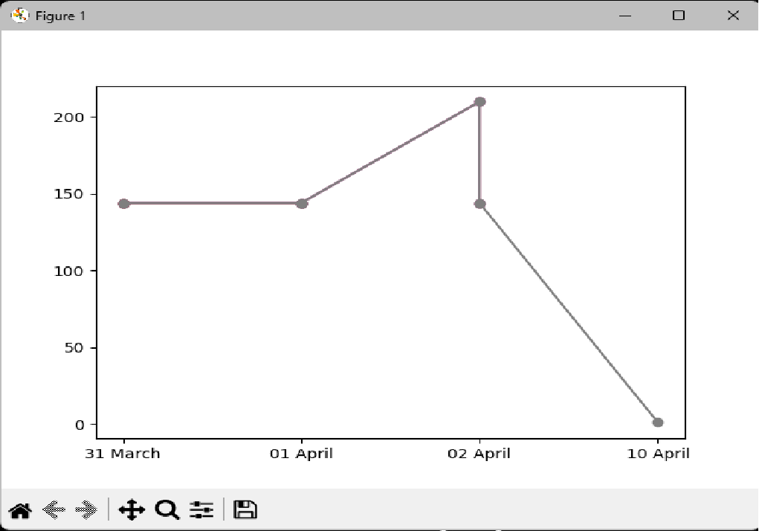

Reps’ progression graph
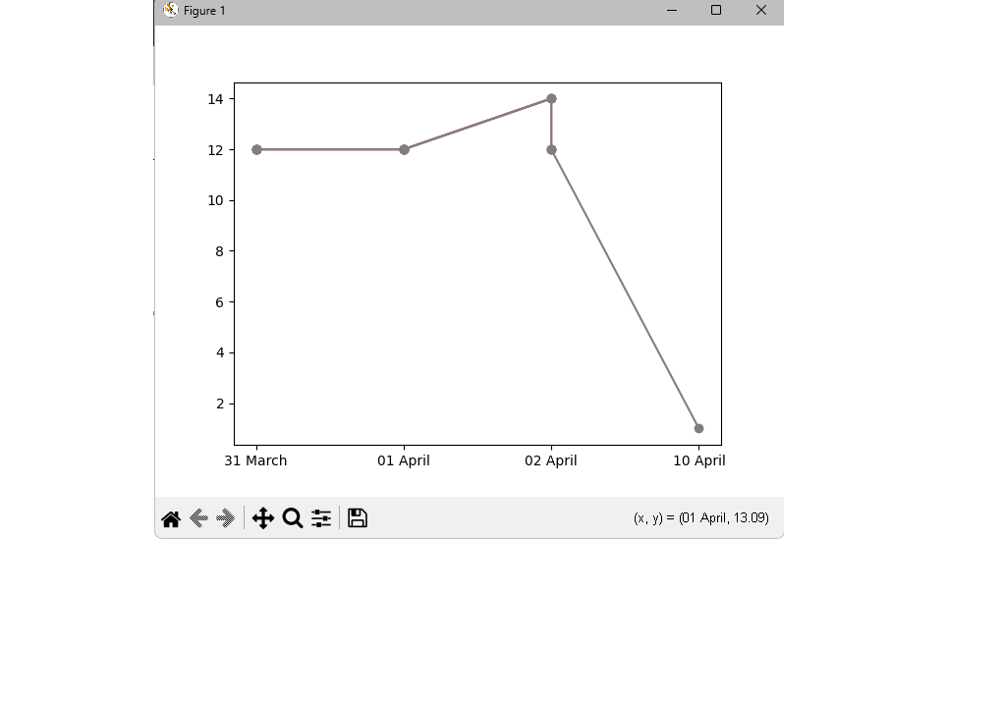

Workout started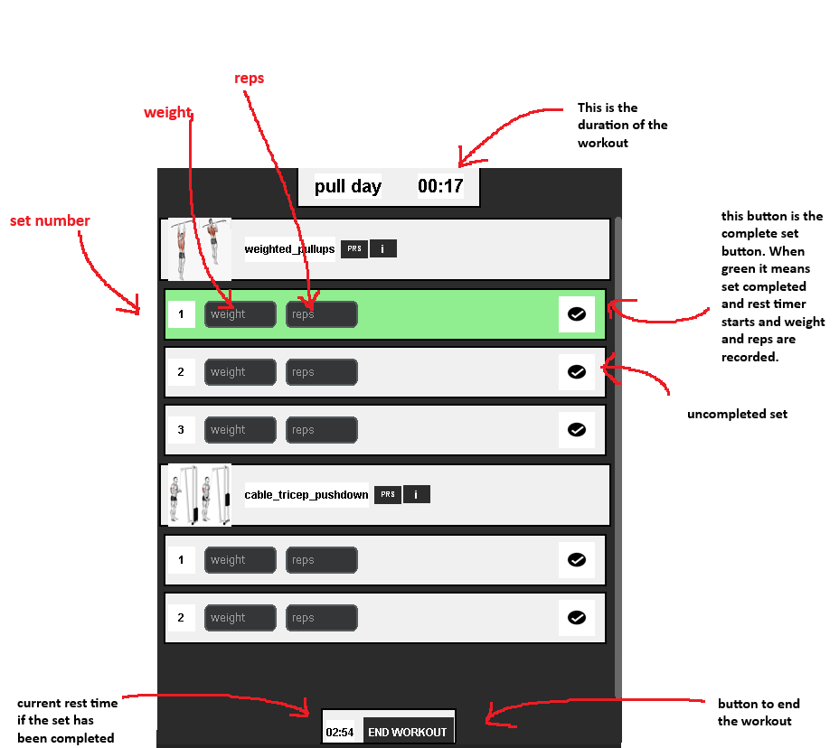

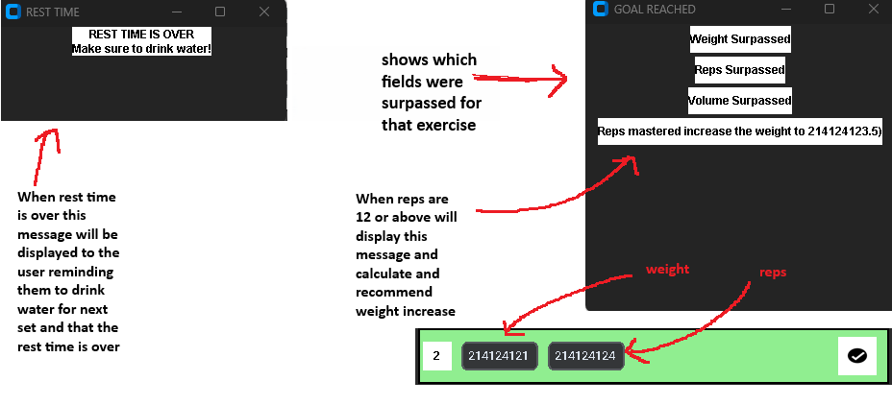
Workout results
When workout finished pressed:
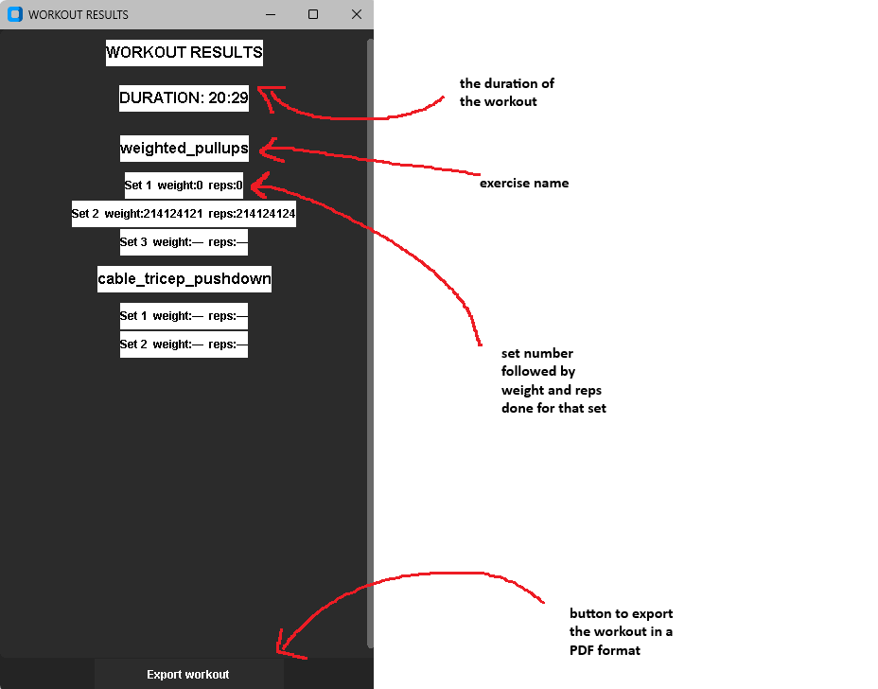

When export workout pressed
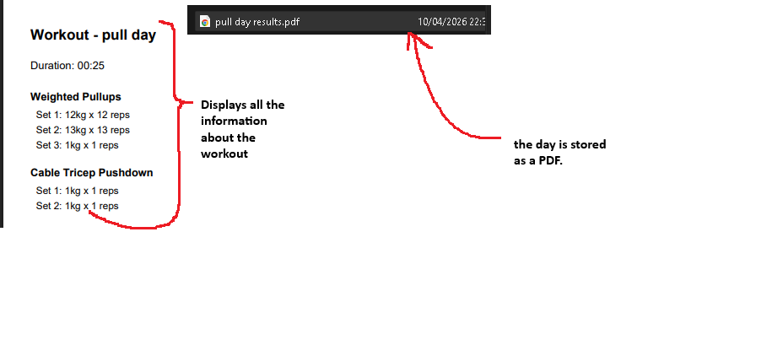

2.4.1.2 Pseudocode
Algorithms-1-add_day()
Purpose:
add_day() allows the user to create a new workout day by opening a secondary window, taking a name input, validating it and saving it to the database.

How it works:
A secondary window is opened prompting the user to type a workout name. When the confirm button is pressed, handle_adding() is called which retrieves the input. It then loops through all existing workout days and checks if a day with the same name already exists. If a duplicate is found an error popup is displayed and the function returns. If no duplicate exists, the new workout day is added to the workouts dictionary as an empty dictionary, the data is saved to the database, the screen is updated to the main menu, and the secondary window is destroyed.
Pseudocode
OPEN secondary window
GET workout name FROM INPUT

WHEN confirm PRESSED:
FOR each existing workout day:
if workout day matches input:
DISPLAY duplicate name error
RETURN
ADD new day to workouts dictionary as empty {}
SAVE data to database
UPDATE screen to main menu
CLOSE secondary window

Algorithim-2-configure_day()
Purpose: configure_day() allows the user to either rename or delete an existing workout day.
How it works: A secondary window is opened displaying two buttons — edit name and delete workout. If edit name is pressed, pull_input() is called which opens another secondary window with a text input for the new name. When confirmed, edit_name() is called which removes the old day from the workouts dictionary using pop() and re-adds it under the new name, preserving all the exercises inside it. The data is then saved and the screen updates to the main menu. If delete workout is pressed, delete_day() is called which removes the day and all its exercises from the workouts dictionary using pop(), saves the data and returns to the main menu.
Pseudocode
Open secondary window with two buttons: edit name, delete workout

If edit name pressed:
OPEN new secondary window with name input
WHEN confirm pressed:
REMOVE old day from workouts dictionary
ADD same data back under new name
SAVE data to database
UPDATE screen to main menu
IF delete pressed:
REMOVE day from workouts dictionary
SAVE data to database
Update screen to main menu

Algorithim-3-build_workout()
Purpose: build_workout() dynamically builds the workout screen based on the exercises stored in the current workout day.
How it works: The function initialises an empty stats dictionary. It retrieves all exercise names from the current workout day. If there are no exercises, a "NO WORKOUTS ADDED" message is displayed. For each exercise a row is created displaying the exercise image, name, a PRS button and an info button. If the workout has not been started, a back button is shown in the top panel along with set rest time, remove exercise, add set and remove set buttons per exercise. If the workout has been started the back button is hidden and a stopwatch label is shown instead. workout_box() is called for each exercise returning weight and reps arrays which are stored in stats under the exercise name. If the workout did not start, add exercise and start workout buttons are shown. If started, end workout button is shown.
Pseudocode
INITIALISE empty stats dictionary
GET list of exercises from current workout day

IF no exercises:
DISPLAY "NO WORKOUTS ADDED"

FOR each exercise:
CREATE row with image, name, PRS button, info button
IF workout not started:
SHOW back button, set rest time, remove, add/remove set buttons
IF workout started:
HIDE back button, show stopwatch
CALL workout_box() → returns weight_arr, reps_arr
STORE in stats[exercise] = {weight: weight_arr, reps: reps_arr}

IF workout not started:
SHOW add exercise and start workout buttons
IF workout started:
SHOW end workout button

Algorithm-4-add_rest_time()
Purpose: Opens a secondary window allowing the user to set the rest time for a specific exercise.
How it works: A secondary window is opened displaying the current rest time for that exercise retrieved from the workouts dictionary. A scrollable frame is populated with buttons numbered 1 to 10 representing minutes. When a button is clicked, set_time() is called.
Pseudocode
OPEN secondary window
DISPLAY current rest time for exercise

DEFINE set_time(t):
SET workouts[current_workout][exercise][rest time] = t
SAVE data to database
UPDATE label to show new rest time

FOR i = 1 to 10:
CREATE button labelled i minutes
WHEN clicked CALL set_time(i)

Algorithm 4 — show_info()
Purpose: Toggles the display of an exercise description when the info button is pressed.
How it works: When the info button is pressed the function first checks if an info panel already exists and is visible on screen. If it is, the panel is hidden and deleted and the function returns. If no info panel exists, the exercise description is retrieved from the exercise database using take_info() and an info panel is created and displayed at the bottom of the screen.#
Pseudocode
IF info panel exists and is visible:
HIDE info panel
DELETE info panel
RETURN

GET exercise description from exercise database
CREATE info panel with description
DISPLAY info panel at bottom of screen

Algorithm 5 — view_workout()
Purpose: Displays personal records, weight progression, plateau detection and progress graphs for a specific exercise when the PR button is pressed.
How it works: A secondary window is opened and the exercise name and description are retrieved from the exercise database. The PRs for weight, reps and volume are retrieved from workout_data and displayed. get_progression() is called twice to retrieve the weight and reps progression history from workout_history. Volume progression is then calculated by looping through both progressions and multiplying weight by reps for each session. The last 5 sessions of weight progression are displayed. check_plateau() is called to check if the weight has stayed the same for 3 or more sessions and if so a plateau warning is displayed. calculate_strength_increase() is called to calculate the percentage weight increase since the last session and displays it. Three buttons are shown to view weight, reps and volume graphs. If the exercise was created by the user a delete button is show. (Functions mentioned are explained on the pages below)

Pseudocode
OPEN secondary window
GET exercise name and description from exercise database
GET PRs for weight, reps, volume from workout_data
DISPLAY PRs

CALL get_progression() for weight → weight progression list
CALL get_progression() for reps → reps progression list

FOR each session in both lists:
volume = weight * reps
APPEND (date, volume) to volume progression list

DISPLAY last 5 sessions of weight progression

IF check_plateau() returns True:
DISPLAY plateau warning

CALL calculate_strength_increase()
DISPLAY percentage increase since last session

SHOW view weight graph button
SHOW view reps graph button
SHOW view volume graph button

IF exercise is not built in:
SHOW delete button

Algorithm 6 — get_progression()
Purpose: Retrieves the progression history for a specific exercise and metric (weight or reps) from workout_history, returning a sorted list of date and value pairs.
How it works: The function loops through all sessions in workout_history. For each session it checks if the exercise is present. If it is, it retrieves all the values for the given key (weight or reps) and finds the maximum value from that session. The date and maximum value are appended as a tuple to the progression list. The list is then sorted by date and returned.
Pseudocode
INITIALISE empty progression list

FOR each date and session in workout_history:
IF exercise not in session:
SKIP
GET all values for key (weight or reps)
FIND maximum value from that session
APPEND (date, max value) to progression list

SORT progression list by date
RETURN progression list

Algorithm 7 — check_plateau()
Purpose: Detects whether a user has plateaued by checking if the weight has stayed the same for the last 3 sessions.
How it works: The function first checks if there are fewer than 3 sessions in the progression list, if so, it returns False as there is not enough data. It then extracts the values from the last 3 sessions and checks if the maximum and minimum values are equal. If they are equal, it means the weight has not changed across those sessions and a plateau is detected.
Pseudocode
IF progression has fewer than 3 sessions:
RETURN False

GET values from last 3 sessions
IF max value == min value:
RETURN True
ELSE:
RETURN False

Algorithm 8 — calculate_strength_increase()
Purpose: Calculates the percentage increase in weight between the last two sessions for a specific exercise.
How it works: The function first checks if there are fewer than 2 sessions in the progression list, if so, it returns 0 as there is not enough data to compare. It then retrieves the latest weight and the previous session weight. If the previous weight is 0 it returns 0 to avoid a division by zero error. Otherwise, it calculates the percentage increase using the formula: ((latest - previous) / previous) * 100 and returns the result.
Pseudocode
IF fewer than 2 sessions:
RETURN 0

GET latest weight from last session
GET previous weight from second to last session

IF previous weight == 0:
RETURN 0

percentage increase = ((latest - previous) / previous) * 100
RETURN percentage increase

Algorithm 9 — weight_graph()
Purpose: Displays a line graph showing the progression of weight, reps or volume over time for a specific exercise.(Name is misleading as this function is for reps, weight and volume)
How it works: The function loops through the progression list extracting the date and value from each entry. The date is shortened to just the day and month by splitting the date string and taking the second and third elements. The dates and values are stored in separate lists which are then plotted as a line graph using matplotlib with markers at each data point.
Pseudocode
INITIALISE empty date_list and value_list

FOR each item in progression:
EXTRACT day and month from date string
APPEND to date_list
APPEND value to value_list
PLOT line graph with markers
DISPLAY graph
percentage increase = ((latest - previous) / previous) * 100
RETURN percentage increase

Algorithm 10 — change_set()
Purpose: Increments or decrements the number of sets for a specific exercise, with validation to prevent sets going below 1 or above 6.
How it works: The current number of sets for that exercise is retrieved from the workouts dictionary. If the command is decrease and sets is already below 1, an error popup is displayed and the function returns. If the command is increase and sets is already at 6 or above, an error popup is displayed and the function returns. Otherwise, if the command is increasing the sets value is incremented by 1, if decrease it is decremented by 1. The workout screen is then rebuilt to reflect the new number of sets visually.
Pseudocode
GET current sets for exercise from workouts dictionary

IF command is decrease AND sets < 1:
DISPLAY error popup "sets at 0"
RETURN

IF command is increase AND sets >= 6:
DISPLAY error popup "sets at max"
RETURN

IF command is increase:
sets = sets + 1
ELSE:
sets = sets - 1

SAVE updated sets to workouts dictionary
UPDATE screen to show new number of sets

Algorithm 11 — change_workout()
Purpose: Adds or removes an exercise from the current workout day depending on the command passed in.
How it works: The function takes a command of either "add" or "remove". If remove is passed, the exercise is removed from the current workout day in the workouts dictionary using pop() and the data is saved. If add is passed, a secondary window is opened with a search box and a scrollable results frame. A nested function on_type() is bound to the search box so that every time the user types, the results frame is cleared, and take_all_info() is called to retrieve all exercises matching the input. The results are displayed as buttons. When an exercise button is clicked, add_workout() is called which adds the exercise to the current workout day with default values of 0 sets, 0 reps, 0 weight and 2 minutes rest time. The data is saved, the screen is updated and the secondary window is closed.
Pseudocode
IF command is remove:
REMOVE exercise from workouts[current_workout]
SAVE data to database
UPDATE screen

IF command is add:
OPEN secondary window with search box and results frame

DEFINE on_type():
CLEAR results frame
GET typed input, replace spaces with _
CALL take_all_info() to get matching exercises
FOR each result:
CREATE button with exercise name
WHEN clicked CALL add_workout(exercise)

DEFINE add_workout(exercise):
ADD exercise to workouts[current_workout] with default values
sets=0, reps=0, weight=0, rest time=2
SAVE data to database
UPDATE screen
CLOSE secondary window

BIND on_type() to search box key release

Algorithm 12 — start_workout() / start_stopwatch() / update_stopwatch()
Purpose: Starts the workout session, begins tracking the total session duration and displays it on screen as a running stopwatch.
How it works: When the start workout button is pressed, start_workout() sets WORKOUT_START to True and rebuilds the workout screen so the configuration buttons are hidden and the tick buttons appear. start_stopwatch() is then called which records the current time as the start time using time.time(). update_stopwatch() is then called which calculates the elapsed time by subtracting the start time from the current time. This is converted into minutes and seconds using divmod(). The stopwatch label is updated with the new time formatted as MM:SS using {:02} to ensure two digits are always displayed. The function then schedules itself to be called again after 1000 milliseconds using an after() call, creating a recurring loop that updates every second. The current time is also stored in current_time so it can be saved when the workout ends.
Pseudocode
WHEN start workout pressed:
SET WORKOUT_START = True
REBUILD workout screen
CALL start_stopwatch()

DEFINE start_stopwatch():
RECORD start_time = current time

DEFINE update_stopwatch():
elapsed = current time - start_time
mins, secs = elapsed / 60 and remainder
UPDATE stopwatch label with mins:secs
STORE current time in current_time
SCHEDULE update_stopwatch() to run again after 1000ms

Algorithm 13 — start_timer() / update_timer()
Purpose: Starts a countdown rest timer for a specific exercise after a set is completed, alerting the user when rest time is over.
How it works: When start_timer() is called it first tries to cancel and destroy any existing timer to prevent multiple timers running at once. It then records the current time as the start time and creates a timer label displaying the full rest time for that exercise. update_timer() is then called which calculates the elapsed time since the timer started. The timer duration is retrieved from the workouts dictionary in seconds by multiplying the rest time in minutes by 60. If the elapsed time is greater than or equal to the timer duration, the timer label is set to 00:00, the after loop is cancelled and a popup is displayed telling the user rest time is over. Otherwise, the remaining time is calculated by subtracting elapsed from duration, converted to minutes and seconds and displayed on the timer label. The function then schedules itself to run again after 1000 milliseconds.
Pseudocode
DEFINE start_timer():
TRY to cancel and destroy existing timer
RECORD start_time = current time
CREATE timer label with full rest time
CALL update_timer()

DEFINE update_timer():
elapsed = current time - start_time
duration = rest time in minutes * 60

IF elapsed >= duration:
SET timer label to 00:00
CANCEL after loop
DISPLAY rest time over popup
RETURN

remaining = duration - elapsed
mins, secs = remaining / 60 and remainder
UPDATE timer label with mins:secs
SCHEDULE update_timer() to run again after 1000ms

Algorithm 14 — workout_box()
Purpose: Dynamically creates the set input rows for each exercise, allowing the user to log weight and reps for each set, and returns the logged data as two arrays.
How it works: Two empty arrays, weight_arr and reps_arr, are initialised to store the logged values. The function then loops through the number of sets configured for that exercise. For each set a row panel is created displaying the set number, a weight input box and a reps input box. A clicked attribute is set to False on each row to prevent the tick button being pressed twice. If the workout has been started a tick button is displayed. A nested function workout_completed() is defined which is called when the tick button is pressed. workout_completed() first checks if the row has already been clicked and returns if so. It then sets clicked to True and turns the row green. The weight and reps are retrieved from the input boxes, defaulting to 0 if empty, and appended to weight_arr and reps_arr. start_timer() is called to begin the rest countdown. compare_values() is then called to check if any PRs have been broken. If any PRs are broken a popup is displayed showing which records were surpassed. If reps are 12 or more a message is displayed recommending a weight increase. If no PRs were broken and reps are under 12 the popup is destroyed. Once all sets are built, weight_arr and reps_arr are returned to build_workout().
Pseudocode
INITIALISE empty weight_arr and reps_arr

FOR each set (0 to number of sets):
CREATE row panel
SET row.clicked = False
DISPLAY set number, weight input, reps input

DEFINE workout_completed():
IF row already clicked:
RETURN
SET row.clicked = True
TURN row green
CALL start_timer()
GET weight from input (default 0 if empty)
GET reps from input (default 0 if empty)
APPEND weight to weight_arr
APPEND reps to reps_arr
CALL compare_values() → returns PRS list
IF PRS[0] True: DISPLAY weight surpassed
IF PRS[1] True: DISPLAY reps surpassed
IF PRS[2] True: DISPLAY volume surpassed
IF reps >= 12: DISPLAY weight increase recommendation
IF no PRs and reps < 12: DESTROY popup

IF workout started:
DISPLAY tick button → WHEN clicked CALL workout_completed()

RETURN weight_arr, reps_arr

Algorithm 14 — end_workout()
Purpose: Ends the workout session, stops all timers, saves the results and displays the workout results screen.
How it works: The function first attempts to cancel the stopwatch after loop using after_cancel(). It then attempts to cancel and destroy the rest timer after loop. Both are wrapped in try/except blocks in case the timers were never started. The current time stored in current_time is added to the stats dictionary under the key duration. save_workout_results() is then called passing the stats dictionary to save the data. The screen is updated to the main menu and WORKOUT_START is set back to False. A secondary results window is opened displaying the workout duration and all exercises with their sets, weights and reps. If a set was not completed a dash is displayed instead of a value. An export button is shown at the bottom which when clicked calls export_pdf().
Pseudocode
TRY cancel stopwatch after loop
TRY cancel and destroy rest timer after loop

ADD current_time to stats["duration"]
CALL save_workout_results(stats)
UPDATE screen to main menu
SET WORKOUT_START = False

OPEN secondary results window
DISPLAY duration
FOR each exercise in current workout:
DISPLAY exercise name
FOR each set:
IF set was completed: DISPLAY weight and reps
ELSE: DISPLAY "—"
SHOW export button → WHEN clicked CALL export_pdf()

Algorithm 15 — save_workout_results()
Purpose: Performs a final personal record check for all exercises and saves the completed workout to workout history.
How it works: The function retrieves all exercise names from the current workout day. For each exercise it retrieves the weight and reps arrays from the stats dictionary and calls compare_values() to perform a final PR check across all sets. The current date and time is formatted as a string in the format "Weekday DD Month YYYY, HH:MM". The entire stats dictionary is stored in workout_history under this formatted date string as the key. The updated workout_history is then saved to the database.
Pseudocode
GET list of exercises from current workout day

FOR each exercise:
GET weight array from stats
GET reps array from stats
CALL compare_values(exercise, weight array, reps array)

FORMAT current date and time as string
STORE stats in workout_history[formatted date]
SAVE workout_history to database

Algorithm 16 — compare_values()
Purpose: Compares the weight, reps and volume logged in the current set against the stored personal records for that exercise and updates them if a new record has been achieved.
How it works: The function retrieves the current workout_data. Three boolean flags weight_pr, reps_pr and volume_pr are initialised to False. If the weights and reps inputs are not lists they are converted to lists to ensure consistent handling. The function then tries to retrieve the existing PRs for that exercise from workout_data. If the exercise does not exist in workout_data it is created with default values of 0. The existing PR values for weight, reps and volume are stored in variables. The function then loops through each weight and reps pair using zip(). Each value is converted to an integer. Volume is calculated as weight multiplied by reps. Each value is compared against the current PR and if greater the PR variable is updated and the corresponding boolean flag is set to True. After the loop the old dates for each PR are preserved so they are not overwritten unless a new PR was achieved. The workout_data dictionary is updated with the new PR values and dates. If any PR flag is True the current date and time is stored as the date for that PR. The updated workout_data is saved to the database and the three boolean flags are returned as a list.
Pseudocode
GET workout_data
SET weight_pr, reps_pr, volume_pr = False

IF weights not a list: CONVERT to list
IF reps not a list: CONVERT to list

TRY get existing PRs for exercise from workout_data
IF exercise not found:
CREATE entry with default values of 0

GET current PR values for weight, reps, volume

FOR each weight and reps pair:
CONVERT to integers
volume = weight * reps
IF weight > weight_pr value: UPDATE weight_pr value, SET weight_pr = True
IF reps > reps_pr value: UPDATE reps_pr value, SET reps_pr = True
IF volume > volume_pr value: UPDATE volume_pr value, SET volume_pr = True

PRESERVE old dates for each PR
UPDATE workout_data with new PR values and old dates

GET current date and time
IF weight_pr True: UPDATE weight date to current date
IF reps_pr True: UPDATE reps date to current date
IF volume_pr True: UPDATE volume date to current date

SAVE workout_data to database
RETURN [weight_pr, reps_pr, volume_pr]

Algorithm 17 — export_pdf()
Purpose: Generates and saves a formatted PDF file containing the workout results.
How it works: A new PDF object is created and a page is added. The workout day name is written as a bold heading at size 16. The duration is written below it at size 12. The function then loops through all items in the stats dictionary skipping the duration key. For each exercise the name is written as a bold heading with underscores replaced by spaces. It then loops through each set using zip() to pair the weight and reps values and writes each set on a new line showing the set number, weight in kg and reps. The workout day name is sanitised by replacing colons and commas to make it a valid filename and the PDF is saved.
Pseudocode
CREATE new PDF and add page
WRITE workout day name as bold heading size 16
WRITE duration at size 12

FOR each exercise in stats:
IF exercise is duration: SKIP
WRITE exercise name as bold heading
FOR each set (pairing weight and reps using zip):
WRITE set number, weight kg, reps

SANITISE workout day name (replace : and , )
SAVE PDF as sanitised name + results.pdf

Algorithm 18 — get_progression()
Purpose: Retrieves the progression history for a specific exercise and metric (weight or reps) from workout_history, returning a sorted list of date and value pairs.
How it works: The function loops through all sessions in workout_history. For each session it checks if the exercise is present. If it is, it retrieves all the values for the given metric (weight or reps) and finds the maximum value from that session using max(). The date and maximum value are then appended as a tuple to the progression list. Once all sessions have been checked the list is sorted by date and returned.
Pseudocode
progression = []
FOR each date, session in workout_history:
IF exercise in session:
values = session[exercise][key]
valid = [v for v in values if v is a number]
IF valid is not empty:
max_value = max(valid)
APPEND (date, max_value) to progression
SORT progression by date
RETURN progression

2.4.1.3 Data Structures

Name: workouts
Type:Nested dictionary
What it stores: Workouts stores workout days for example “push day”. And inside of all the workout days there will be exercises inside (1 or multiple) and inside the exercises there will be number of sets for that exercise, and the rest time for each set of that exercise.
Example:
How its used:Workouts is used by the appliaction in order to persoanlise to there saved data. Firstly in mainmenu the names and number of workouts are dependent on the data in workouts. When a workout day pressed, the workouts that are shown are taken from the exercises in that day which is gathered from the workouts dictionary. Furthermore, the number of sets and the rest time are also gathered from here.

Name: workout_history
Type: Nested dictionary
What it stores: Every completed workout session, stored under a date string key, containing all exercises with their weight and reps per set plus the session duration.
Example:
{
"Thursday 02 April 2026, 22:10": {
"barbell_bench_press": {
"weight": ["123", "12", "12"],
"reps": ["12", "12", "12"]
},
"duration": "00:06"
}
}
How it's used: Used in save_workout_results() to store a new session after a workout ends. Used in get_progression() to retrieve historical weight and reps data. Used in build_workout_history() to display past sessions to the user.

Name: weight_arr and reps_arr
Type: 1D list
What it stores: The weight and reps logged for each set during a workout session as the user ticks them off.
Example:
weight_arr = [80, 85, 90] reps_arr = [12, 10, 8]
How it's used: Initialised as empty lists in workout_box(). Each time the user presses the tick button for a set, the weight and reps values are appended to these lists. They are then returned to build_workout() and stored in the stats dictionary under the exercise name.

Name: progression
Type: List of tuples
What it stores: A chronological list of date and value pairs showing how a metric (weight, reps or volume) has changed across sessions for a specific exercise.
Example: [ ("Tuesday 31 March 2026, 12:30", 80), ("Thursday 02 April 2026, 22:10", 85) ]
How it's used: Initialised in build_workout() and populated by workout_box() as the user logs sets. Passed into end_workout() where duration is added, then passed into save_workout_results() to be saved to the database and into export_pdf() to generate the PDF.

Name: workout_data
Type: Nested dictionary
What it stores: The personal records for each exercise — best weight, best reps and best volume ever logged, each stored alongside the date they were achieved.
Example: {
"barbell_bench_press": {
"weight": [123, "Thursday 02 April 2026, 22:10"],
"reps": [24, "Thursday 02 April 2026, 22:08"],
"volume": [1476,"Thursday 02 April 2026, 22:10"]
}
}
How it's used: Retrieved in compare_values() to check if new PRs have been set. Updated whenever a new PR is achieved and saved back to the database. Retrieved in view_workout() to display the current PRs to the user.

2.4.1.4 Calculations

Calculations:
- Volume = weight ⋅ reps. This is calculated in compare_values() to check if a new volume personal record has been achieved.
- Percentage increase = ((latest - previous) / previous) ⋅ 100. This is calculated in calculate_strength_increase() to show the user how much their weight has increased since their last session.
- Timer duration = rest time ⋅ 60. This converts the rest time from minutes to seconds in update_timer() so it can be compared against the elapsed time.

2.4.1.5 SQL Queries
Query 1 — Retrieving exercise information
SELECT {key} FROM Exercises WHERE exercise = ?
This query retrieves a single field from the Exercises table for a specific exercise. The key is replaced at runtime with the field needed such as image, description or muscles_targeted. The ? is a parameter placeholder replaced with the exercise name at runtime which prevents SQL injection. This is used in build_workout() to get the image and name of each exercise to display on screen.
Query 2 — Searching exercises
SELECT * FROM Exercises WHERE exercise LIKE ?
This query retrieves all fields for every exercise where the exercise name contains the text the user typed. The % wildcards on either side mean it matches any exercise containing those letters anywhere in the name. This is used in change_workout() when the user searches for an exercise to add to their workout day.
Query 3 — Saving workout results
UPDATE Users SET workout_history = ? WHERE username = ?
This query finds the row in the Users table where the username matches and overwrites the workout_history field with the updated JSON data. The workout history is serialised to a JSON string before being saved. This is called in save_workout_results() after a workout is completed.

2.4.1.6 Validation

Data Validated | Where | Trigger | Validation Rule
Number of sets | change_set() | When add set or remove set button is clicked | Sets cannot go below 1 or above 6. Error popup displayed if limit reached
Workout day name | add_day() | When confirm button is clicked | Duplicate workout day names are not allowed. If a day with the same name exists an error popup is displayed
Weight input | workout_box() | When tick button is pressed | If the weight input box is empty it defaults to 0 to prevent empty data being stored
Reps input | workout_box() | When tick button is pressed | If the reps input box is empty it defaults to 0 to prevent empty data being stored
Tick button | workout_box() | When tick button is pressed | Each set row has a clicked attribute set to False. Once the tick button is pressed clicked is set to True and the function returns immediately if pressed again, preventing duplicate data being logged
Rest timer | start_timer() | When a set is completed | Before starting a new timer the previous timer is cancelled and destroyed to prevent multiple timers running simultaneously
Stopwatch/timer | end_workout() | When end workout is pressed | Both the stopwatch and rest timer are wrapped in try/except blocks to prevent the program crashing if they were never started

2.4.2 User Authentication (Login and Signuup)
This objective is responsible for the secure login and signup system of the application. It allows the user to create a new account with a username and password, or log into an existing account. When a new account is created, the password is hashed using bcrypt before being stored in the SQLite database, ensuring passwords are never saved in plain text. When logging in, the entered password is verified against the stored hash using bcrypt.checkpw(). If authentication is successful, the user's data including their workouts, workout history and personal records are loaded from the database into memory, personalising the application to that specific user.

2.4.2.1 User interface and explanation of user journey throughout program
Title screen

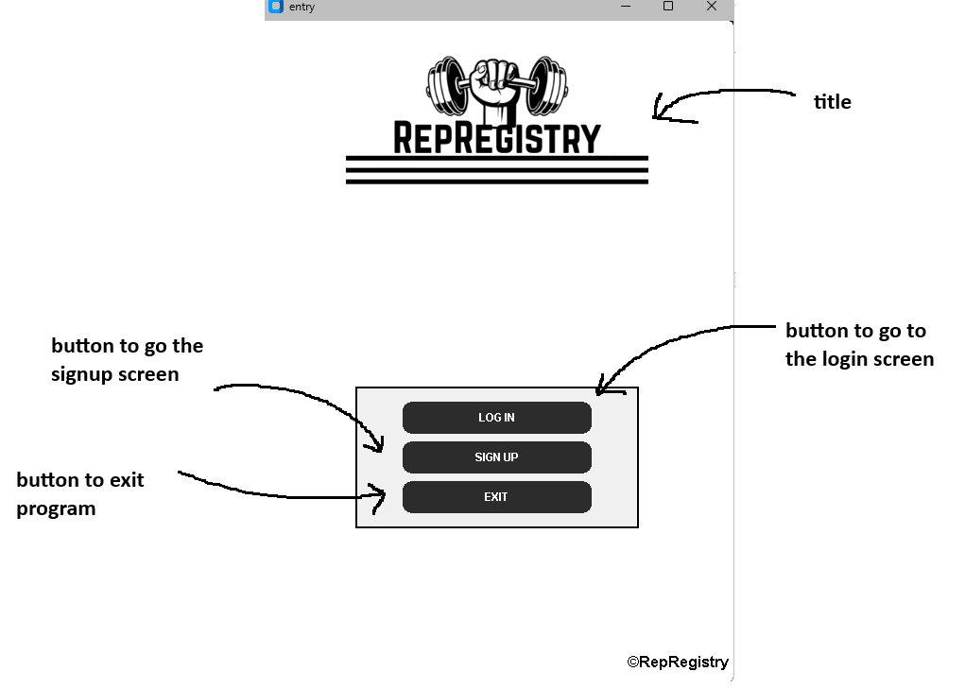
Login screen pressed
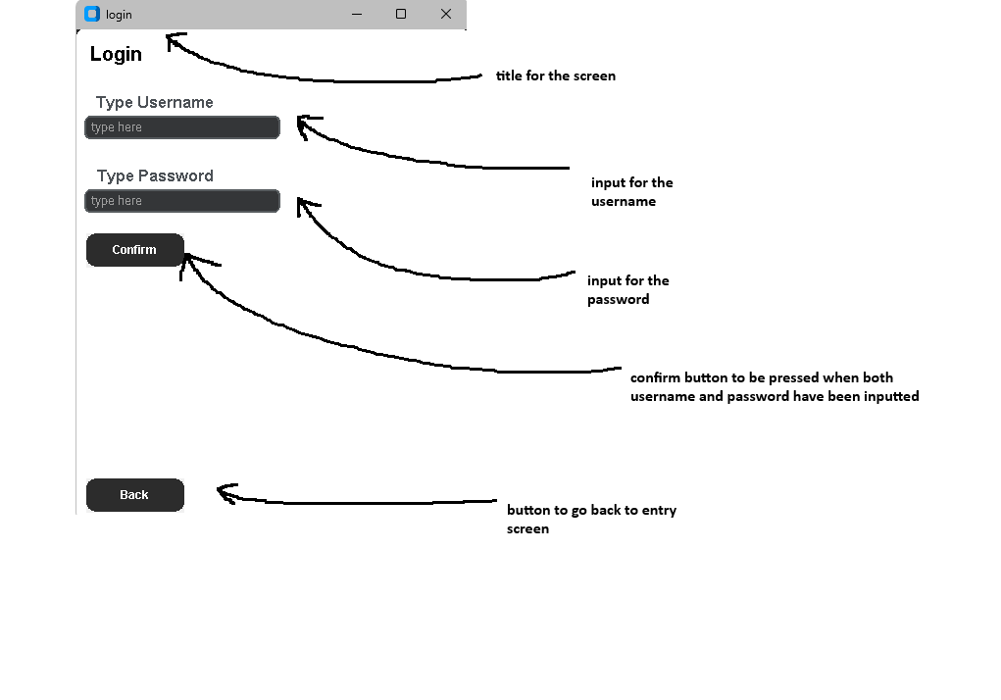
Wrong inputs for login screen
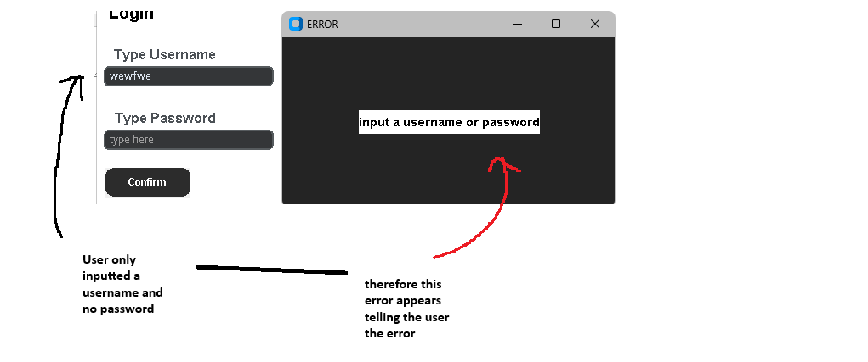
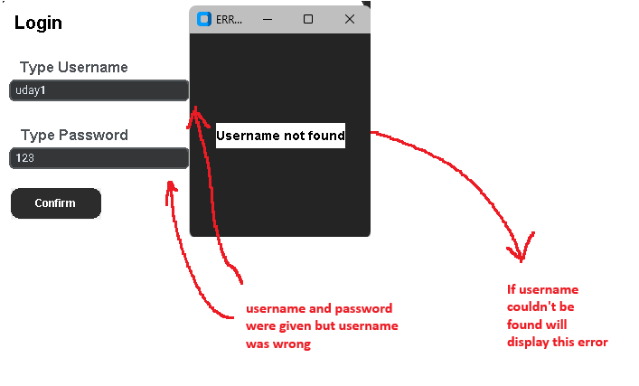
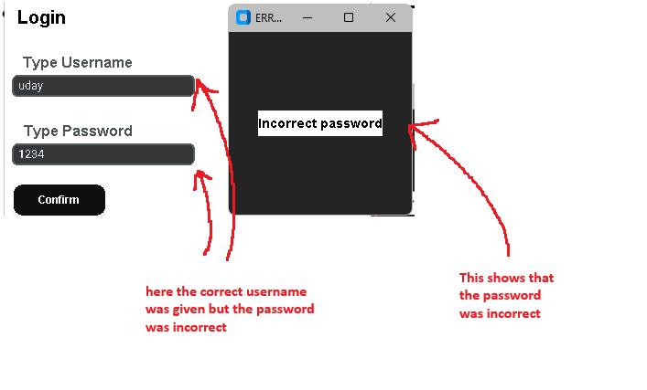
Signup screen pressed
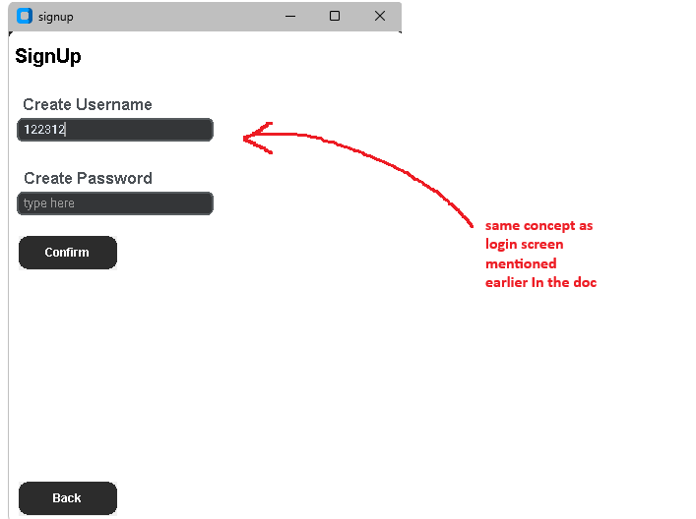

wrong inputs for signup screen
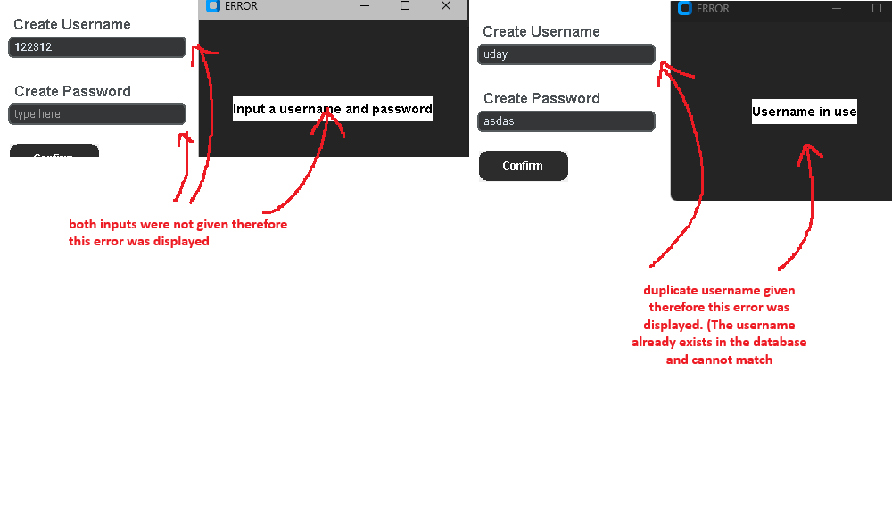
When login or signnup succesfull
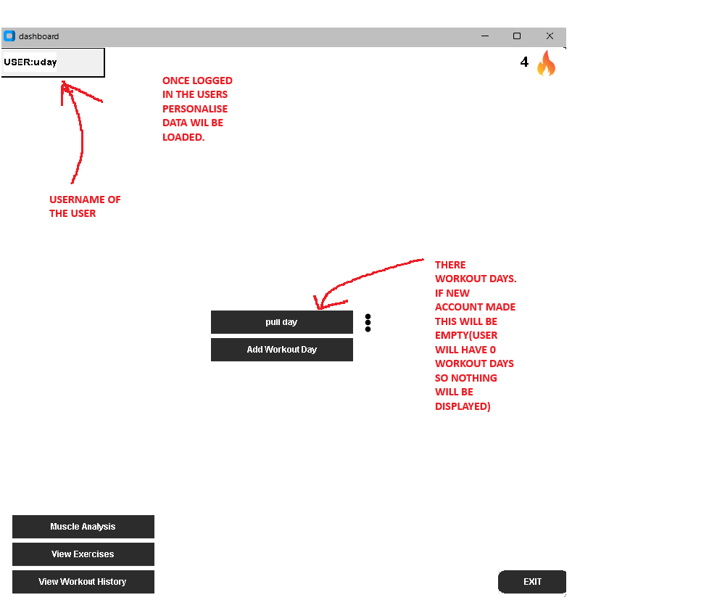

2.4.2.2 pseudocode

Algorithm — build_entry()
Purpose: Builds the entry screen which is the first screen displayed when the application launches. It displays the Rep Registry logo and three buttons allowing the user to log in, sign up or exit.
How it works: The function first displays the Rep Registry logo graphic in the centre of the screen. A panel is then created to hold the buttons. Three buttons are created — log in, sign up and exit. The log in and sign-up buttons call update_screen() with the corresponding screen name when pressed, navigating the user to the relevant screen. The exit button terminates the application.
Pseudocode
FUNCTION build_entry(parent):
DISPLAY logo graphic
CREATE panel
CREATE button "LOG IN"
IF clicked CALL update_screen("login")
CREATE button "SIGN UP"
IF clicked CALL update_screen("signup")
CREATE button "EXIT"
IF clicked CALL exit()
END FUNCTION

Algorithm — build_login()
Purpose: Builds the login screen, displaying input boxes for the user to enter their username and password, and buttons to confirm or go back to the entry screen.
How it works: The function creates two text input boxes — one for the username and one for the password. A confirm button is created which calls handle_login() when pressed, passing the input values to be validated. A back button is also created which calls update_screen("entry") to return the user to the entry screen.
Pseudocode:
FUNCTION build_login(parent):
DISPLAY label "Login"
DISPLAY label "Type Username"
CREATE text input box for username
DISPLAY label "Type Password"
CREATE text input box for password
CREATE button "Confirm"
IF clicked CALL handle_login()
CREATE button "Back"
IF clicked CALL update_screen("entry")
END FUNCTION

Algorithm — handle_login()
Purpose: Retrieves the username and password input by the user and attempts to log in by calling DataManager.load_data(). If successful the user is taken to the main menu, otherwise an error message is displayed.
How it works: The function retrieves the username and password from the input boxes. These are passed to DataManager.load_data() which checks the credentials against the database. If the returned value is "logged in successfully", the main menu, workout history and muscle analysis screens are pre-built and the screen is updated to the main menu. If login fails, a secondary window is displayed showing the relevant error message.
Pseudocode:
FUNCTION handle_login():
GET username from input box
GET password from input box
CALL DataManager.load_data(username, password)
IF result == "logged in successfully" THEN
CALL build_mainmenu()
CALL build_workout_history()
CALL build_muscle_analysis()
CALL update_screen("mainmenu")
ELSE
DISPLAY secondary window with error message
END IF
END FUNCTION

Algorithm — load_data()
Purpose: Validates the username and password entered by the user against the database. If credentials are correct, the user's data is loaded into memory and "logged in successfully" is returned.
How it works: The function first checks if either input is empty and returns an error if so. The username is converted to lowercase for consistency. A SQL SELECT query is executed to find the row where the username matches the input. If no row is found the username does not exist and an error is returned. If the username is found, bcrypt.checkpw() is used to compare the entered password against the stored hashed password. If the password is incorrect an error is returned. If both checks pass, the user's data including workouts, workout_data and workout_history are loaded from the database by deserialising the JSON strings into Python dictionaries and "logged in successfully" is returned.
Pseudocode:
FUNCTION load_data(username, password):
IF username == "" OR password == "" THEN
RETURN "input a username or password"
END IF
username = username.lower()
EXECUTE SQL: SELECT * FROM Users WHERE username = username
IF no row found THEN
RETURN "Username not found"
END IF
IF bcrypt.checkpw(password, stored_hash) == False THEN
RETURN "Incorrect password"
END IF
LOAD username, password, workouts, workout_data, workout_history from row
RETURN "logged in successfully"
END FUNCTION

Algorithm — build_signup()
Purpose: Builds the signup screen, displaying input boxes for the user to create a username and password, and buttons to confirm or go back to the entry screen.
How it works: The function creates two text input boxes — one for creating a username and one for creating a password. A confirm button is created which calls handle_signup() when pressed. A back button is also created which calls update_screen("entry") to return the user to the entry screen.
Pseudocode:
FUNCTION build_signup(parent):
DISPLAY label "SignUp"
DISPLAY label "Create Username"
CREATE text input box for username
DISPLAY label "Create Password"
CREATE text input box for password
CREATE button "Confirm"
IF clicked CALL handle_signup()
CREATE button "Back"
IF clicked CALL update_screen("entry")
END FUNCTION

Algorithm — handle_signup()
Purpose: Retrieves the username and password input by the user and attempts to create a new account by calling DataManager.new_save(). If successful the user is taken to the main menu, otherwise an error message is displayed.
How it works: The function retrieves the username and password from the input boxes. These are passed to DataManager.new_save() which attempts to create a new account in the database. If the returned value is "account created", the screen is updated to the main menu. If account creation fails, a secondary window is displayed showing the relevant error message.
Pseudocode:
FUNCTION handle_signup():
GET username from input box
GET password from input box
CALL DataManager.new_save(username, password)
IF result == "account created" THEN
CALL update_screen("mainmenu")
ELSE
DISPLAY secondary window with error message
END IF
END FUNCTION

Algorithm — new_save()
Purpose: Creates a new user account by validating the inputs, checking for duplicate usernames, hashing the password and inserting a new row into the Users table.
How it works: The username is first converted to lowercase for consistency. The function then checks if either input is empty and returns an error if so. A SQL SELECT query checks if the username already exists in the database — if it does, "Username in use" is returned. If the username is available, bcrypt.hashpw() is used to hash the password before storage. The workouts, workout_data and workout_history are initialised as empty dictionaries and serialised to JSON strings. A SQL INSERT statement then writes the new row to the Users table and the changes are committed. The username and password are stored in memory and "account created" is returned.
Pseudocode:
FUNCTION new_save(username, password):
username = username.lower()
IF username == "" OR password == "" THEN
RETURN "Input a username and password"
END IF
EXECUTE SQL: SELECT * FROM Users WHERE username = username
IF row found THEN
RETURN "Username in use"
END IF
scrambled = bcrypt.hashpw(password)
workouts = {}
workout_data = {}
workout_history = {}
CONVERT workouts, workout_data, workout_history TO JSON strings
EXECUTE SQL: INSERT INTO Users VALUES(username, scrambled, workouts, workout_data, workout_history)
COMMIT changes
RETURN "account created"
END FUNCTION

Algorithm — save_data()
Purpose: Saves updated data for a specific field belonging to a user by serialising it to a JSON string and updating the corresponding column in the Users table.
How it works: The data passed in is serialised to a JSON string using json.dumps() so it can be stored as text in the database. A SQL UPDATE statement is then executed, targeting the row where the username matches and setting the specified column to the new JSON string. The changes are then committed to the database.
Pseudocode:
FUNCTION save_data(username, key, data):
data_string = json.dumps(data)
EXECUTE SQL: UPDATE Users SET key = data_string WHERE username = username
COMMIT changes
END FUNCTION

2.4.2.3 Data Structures
Name: Users table row
Type: Tuple
What it stores: A single row fetched from the Users table in SQLite, containing the username, hashed password, and the three JSON strings for workouts, workout_data and workout_history.
Example:
("uday", "$2b$12$hashed...", "{}", "{}", "{}")
How it's used: Returned by fetchone() in load_data() after the SQL SELECT query. The values are extracted by index — rows[0] gives the username, rows[1] gives the hashed password which is passed to bcrypt.checkpw() for verification, and rows[2], rows[3], rows[4] give the JSON strings which are deserialised into dictionaries using json.loads().

Name: JSON string
Type: String
What it stores: A serialised representation of a Python dictionary, used to store complex nested data structures as plain text in SQLite.
Example: '{"push day": {"bench_press": {"sets": 3, "reps": 0, "weight": 0, "rest time": 2}}}'
How it's used: Created using json.dumps() in new_save() and save_data() before inserting or updating data in the database. Converted back into a Python dictionary using json.loads() in load_data() when the user logs in. This allows complex data structures to be stored in SQLite which only supports basic data types.

2.4.2.4 Queries

DDL (Data Definition Language) — defines the structure of the database:
CREATE TABLE IF NOT EXISTS Users(
username TEXT,
password TEXT,
workouts TEXT,
workout_data TEXT,
workout_history TEXT
)
Purpose: This creates the table if it doesn’t already exist

DML (Data Manipulation Language) — manipulating the data:
(load_data)
SELECT * FROM Users WHERE username = ?

(new_save)
INSERT INTO Users VALUES(?, ?, ?, ?, ?)

(save_data)
UPDATE Users SET key = ? WHERE username = ?
These queries manipulate, add and extract data from the table.

2.4.2.5 Validation

Data Validated | Where | Trigger | Validation Rule
Username and password | load_data() and new_save() | When confirm button is pressed | If either input is empty an error message is returned and no database operation is performed
Duplicate username | new_save() | When confirm button is pressed | A SQL SELECT query checks if the username already exists. If found "Username in use" is returned and the account is not created
Username existence | load_data() | When confirm button is pressed | A SQL SELECT query checks if the username exists. If no row is found "Username not found" is returned
Password correctness | load_data() | When confirm button is pressed | bcrypt.checkpw() compares the entered password against the stored hash. If they do not match "Incorrect password" is returned
Username case | load_data() and new_save() | When confirm button is pressed | Username is converted to lowercase before any database operation to prevent duplicate accounts with different cases

2.4.3 workout history and attendance
This objective allows the user to view all of their previously completed workout sessions and search for specific sessions by date. Each session is stored in the workout_history dictionary under a date string key, allowing the user to look back at the exercises, sets, weight and reps logged in any past session. The user can also export any historical session as a PDF. Additionally, a workout frequency graph is displayed showing the number of sessions completed in the current week and month, giving the user a visual overview of their training consistency and attendance over time.

2.4.3.1 User interface and explanation of user journey throughout program

Going to workout history
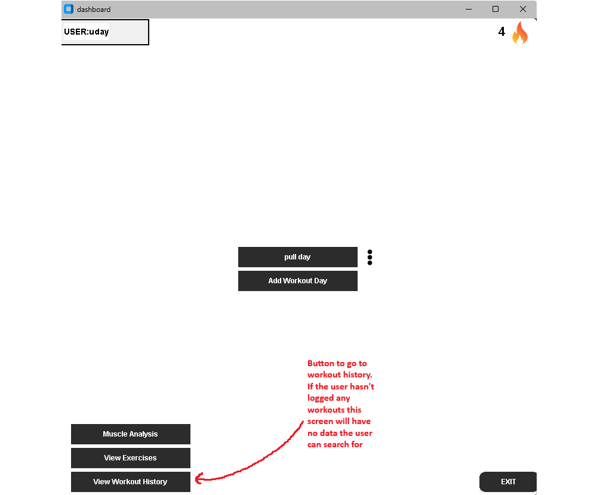

Workout history screen
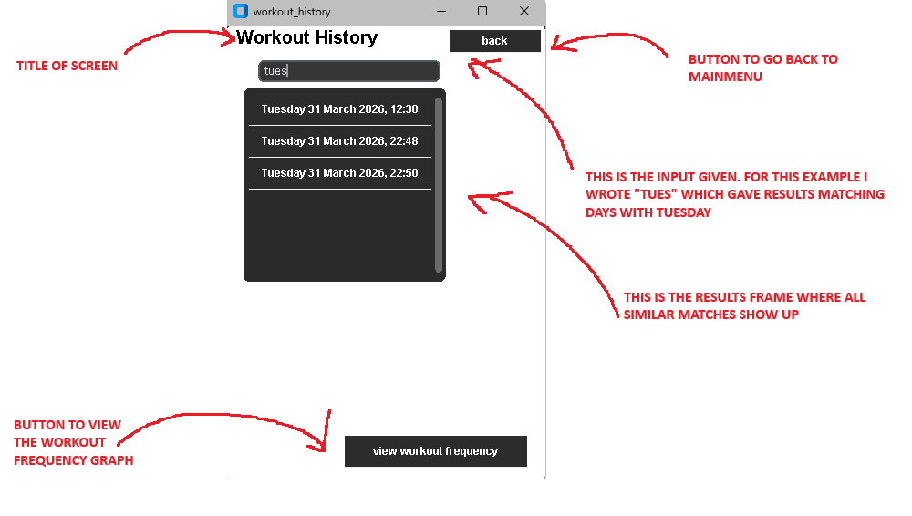
When date pressed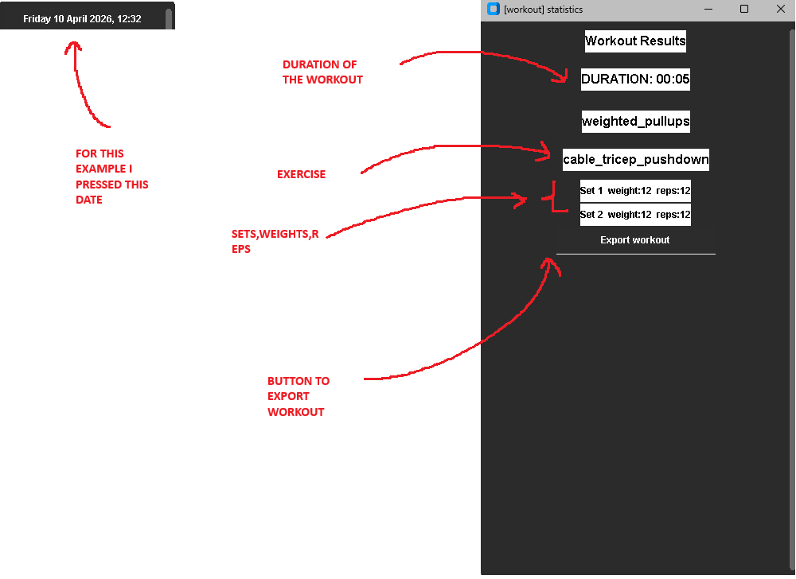

Workout frequency graph

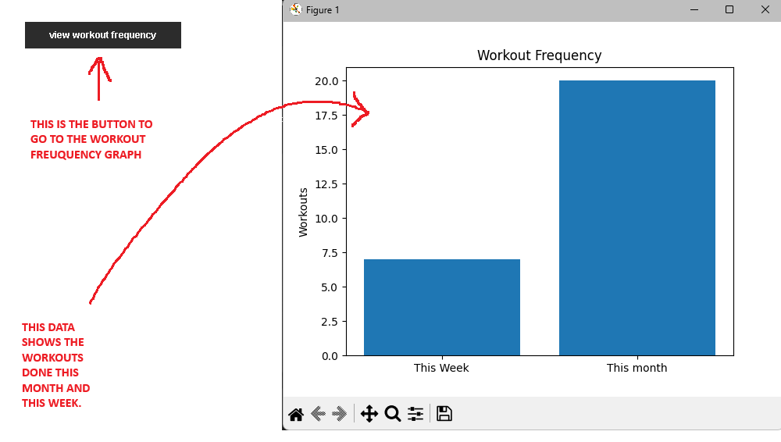

2.4.3.2 Pseudocode
Algorithm — build_workout_history()
Purpose: Builds the workout history screen, allowing the user to search for past sessions by date and view their results. Also provides a button to view the workout frequency graph.
How it works: A text input box is created and bound to the on_type function on each key release. As the user types, on_type searches through all dates in workout_history and displays any matching sessions as buttons in a scrollable frame. When a session button is clicked, view_workout is called which retrieves the stats for that session from workout_history and displays all exercises, sets, weight and reps in a secondary window. An export button is also available to call export_pdf() for that session.
Pseudocode:
FUNCTION build_workout_history(parent):
CREATE text input box bound to on_type

FUNCTION on_type():
CLEAR results frame
typed = input.get()
FOR each date in workout_history:
IF typed in date THEN
CREATE button with date
IF button clicked CALL view_workout(date)
END IF
END FOR
END FUNCTION

FUNCTION view_workout(workout):
GET stats from workout_history[workout]
DISPLAY secondary window
FOR each exercise in stats:
DISPLAY exercise name
FOR each set:
DISPLAY weight and reps
END FOR
END FOR
CREATE export button → CALL export_pdf()
END FUNCTION

CREATE button "view workout frequency" → CALL attendance_graph()
END FUNCTION
Algorithm — workout_frequency()
Purpose: Calculates the number of workout sessions completed in the current week and current month by looping through workout_history and comparing dates.
How it works: The current date and time is retrieved using datetime.now(). Two counters are initialised for week and month. The function loops through all date strings in workout_history, converting each one to a datetime object using strptime(). Each date is then compared to the current month and year — if they match, month_count is incremented. The ISO calendar week number is also compared — if they match, week_count is incremented. Both counters are returned.
Pseudocode:
FUNCTION workout_frequency():
now = datetime.now()
week_count = 0
month_count = 0
FOR each date_string in workout_history:
date = convert date_string to datetime
IF date.month == now.month AND date.year == now.year THEN
month_count += 1
END IF
IF date.week == now.week THEN
week_count += 1
END IF
END FOR
RETURN week_count, month_count
END FUNCTION
Algorithm — weight_graph()
Purpose: Displays a line graph showing how a metric (weight, reps or volume) has progressed over time for a specific exercise using matplotlib.
How it works: Two empty lists are initialised for dates and values. The function loops through the progression list of tuples, extracting the day and month from each date string and appending it to date_list, and appending the value to weight_list. matplotlib is then used to plot a line graph with markers and display it.#
Pseudocode:
FUNCTION weight_graph(progression):
date_list = []
weight_list = []
FOR each item in progression:
APPEND day and month to date_list
APPEND value to weight_list
END FOR
PLOT date_list against weight_list
SHOW graph
END FUNCTION

2.4.3.3 Validation

Data Validated | Where | Trigger | Validation Rule
Date search input | on_type() | On each key release | The typed input is converted to lowercase and compared against all dates in workout_history using an "in" check, ensuring partial matches are found and the search is case insensitive
Duration key | view_workout() | When displaying session results | Before looping through exercises, the duration key is skipped using a continue statement to prevent it being displayed as an exercise name
Set index | view_workout() | When displaying set results | range(len()) is used to ensure only sets that were actually logged are displayed, preventing index errors

2.4.3.3 SQL Queries
This is covered in objective two of 2.4

2.4.3.4 Calculations
Calculation 1 — Workout frequency count
workout_frequency() calculates the number of sessions completed in the current week and month by comparing each session date against the current date. The week comparison uses Python's ISO calendar week number to determine if two dates fall in the same week.
week_count = number of sessions where date.week == now.week
month_count = number of sessions where date.month == now.month AND date.year == now.year

Calculation 2 — Progression graph values
weight_graph() extracts the day and month from each date string in the progression list using string splitting, and pairs it with the corresponding metric value to plot on the graph.
date_label = day + month extracted from date string
e.g. "Thursday 02 April 2026, 22:10" → "02 April"
x axis = date_label
y axis = weight/reps/volume value

Calculation 3 — Attendance graph
attendance_graph() calls workout_frequency() to get the week and month counts and plots them as a bar chart using matplotlib.
labels = ["This Week", "This Month"]
values = [week_count, month_count]
PLOT bar chart with labels and values

2.4.3.5 Extra

- matplotlib being used to generate the graphs

- The use of datetime.strptime() to convert stored date strings back into datetime objects for comparison

- The ISO calendar week system used for week comparison

2.4.4 Muscles analysis, streak, and warnings
This objective implements three features that provide the user with additional insight into their training. The muscle analysis feature calculates which muscle groups have been trained during the current month by analysing the exercises completed and their associated muscle groups and intensities from the exercise database. Each muscle group is assigned a percentage indicating how thoroughly it has been trained, and a status such as "not trained", "undertrained", "moderate" or "well trained" is displayed. The workout streak feature tracks how many consecutive training days the user has maintained, resetting if more than three days pass without a session. The overtraining warning detects if the user has completed three or more sessions in a single day and displays a warning message on the main menu encouraging them to rest.

2.4.4.1 User interface and explanation of user journey throughout program
Going to muscle analysis
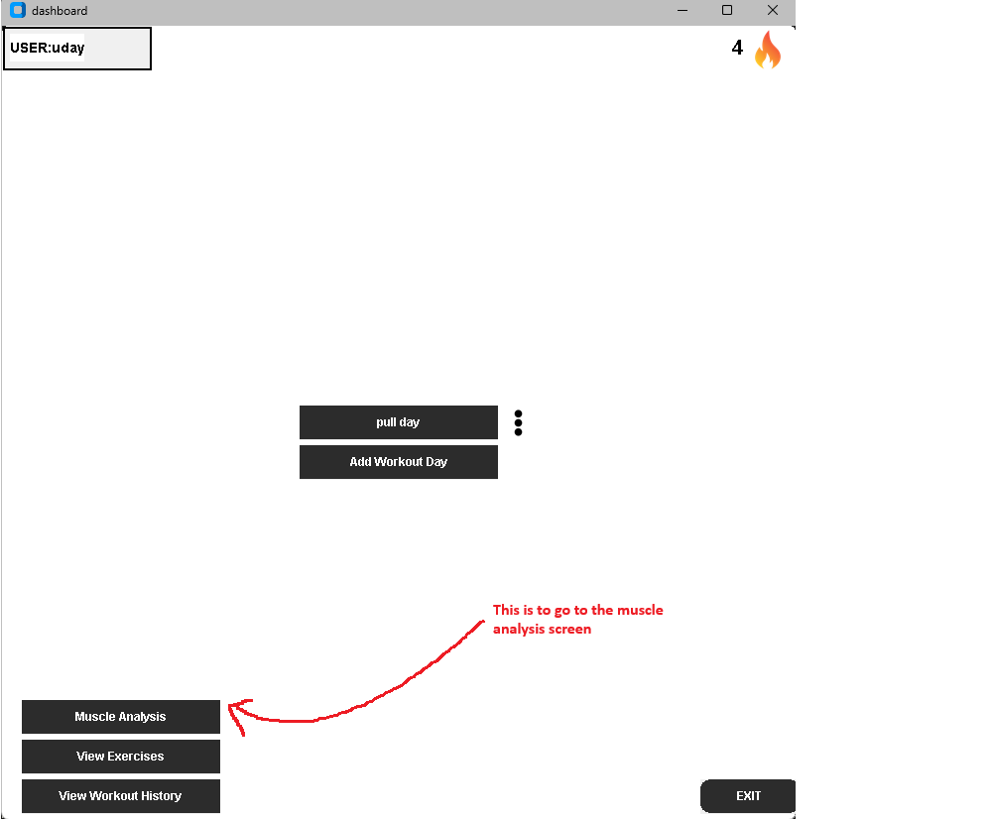

Muscle analysis
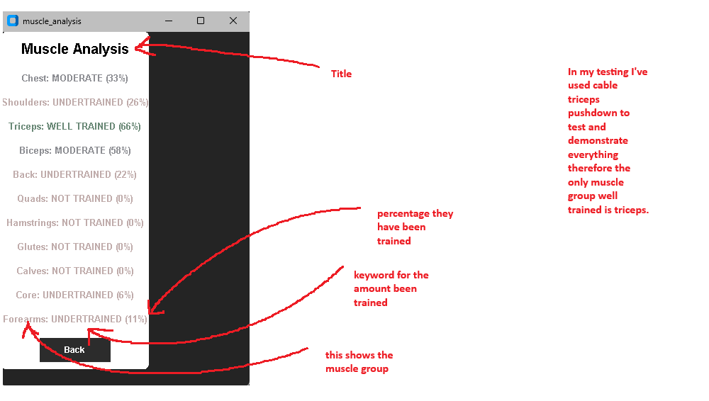
Workout streaks and warnings
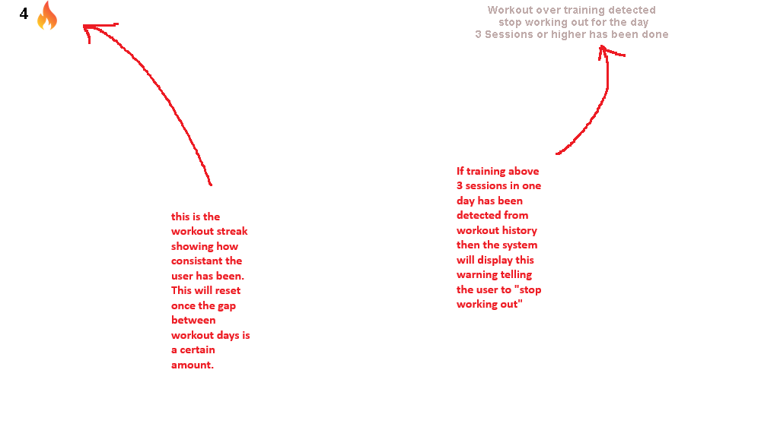

2.4.4.2 Pseudocode
Algorithm — workout_streak()
Purpose: Calculates the user's current workout streak by checking the gap between consecutive training sessions.
How it works: All date strings in workout_history are converted to datetime objects and sorted chronologically. The function loops through the sorted dates and checks the gap between each consecutive pair. If the gap is 3 days or less the streak is incremented. If the gap exceeds 3 days the streak resets to 1. The final streak value is returned.
Pseudocode:
FUNCTION workout_streak():
streak = 1
dates = all dates in workout_history converted to datetime and sorted
FOR i in range 1 to length of dates:
IF dates[i] - dates[i-1] <= 3 days THEN
streak += 1
ELSE
streak = 1
END IF
END FOR
RETURN streak
END FUNCTION

Algorithm — check_workout_fatigue()
Purpose: Checks whether the user has completed 3 or more workout sessions in a single day and returns True if so, triggering an overtraining warning on the main menu.
How it works: The current date is retrieved using datetime.now(). A counter is initialised for sessions completed today. The function loops through all dates in workout_history, converting each to a datetime object and checking if the day, month and year match today. If the count reaches 3 or more True is returned, otherwise False is returned.
Pseudocode:
FUNCTION check_workout_fatigue():
now = datetime.now()
workouts_today = 0
FOR each date_string in workout_history:
date = convert date_string to datetime
IF date.day == now.day AND date.month == now.month AND date.year == now.year THEN
workouts_today += 1
END IF
END FOR
IF workouts_today >= 3 THEN
RETURN True
END IF
RETURN False
END FUNCTION
Algorithm — calculate_muscles_worked() Purpose: Retrieves all exercises completed in the current month from workout_history and returns two lists — the muscles targeted and their training intensities — by querying the exercise database for each exercise.
How it works: The current date is retrieved and an empty dictionary is initialised for monthly exercises. The function loops through all sessions in workout_history, converting each date string to a datetime object and checking if it falls in the current month and year. If it does, each exercise in that session is added to the monthly_exercises dictionary, skipping the duration key. Once all sessions are processed, the function loops through the monthly exercises and queries the exercise database for the muscles targeted and intensity trained for each one, appending the results to two separate lists which are then returned.
Pseudocode:
FUNCTION calculate_muscles_worked():
monthly_exercises = {}
now = datetime.now()
FOR each date_string, session in workout_history:
date = convert date_string to datetime
IF date.month == now.month AND date.year == now.year THEN
FOR each exercise in session:
IF exercise == "duration" THEN CONTINUE
ADD exercise to monthly_exercises
END FOR
END IF
END FOR
muscles_worked = []
intensity_worked = []
FOR each exercise in monthly_exercises:
APPEND exercisedatabase.muscles_targeted to muscles_worked
APPEND exercisedatabase.intensity_trained to intensity_worked
END FOR
RETURN muscles_worked, intensity_worked
END FUNCTION

Algorithm — build_muscle_analysis()
Purpose: Builds the muscle analysis screen, calculating and displaying how thoroughly each muscle group has been trained during the current month based on the exercises completed and their intensity values.
How it works: A dictionary of muscle groups is defined, mapping each group to its individual muscles. calculate_muscles_worked() is called to retrieve the muscles worked and their intensities from the current month's sessions. For each muscle, the highest intensity value across all sessions is stored in a muscle_intensity dictionary. The function then loops through each muscle group, summing the intensity values of all muscles in that group and dividing by the maximum possible intensity to calculate a percentage. Based on the percentage, a status of "NOT TRAINED", "UNDERTRAINED", "MODERATE" or "WELL TRAINED" is assigned and displayed in the corresponding colour.
Pseudocode:
FUNCTION build_muscle_analysis(parent):
DEFINE muscle_groups dictionary
muscles_worked, intensity_worked = calculate_muscles_worked()
muscle_intensity = {}
FOR each muscle and intensity in muscles_worked and intensity_worked:
muscle_intensity[muscle] = max(current value, intensity)
END FOR
FOR each group in muscle_groups:
total_intensity = sum of intensity for each muscle in group
max_possible = number of muscles in group * 3
percentage = (total_intensity / max_possible) * 100
IF percentage == 0 THEN status = "NOT TRAINED"
ELSE IF percentage < 30 THEN status = "UNDERTRAINED"
ELSE IF percentage < 60 THEN status = "MODERATE"
ELSE status = "WELL TRAINED"
DISPLAY group, status and percentage
END FOR
END FUNCTION

2.4.4.3 Data Structures

Name: muscle_groups
Type: Dictionary of lists
What it stores: Maps each muscle group name to a list of individual muscles belonging to that group.
Example: {"Chest": ["pecs", "upper pecs", "lower pecs", "serratus anterior"]}
How it's used: Used in build_muscle_analysis() to loop through each muscle group and sum the intensity values of all muscles within it to calculate the training percentage for that group.

Name: muscle_intensity
Type: Dictionary
What it stores: Maps each individual muscle name to its highest recorded training intensity value (0-3) across all sessions in the current month.
Example: {"pecs": 3, "lats": 2, "biceps": 1}
How it's used: Built in build_muscle_analysis() by looping through muscles_worked and intensity_worked. For each muscle the maximum intensity is stored. Used to calculate the total intensity for each muscle group.

Name: muscles_worked and intensity_worked
Type: 1D list
What it stores: muscles_worked stores a list of muscles targeted by each exercise completed this month. intensity_worked stores the corresponding intensity values for those muscles.
Example: muscles_worked = [["pecs", "triceps"], ["lats", "biceps"]]
intensity_worked = [["3", "2"], ["3", "2"]]
How it's used: Returned by calculate_muscles_worked() and used in build_muscle_analysis() to build the muscle_intensity dictionary.

2.4.4.4 Data Structures

Calculation 1 — Muscle group training percentage
For each muscle group, the total intensity is calculated by summing the intensity values of all individual muscles in that group from muscle_intensity. This is then divided by the maximum possible intensity and multiplied by 100 to give a percentage.
total_intensity = sum of muscle_intensity[muscle] for each muscle in group
max_possible = number of muscles in group × 3
percentage = (total_intensity / max_possible) × 100
For example for Chest which has 4 muscles, the maximum possible intensity is 4 × 3 = 12. If the total intensity is 6 then the percentage is (6/12) × 100 = 50%, giving a status of "MODERATE".

2.4.5 Exercise management

2.4.5.1 User interface and explanation of user journey throughout program

Button to view exercises and to exit program
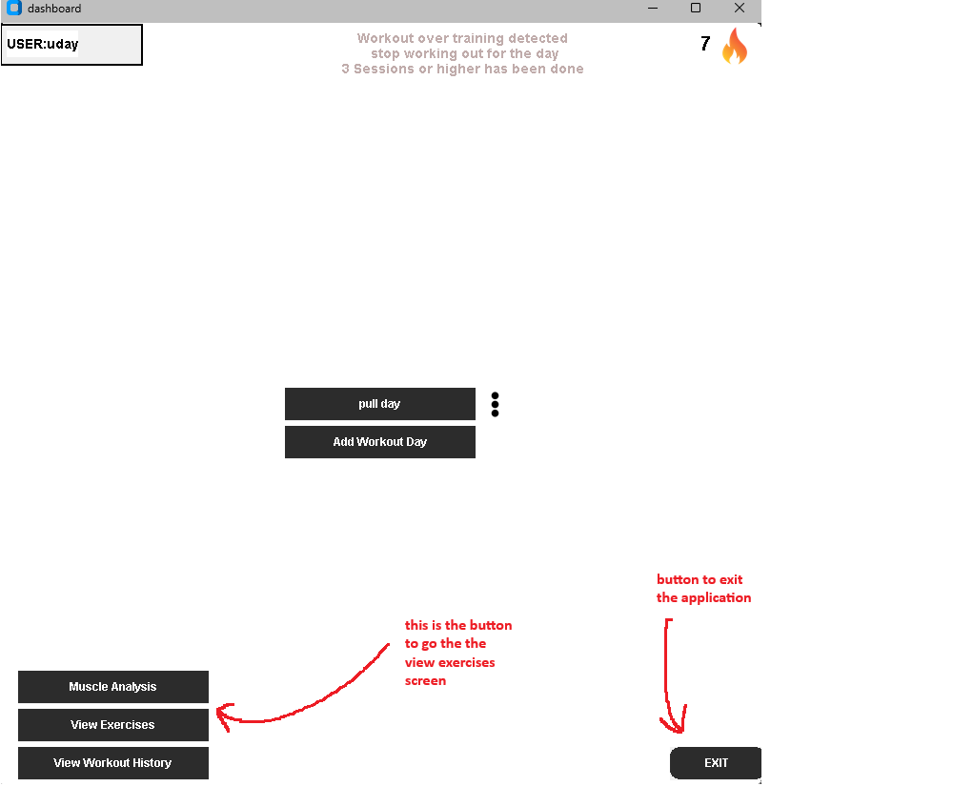
Inside the exercise screen
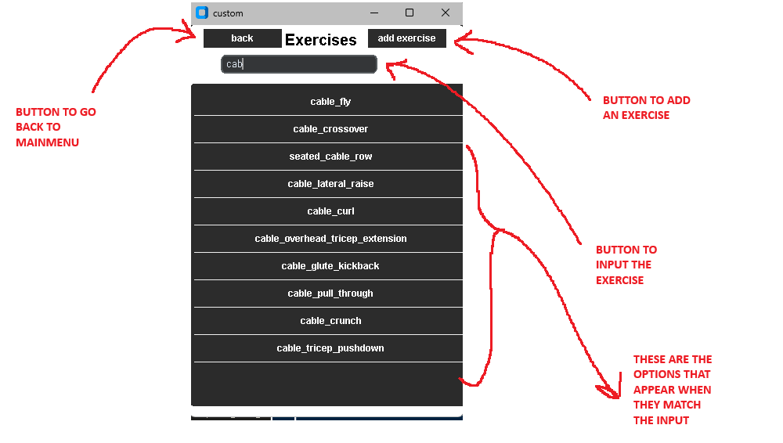
When exercise clicked in list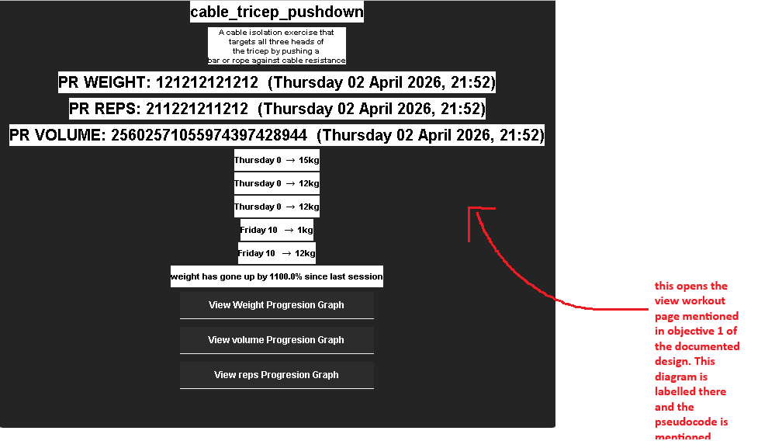
Create new exercise(add new exercise pressed)
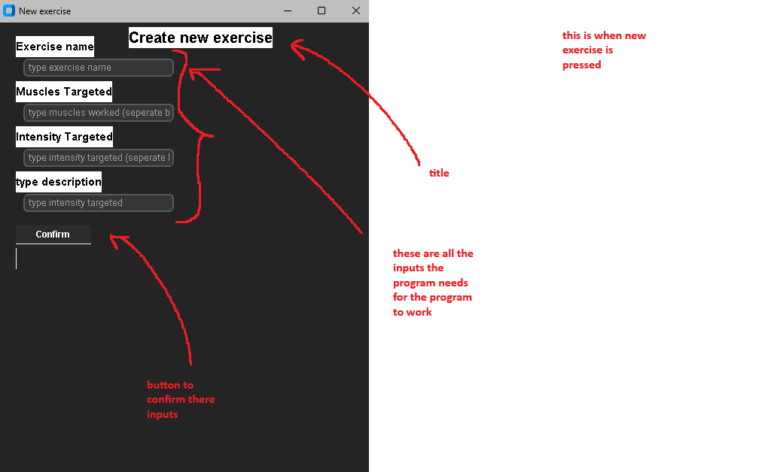
Custom exercise procress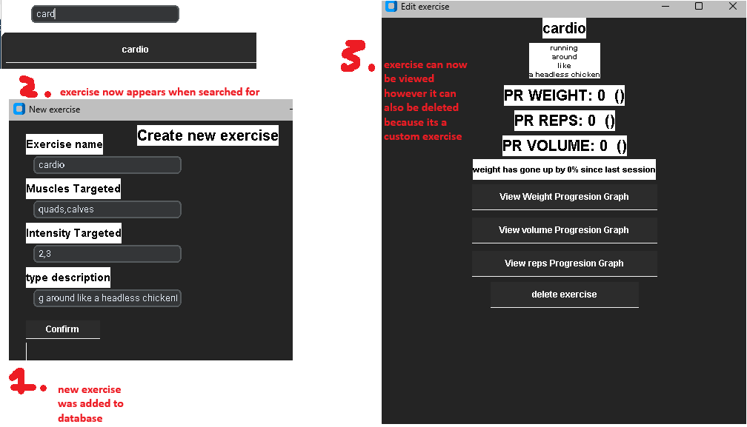

2.4.5.2 Pseudocode
Algorithm — build_custom()
Purpose: Builds the exercise screen where the user can search through all exercises, view their details and add new custom exercises.
How it works: A search input box is created and bound to on_type on each key release. As the user types, spaces are replaced with underscores to match the database format and take_all_info() is called to retrieve all matching exercises. Each result is displayed as a button in a scrollable frame. When an exercise button is clicked, view_workout() is called to display the exercise details. An add exercise button is also available which calls create_custom_exercise().
Pseudocode:
FUNCTION build_custom(parent):
CREATE search input box bound to on_type
CREATE scrollable results frame
CREATE button "add exercise" → CALL create_custom_exercise()

FUNCTION on_type():
CLEAR results frame
typed = input.get().replace(" ", "_")
results = exercisedatabase.take_all_info(typed)
FOR each result in results:
CREATE button with exercise name
IF clicked CALL view_workout(name, 1, edit)
END FOR
END FUNCTION
END FUNCTION

Algorithm — create_custom_exercise()
Purpose: Opens a secondary window allowing the user to create a new custom exercise by entering a name, muscles targeted, intensity values and a description.
How it works: A secondary window is displayed with input boxes for exercise name, muscles targeted, intensity values and description. When the confirm button is clicked, check_values() is called which validates all inputs before adding the exercise to the database.
Pseudocode:
FUNCTION create_custom_exercise():
OPEN secondary window
CREATE input boxes for name, muscles, intensity, description
CREATE button "Confirm" → CALL check_values()

FUNCTION check_values():
IF exercise name is empty THEN
DISPLAY error
RETURN
END IF
IF exercise already exists in database THEN
DISPLAY error
RETURN
END IF
muscles_arr = muscles input split by ","
intensitys_arr = intensity input split by ","
FOR each value in intensitys_arr:
IF value is not a number THEN
DISPLAY error
RETURN
END IF
END FOR
IF len(muscles_arr) != len(intensitys_arr) THEN
DISPLAY error
RETURN
END IF
CALL exercisedatabase.add_exercise(name, image, muscles_arr, intensitys_arr, description, "false")
END FUNCTION
END FUNCTION

Algorithm — view_workout()
Purpose: Displays a secondary window showing the exercise description, personal records, recent progression history, plateau detection, strength increase percentage and buttons to view progression graphs. If the exercise is custom, a delete button is shown.
How it works: A secondary window is opened and the exercise name and description are retrieved from the exercise database and displayed. The personal records for weight, reps and volume are retrieved from workout_data and displayed with their dates. get_progression() is called twice to get weight and reps progression, and volume progression is calculated by multiplying weight and reps for each session. The last 5 sessions are displayed. check_plateau() is called to detect if weight has stagnated and calculate_strength_increase() calculates the percentage increase since the last session. Buttons are created to view weight, reps and volume graphs. If the edit parameter is not "true" a delete button is shown allowing the user to delete the exercise.
Pseudocode:
FUNCTION view_workout(exercise, command, edit):
OPEN secondary window
DISPLAY exercise name and description
GET weight, reps, volume PRs from workout_data
DISPLAY PR weight, PR reps, PR volume with dates
progression = get_progression(exercise, "weight")
progression_reps = get_progression(exercise, "reps")
FOR each item in progression and progression_reps:
volume = weight * reps
APPEND to progression_volume
END FOR
DISPLAY last 5 sessions from progression
IF check_plateau(progression) == True THEN
DISPLAY "Plateau detected"
END IF
DISPLAY calculate_strength_increase(progression) as percentage
CREATE buttons to view weight, reps, volume graphs
IF edit != "true" THEN
CREATE delete button → CALL delete_exercise()
END IF
END FUNCTION

Algorithm — ExerciseDatabase.delete_exercise()
Purpose: Deletes an exercise from the Exercises table where the exercise name matches the input.
How it works: A SQL DELETE statement is executed targeting the row where the exercise name matches the input. The changes are then committed to the database.
Pseudocode:
FUNCTION delete_exercise(exercise):
EXECUTE SQL: DELETE FROM Exercises WHERE exercise = exercise
COMMIT
END FUNCTION

Algorithm — ExerciseDatabase.take_info()
Purpose: Retrieves a single field value for a specific exercise from the Exercises table. If the field is muscles_targeted or intensity_trained, the JSON string is deserialised back into a list before returning.
How it works: The key is first validated against a set of allowed column names to prevent SQL injection. A SELECT query retrieves the specified field for the given exercise. If the field is muscles_targeted or intensity_trained the result is deserialised from a JSON string back into a Python list using json.loads(). The value is then returned.
Pseudocode:
FUNCTION take_info(key, exercise):
IF key not in allowed_keys THEN
RAISE error
END IF
EXECUTE SQL: SELECT key FROM Exercises WHERE exercise = exercise
IF key is muscles_targeted OR intensity_trained THEN
RETURN json.loads(data)
END IF
RETURN data
END FUNCTION

Algorithm — ExerciseDatabase.take_all_info()
Purpose: Retrieves all exercises from the Exercises table where the exercise name contains the input string. Used to power the live search in build_custom().
How it works: A SQL SELECT query using the LIKE operator with % wildcards on both sides of the input is executed, returning all rows where the exercise name contains the typed string. All matching rows are returned as a list of tuples.
Pseudocode:
FUNCTION take_all_info(INPUT):
EXECUTE SQL: SELECT * FROM Exercises WHERE exercise LIKE %INPUT%
RETURN all matching rows
END FUNCTION

2.4.5.2 SQL queries
DDL (Data Definition Language)-defines the structure of the Exercises database:
CREATE TABLE IF NOT EXISTS Exercises (
exercise TEXT,
image TEXT,
muscles_targeted TEXT,
intensity_trained TEXT,
description TEXT,
built_in TEXT
)

DML (Data Manipulation Language) — manipulates the data inside the Exercises database:
SELECT — used in take_info() to retrieve a specific field for an exercise:
SELECT {key} FROM Exercises WHERE exercise = ?
SELECT * FROM Exercises WHERE exercise LIKE ?
INSERT INTO Exercises VALUES(?, ?, ?, ?, ?, ?)
DELETE FROM Exercises WHERE exercise = ?

The ? placeholders are used throughout to prevent SQL injection. The LIKE operator uses %INPUT% wildcards on both sides so partial matches are returned, powering the live search feature in build_custom().

2.4.5.3 Codes used/invented
Codes used/invented
The built_in field stores either "true" or "false" as a string. Built in exercises have built_in set to "true" and cannot be deleted by the user. Custom exercises created by the user have built_in set to "false", allowing them to be deleted. This is checked in view_workout() where the delete button only appears if edit != "true".

2.4.5.3 Validation

Data Validated | Where | Trigger | Validation Rule
Exercise name empty | check_values() | When confirm button clicked | If exercise name is empty or whitespace an error is displayed and the function returns
Duplicate exercise | check_values() | When confirm button clicked | take_info() checks if the exercise already exists in the database. If it does an error is displayed
Intensity values | check_values() | When confirm button clicked | Each intensity value is checked using int() inside a try/except. If any value is not a number an error is displayed
Muscles and intensities length | check_values() | When confirm button clicked | The length of muscles_arr and intensitys_arr are compared. If they do not match an error is displayed

3. Technical solution

3.1 Main.py

import customtkinter as ctk
from datetime import datetime,timedelta
from PIL import Image
from database import DataManager
from database import ExerciseDatabase
import os
import json
import time
from fpdf import FPDF
import matplotlib.pyplot as plt

#Setting appearance
ctk.set_appearance_mode("dark")
ctk.set_default_color_theme("blue")

#Default app size
APP_SIZE = "800x800"
APP_WIDTH, APP_HEIGHT = 800, 800

#'setting app title and geometry
app = ctk.CTk()
app.title("Rep Registry")
app.geometry(APP_SIZE)

#COLOUR USED
TEXT_COLOR = "#000000"
TEXT_COLOR2 = "#4C5156"
TEXT_COLOR3 = "#333844"
TEXT_COLOR4 = "#8D8E93"
POSITIVE_COLOR = "#698876"
NEGATIVE_COLOR = "#C0ACAB"
APP_BG = "#FFFFFF"
PANEL_BG = "#F0F0F0"
PRIMARY_BLUE = "#4B709D"
BUTTON_BG_NORMAL = "#2C2C2C"
BUTTON_BG_HOVER = "#1F1F1F"
BUTTON_BG_CLICKED = "#0F0F0F"

class Objects():
#Static method class used to simplify lengthy code allowing for consistant design throughout the program.
@staticmethod
def label(parent, text, x, y, w, h, size, text_color=TEXT_COLOR, bold=True, panel_color=APP_BG):
#Creates a label taking in the parameters
font_styles = "bold" if bold else "normal"
font = ("Arial", size, font_styles)

label = ctk.CTkLabel(
parent,
text=text,
font=font,
text_color=text_color,
bg_color=panel_color
)
#Modifys width and height if inputed into the function
if w is not None:
label.configure(width=w)
if h is not None:
label.configure(height=h)

#Use x and y placing if it is not None
if x is not None and y is not None:
label.place(x=x, y=y)
#returns the label so extra modifcations can be made or needed for another use
return label

@staticmethod
def panel(parent, x, y, w, h, bg_color=PANEL_BG):
#Creates a CTK panel to hold information
panel = ctk.CTkFrame(
parent,
width=w,
height=h,
fg_color=bg_color,
corner_radius=0,
border_width=2.5,
border_color="black"
)
if x is not None and y is not None:
panel.place(x=x, y=y)

return panel

@staticmethod
def button(parent, x, y, w, h, text, text_size, corner_radius, bg_color, text_color="#FFFFFF", bg_normal=BUTTON_BG_NORMAL, bg_hover=BUTTON_BG_HOVER, bg_clicked=BUTTON_BG_CLICKED, bold=True, callback=None):

#Creates a CTK button
font_style = "bold" if bold else "normal"
font = ("arial", text_size, font_style)

button = ctk.CTkButton(parent, text=text, width=w, height=h, fg_color=bg_normal, hover_color=bg_hover, bg_color=bg_color, text_color=text_color, font=font, corner_radius=corner_radius, command=callback)

#Animates the button so the color is changed once the button is pressed
def on_press(event):
button.configure(fg_color=bg_clicked)
#Returns the original color once the button isnt pressed
def on_release(event):
button.configure(fg_color=bg_normal)

#Binds the functions to the button
button.bind("<ButtonPress-1>", on_press)
button.bind("<ButtonRelease-1>", on_release)

if x is not None and y is not None:
button.place(x=x, y=y)
return button

@staticmethod
def graphical_button(parent, w, h, x, y, image, image_hover, image_clicked, callback=None):
#A button except can use a PNG

#Create the images for all three states
image = ctk.CTkImage(Image.open(image), size=(w, h))
image_hover = ctk.CTkImage(Image.open(image_hover), size=(w, h)) if image_hover else image
image_clicked = ctk.CTkImage(Image.open(image_clicked), size=(w, h)) if image_clicked else image

button = ctk.CTkButton(parent, image=image, text="", width=w, height=h, command=callback)

# Checks if other images were given.
if image_hover and image_clicked is None:
button.configure(fg_color="white", hover_color="black")
else:
# If other images are given, keep background transparent
button.configure(fg_color="transparent")

def on_press(event):
button.configure(image=image_clicked)

def revert(event):
button.configure(image=image)
#When mouse enters button image changes image.
def on_hover(event):
button.configure(image=image_hover)

button.bind("<Enter>", on_hover)
button.bind("<Leave>", revert)
button.bind("<ButtonPress-1>", on_press)
button.bind("<ButtonRelease-1>", revert)

if x is not None and y is not None:
button.place(x=x, y=y)

return button

@staticmethod
def graphic(parent, x, y, w, h, image):
#Creates an image on the screen
graphic = ctk.CTkImage(dark_image=Image.open(image), size=(w, h))
graphic_label = ctk.CTkLabel(parent, image=graphic, text="")
if x is not None and y is not None:
graphic_label.place(x=x, y=y)
return graphic_label

@staticmethod
def text_box(parent, x, y, w, h, p_text):
#Text box is used to get user input. A box where the user can type into
text_box = ctk.CTkEntry(parent, placeholder_text=p_text, width=w, height=h)
if x is not None and y is not None:
text_box.place(x=x, y=y)
return text_box

@staticmethod
def info_panel(parent, w, h, text, text_color):
#Used just for long sentences that need to be indented
words = text.split()
quarter = len(words) // 4
line1 = " ".join(words[:quarter])
line2 = " ".join(words[quarter:quarter*2])
line3 = " ".join(words[quarter*2:quarter*3])
line4 = " ".join(words[quarter*3:])
text = line1 + "\n" + line2 + "\n" + line3 + "\n" + line4
panel1 = Objects.panel(parent=parent, x=None, y=None, w=w, h=h)
text1 = Objects.label(parent=panel1, x=None, y=None, w=None, h=None, size=10, text_color=text_color, text=text)
text1.pack()
return panel1

@staticmethod
def workout_box(parent, workout, w, h, sets, relx, rely, workout_start, timer_location, workout_name):
#specific method used for the workout section of the code. This code gathers the data and builds the sets according to the data

#Create empty arrays to eventually store all the weight and rep entrys given
weight_arr = []
reps_arr = []
for i in range(sets):
#Make a panel
bg = Objects.panel(parent=parent, x=None, y=None, w=w, h=h, bg_color=PANEL_BG)
bg.clicked = False
bg.pack(fill="x", pady=3, padx=5)

#To determine which set is which
frame_count_circle = ctk.CTkFrame(bg, width=30, height=30, fg_color=APP_BG, corner_radius=0)
frame_count_circle.pack(side="left", padx=5, pady=5)
frame_count_text = Objects.label(parent=frame_count_circle, text=i+1, x=None, y=None, w=30, h=30, size=12)
frame_count_text.place(relx=0.5, rely=0.5, anchor="center")

#Input box for receving data
weight_input_box = Objects.text_box(bg, x=None, y=None, w=80, h=30, p_text="weight")
weight_input_box.pack(side="left", padx=5, pady=5)
#input box for receving reps data
rep_input_box = Objects.text_box(bg, x=None, y=None, w=80, h=30, p_text="reps")
rep_input_box.pack(side="left", padx=5, pady=5)

def workout_completed(object1, weight_input, reps_input, turn, workout_name):
#This function is called when the user presses the tick button indicating the set has been finished

#Prevents the user from clicking the button twice
if object1.clicked:
return
object1.clicked = True

object1.configure(fg_color="#90EE90")

#When workout is completed Rest timer must start
APP.start_timer(timer_location, workout_name)

#Gets the input
weight = weight_input.get()
#If 0 input given sets to 0
if weight == "":
weight = 0
weight_arr.append(weight)

reps = reps_input.get()
if reps == "":
reps = 0
reps_arr.append(reps)

#Checks for the PRS in the users personal best for that exercise comparing them with weight and reps.
PRS = APP.compare_values(workout_name, weight, reps)
parent = APP.secoundary_window("GOAL REACHED", 200, 300)
if PRS[0] == True:
#Checks if weight for that exercise has been surpassed and displays a message for the user
text1 = Objects.label(parent=parent, x=None, y=None, w=None, h=None, size=12, text_color=TEXT_COLOR, text="Weight Surpassed")
text1.pack(pady=2)
if PRS[1] == True:
text2 = Objects.label(parent=parent, x=None, y=None, w=None, h=None, size=12, text_color=TEXT_COLOR, text="Reps Surpassed")
text2.pack(pady=2)
if PRS[2] == True:
text3 = Objects.label(parent=parent, x=None, y=None, w=None, h=None, size=12, text_color=TEXT_COLOR, text="Volume Surpassed")
text3.pack(pady=2)
if int(reps) >= 12:
#Checks if the user has gotten 12 or more reps which means they can increase the weight.
new_weight = int(weight) + 2.5
text4 = Objects.label(parent=parent, x=None, y=None, w=None, h=None, size=12, text_color=TEXT_COLOR, text=f"Reps mastered increase the weight to {new_weight})")
text4.pack(pady=2)
#Destroys the secoundary screen because no PRS have been or the reps havent hit 0 so no message needs to be displayed
if not any(PRS) and int(reps) < 12:
parent.destroy()
#Only display tick button once the workout has been started
if workout_start:
tick_button = Objects.graphical_button(bg, w=40, h=40, x=None, y=None, image="Graphics/tick.png", image_hover="Graphics/tick_hover.png", image_clicked="Graphics/tick_pressed.png", callback=lambda bg_=bg, w=weight_input_box, r=rep_input_box, turn=i, wn=workout_name: workout_completed(bg_, w, r, turn, wn))
tick_button.pack(side="right", padx=5, pady=5)
#Return all the weight and reps that have been logged.
return weight_arr, reps_arr

@staticmethod
def scrollable_frame(parent, w, h):
#A scrollable frame to scroll through items put on the frame
scrollable_frame = ctk.CTkScrollableFrame(parent, width=w, height=h)
return scrollable_frame

class Running:
def __init__(self):
#Main class

#Initialize to prevent errors
self.current_screen = None
self.current_workout = None

#Call classes from sqlite3 py file
self.datamanager = DataManager()
self.exercisedatabase = ExerciseDatabase()

#Initialise workout
self.WORKOUT_START = False

#Create all the different screens in the app
self.mainmenu_screen = ctk.CTkFrame(app, width=APP_WIDTH, height=APP_HEIGHT, fg_color=APP_BG)
self.entry_screen = ctk.CTkFrame(app, width=500, height=700, fg_color=APP_BG)
self.signup_screen = ctk.CTkFrame(app, width=400, height=500, fg_color=APP_BG)
self.login_screen = ctk.CTkFrame(app, width=400, height=500, fg_color=APP_BG)
self.workout_screen = ctk.CTkFrame(app, width=520, height=800, fg_color="#2B2B2B")
self.workout_history_screen = ctk.CTkFrame(app,width=350,height =500,fg_color=APP_BG)
self.custom_screen = ctk.CTkFrame(app,width=350,height=500,fg_color = APP_BG)
self.muscle_analysis_screen = ctk.CTkFrame(app,width=350,height=500,fg_color = APP_BG)
#Builds the entry screen
self.build_entry(self.entry_screen)

#Dictionary storing data about screen and information to call functions for them. Used to easily loop through screens and calling specific functions to avoid extra code
self.screen_dictionary = {
"mainmenu": [self.mainmenu_screen, 800, 800, "dashboard", app, self.build_mainmenu],
"entry": [self.entry_screen, 500, 700, "entry", app, self.build_entry],
"signup": [self.signup_screen, 400, 500, "signup", app, self.build_signup],
"login": [self.login_screen, 400, 500, "login", app, self.build_login],
"workout": [self.workout_screen, 520, 800, "workout", app, self.build_workout],
"workout_history":[self.workout_history_screen, 350, 500, "workout_history", app, self.build_workout_history],
"custom":[self.custom_screen, 350, 500, "custom", app, self.build_custom],
"muscle_analysis":[self.muscle_analysis_screen, 350, 500, "muscle_analysis", app, self.build_muscle_analysis]
}

#Function to change the screen
def update_screen(self, screen):
#Checks if current screen is on and removes it
if self.current_screen:
self.current_screen.place_forget()

#Loops through all the items in the dictionary
for screen_list in self.screen_dictionary.values():
#gets the screen
frame = screen_list[0]
#checks and then calls the function to destroy all the items in that screen
if frame is not None:
self.destroy_widgets(frame)
#Loops through all the names of screen and then has the corresponding items
for name, screen_list in self.screen_dictionary.items():
#Loops through all screen names till it matches the input given
if name == screen:
#Configures the window based on that screen. the screen, Width,Height,Title
self.window_configure(screen_list[4], screen_list[1], screen_list[2], screen_list[3])
# Call the build function if it exists
if screen_list[5] is not None:
#Builds the screen
screen_list[5](screen_list[0])
#Places the screen
screen_list[0].place(x=0, y=0)
#Sets current screen to the screen being displayed
self.current_screen = screen_list[0]

def window_configure(self, screen, w, h, name):
#Configures name width and height of screen
screen.geometry(str(w) + "x" + str(h))
screen.title(name)

def secoundary_window(self, title, w, h):
#A secoundary window to display extra information, errors

#Try to destroy the popup if it exists
try:
self.popup.destroy()
except:
pass
#Create popup
self.popup = ctk.CTkToplevel(app)
#Puts popup above
self.popup.attributes('-topmost', True)
#Change popup geometry and title
self.window_configure(self.popup, w, h, title)
self.popup.geometry(f"{w}x{h}+960+540")
return self.popup

def handle_signup(self):
#Gets the inputs
username = self.signup_username_input.get()
password = self.signup_password_input.get()

#calls new save which returns strings to determine whether sign up was successfull or not
error = self.datamanager.new_save(username, password)

#If account creation was successfull takes the user to the mainmenu
if error == "account created":
self.update_screen("mainmenu")
return
#Creates popup and displays the error message is sign in wasnt successfull
self.popup = self.secoundary_window("ERROR", 300, 200)
text1 = Objects.label(parent=self.popup, x=None, y=None, w=None, h=None, size=14, text_color=TEXT_COLOR, text=error)
text1.place(relx=0.5, rely=0.5, anchor="center")

def handle_login(self):
#Same concept as handle signup
username = self.login_username_input.get()
password = self.login_password_input.get()

error = self.datamanager.load_data(username, password)

if error == "logged in successfully":
self.build_mainmenu(self.mainmenu_screen)
self.build_workout_history(self.workout_history_screen)
self.build_muscle_analysis(self.muscle_analysis_screen)
self.update_screen("mainmenu")
return
self.popup = self.secoundary_window("ERROR", 200, 200)
text1 = Objects.label(parent=self.popup, x=None, y=None, w=None, h=None, size=14, text_color=TEXT_COLOR, text=error)
text1.place(relx=0.5, rely=0.5, anchor="center")

def destroy_widgets(self, parent):
#Destroys all the widgets of a screen
for widget in parent.winfo_children():
widget.destroy()

def check_plateau(self, progression, window=3):
#extracts all the secound items of progression and if all three are the same plateau is true
if len(progression) < window:
return False
recent = [w for _, w in progression[-window:]]
return max(recent) == min(recent)

def calculate_strength_increase(self, progression):
#checks if enough sessions to compare
if len(progression) < 2:
return 0

# Gets the number of items in progression
total = len(progression)
# Finds the latest weight
latest = progression[total - 1][1]
# Finds the weight for previous session
previous = progression[total - 2][1]

#guard
if previous == 0:
return 0

# Calculate the percentage increase of weight for that exercise since the last session
percentage_increase = ((latest - previous) / previous) * 100
return percentage_increase

def calculate_muscles_worked(self):
#Calculates which muscles are being worked and to what extent
monthly_exercises = {}
now = datetime.now()
#Gets all the dates in the dictionary
for date_string, session in self.datamanager.workout_history.items():
#strptime date in order to compare
date = datetime.strptime(date_string, "%A %d %B %Y, %H:%M")
#Finds all the data for the muscles worked in the current month
if date.month == now.month and date.year == now.year:
#Then takes the exercise and the exercise data from sessions
for exercise, data in session.items():
#Passes on duration
if exercise == "duration":
continue
#adds the exercise and its data to the months exercise dict
if exercise not in monthly_exercises:
monthly_exercises[exercise] = []
monthly_exercises[exercise].append(data)
#Creates arrays for the muscles and intensitys worked
muscles_worked = []
intensity_worked = []

#Now gets the exercise in the monthly_exercise dictionary
for exercise in monthly_exercises.keys():
#Then stores the result of the muscles targeted from that exercise and the intensity those muscles are trained from that exercise
muscles_worked.append(self.exercisedatabase.take_info("muscles_targeted", exercise))
intensity_worked.append(self.exercisedatabase.take_info("intensity_trained", exercise))

#Returns these two arrays
return muscles_worked, intensity_worked

def workout_frequency(self):
#Gets current time
now = datetime.now()
#Intialise training sessions being down per week and month
week_count = 0
month_count = 0

for date_string in self.datamanager.workout_history:
date = datetime.strptime(date_string, "%A %d %B %Y, %H:%M")

#Checks if month is same as current month and the year
if date.month == now.month and date.year == now.year:
#Adds one session to the month count
month_count +=1
#Checks if week is the same
if date.isocalendar().week == now.isocalendar().week:
week_count += 1

return week_count, month_count # return both counters

def check_workout_fatigue(self):
#Current time
now = datetime.now()
#Initialise the workouts done today
workouts_today = 0

#Loops throuhh all the dates in workout_history
for date_string in self.datamanager.workout_history:
date = datetime.strptime(date_string, "%A %d %B %Y, %H:%M")
#If the day the session was recorded is the same day as today workouts today is increased by 1
if date.day == now.day and date.month == now.month and date.year == now.year:
workouts_today += 1
#If workouts above 3 Warning message will be displayed to the user
if workouts_today >= 3:
return True
return False

def workout_streak(self):
#Intialise streak
streak = 1

#Gets all the dates from sessions that have been recorded
dates_worked = [
datetime.strptime(d, "%A %d %B %Y, %H:%M")
for d in self.datamanager.workout_history
]
#sorts them chronologically
dates_worked.sort()
#Checks if the gap between two workout days
for i in range(1, len(dates_worked)):
if dates_worked[i] - dates_worked[i-1] <= timedelta(days=3):
#If gap is less than will increase the streak
streak += 1
else:
#Else streak gets reset
streak = 1

return streak

def weight_graph(self,progression):
#intialise the arays
date_list = []
weight_list = []
#Checks the items in progression
for item in progression:
#Splits the dates so its just the number and the month.
date_list.append(" ".join(item[0].split(" ")[1:3]))
#adds the weight to the weight list
weight_list.append(item[1])
#Uses both those list to display a graphical diagram to display how weight is progressing over time
plt.plot(date_list, weight_list, marker="o")
plt.show(block=False)

def attendance_graph(self):
#Workout frequency returns sesssions done in a week and a month
week,month = self.workout_frequency()
#Get the lables for the bar chart
labels = ["This Week","This month"]
#Values are the sessions done this week and month
values = [week,month]

#Plot the graph
plt.bar(labels,values)
plt.ylabel("Workouts")
plt.title("Workout Frequency")
plt.show()

def open_workout(self, day):
#Set current workout to the day of the button being clicked. EG push day has been clicked so set current workout to push day.
self.current_workout = day
self.update_screen("workout")

def change_set(self, workout_name, s):
#Gets current sets
sets = self.datamanager.workouts[self.current_workout][workout_name]["sets"]
#prevents sets from being less than 0 and greater than 6
if sets < 1 and s == "decrease":
parent = self.secoundary_window("ERROR", 300, 400)
text1 = Objects.label(parent=self.popup, x=None, y=None, w=None, h=None, size=14, text_color=TEXT_COLOR, text="ERROR: sets at 0")
text1.place(relx=0.5, rely=0.5, anchor="center")
return
if sets >= 6 and s == "increase":
parent = self.secoundary_window("ERROR", 300, 400)
text1 = Objects.label(parent=self.popup, x=None, y=None, w=None, h=None, size=14, text_color=TEXT_COLOR, text="ERROR: sets at max")
text1.place(relx=0.5, rely=0.5, anchor="center")
return
#If s increase, increase the sets else decrease the amount of sets
if s == "increase":
self.datamanager.workouts[self.current_workout][workout_name]["sets"] += 1
else:
self.datamanager.workouts[self.current_workout][workout_name]["sets"] -= 1
#Update the screen to show the new amount of sets visually
self.update_screen("workout")

def change_workout(self, command, workout_name=None):
#Functions to change exercises (called change workout but meant to be called change_exercise)

#Checks if input for command given was remove
if command == "remove":
#Goes into the current workout and remove the exercise from it
self.datamanager.workouts[self.current_workout].pop(workout_name, None)
#Saves the data
self.datamanager.save_data(self.datamanager.username, "workouts", self.datamanager.workouts)

#Adding a new exercise to the workout day
if command == "add":
#Seperate screen to search for the workout
parent = self.secoundary_window("SEARCH WORKOUT", 300, 400)
#Textbox for input
workout_search = Objects.text_box(parent=parent, x=None, y=None, w=200, h=25, p_text="type here")
workout_search.place(relx=0.5, rely=0.2, anchor="center")
#Scrollable frame to show all the exercises that match what the user typed
results_frame = Objects.scrollable_frame(parent, w=200, h=100)
results_frame.place(relx=0.5, rely=0.65, anchor="center")
pass

def add_workout(exercise):
#if an exercise clicked will then set the default parameters for the exercise
self.datamanager.workouts[self.current_workout][exercise] = {"sets": 0,"rest time": 2}
#Saves the new data
self.datamanager.save_data(self.datamanager.username, "workouts", self.datamanager.workouts)
#updates the screen
self.update_screen("workout")
#Destroys the secounday screen used to search for the exercise
parent.destroy()

def on_type(event):
#Destroys all the previous widgets
self.destroy_widgets(results_frame)
#replaces any spaces with _ because thats how the data for exercise names was stored
typed = workout_search.get().replace(" ", "_")
#Gets all the exercises that have letters that were typed in them
results = self.exercisedatabase.take_all_info(typed)
#displays all the exercises that match the input given and display them as button that can be picked
for key in results:
#Name of workout
name = key[0]
#Makes the button with the exercise name and if the button is clicked will then add that workout taking in that exercise name
button1 = Objects.button(parent=results_frame, x=None, y=None, w=200, h=35, text=name, text_size=12, corner_radius=0, bg_color=PANEL_BG, callback=lambda n=name: add_workout(n))
button1.pack()
#Bind the function to when the user types
workout_search.bind("<KeyRelease>", on_type)
return

self.update_screen("workout")

def add_rest_time(self, workout_name):
#Function for setting the rest time of the exercise
parent = self.secoundary_window("ADD REST TIME", 300, 400)
#Display current rest time for exercise
text1 = Objects.label(parent=parent, x=None, y=None, w=None, h=None, size=12, text_color=TEXT_COLOR, text=f"CURRENT REST TIME:{self.datamanager.workouts[self.current_workout][workout_name]['rest time']} MINS")
text1.place(relx=0.1, rely=0.1)
#Makes a scrollable frame
time_choice_frame = Objects.scrollable_frame(parent, w=200, h=100)
time_choice_frame.place(relx=0.5, rely=0.65, anchor="center")

def set_time(t):
#Sets rest time to t which is time of the butotn clicked
self.datamanager.workouts[self.current_workout][workout_name]["rest time"] = t
#save the data
self.datamanager.save_data(self.datamanager.username, "workouts", self.datamanager.workouts)
#configure label to display new rest time
text1.configure(text=f"CURRENT REST TIME:{self.datamanager.workouts[self.current_workout][workout_name]['rest time']} MINS")
#Creates minuties all the way up to 10
#which ever button clicked is what the new rest time is set to
for i in range(1, 11):
button1 = Objects.button(parent=time_choice_frame, x=None, y=None, w=200, h=35, text=f"{i} Minuites", text_size=12, corner_radius=0, bg_color=PANEL_BG, callback=lambda i=i: set_time(i))
button1.pack()

def start_workout(self):
#Set workout_start to true. Will change the build_workout screen
self.WORKOUT_START = True
self.update_screen("workout")
#Start stopwatch which calculates the time the session lasted for
self.start_stopwatch()

def update_stopwatch(self):
#Elapsed time is = to the current time - the start time
elapsed_time = int(time.time() - self.start_time)
#coverts the elapsed time into min and sec #60 sec
mins, secs = divmod(elapsed_time, 60)
#Updates the stopwatch label {:02 is used so number can always be displayed as two digiits}
self.stopwatch_label.configure(text=f"{mins:02}:{secs:02}")
#Uses an after statement to recal the function every 1000ms = 1 sec
self.timer_i = self.stopwatch_label.after(1000, self.update_stopwatch)
self.current_time = f"{mins:02}:{secs:02}"

def start_stopwatch(self):
#Gets current time
self.start_time = time.time()
#Calls update stopwatch
self.update_stopwatch()

def update_timer(self, start_time, workout_name):
#same concept as stopwatch
elapsed_time = int(time.time() - start_time)
#gets the rest time for that exercise
timer_duration = self.datamanager.workouts[self.current_workout][workout_name]["rest time"] * 60
if elapsed_time >= timer_duration:
#If the time passed if greater than the duration stop the stopwatch
self.timer_label.configure(text="00:00")
#cancel after loop
self.timer_label.after_cancel(self.timer_j)
#Create a reminder saying rest time is over
parent = self.secoundary_window("REST TIME", 300, 100)
message = Objects.label(parent=parent, x=None, y=None, w=None, h=None, size=12, text_color=TEXT_COLOR, text="REST TIME IS OVER\nMake sure to drink water!")
message.pack()
return
mins, secs = divmod(timer_duration - elapsed_time, 60)
self.timer_label.configure(text=f"{mins:02}:{secs:02}")
self.timer_j = self.timer_label.after(
1000,
lambda: self.update_timer(start_time, workout_name)
)

def start_timer(self, parent, workout_name):
try:
#Destroy any previous timers
self.timer_label.after_cancel(self.timer_j)
self.timer_label.destroy()
except:
pass
#Same concept as stopwatch
start_time = time.time()
self.timer_label = Objects.label(parent=parent, x=None, y=None, w=None, h=None, size=12, text_color=TEXT_COLOR, text=f"{self.datamanager.workouts[self.current_workout][workout_name]['rest time']}:00")
self.timer_label.pack(side="left", padx=6)
self.update_timer(start_time, workout_name)

def compare_values(self, workout_name, weights, reps_list):
#Workout data stores data for PRs of specific exercises
workout_data = self.datamanager.workout_data

#Intialise wether a PR was hit
weight_pr = False
reps_pr = False
volume_pr = False
#Defensive list to make sure data is lists
if not isinstance(weights, list): weights = [weights]
if not isinstance(reps_list, list): reps_list = [reps_list]
try:
saved = workout_data[workout_name]
except KeyError:
#Creates the exercise and the PRs if it wasnt already inside of workout data
workout_data[workout_name] = {"weight": [0, ""], "reps": [0, ""], "volume": [0, ""]}
saved = workout_data[workout_name]
#These vars are the original PRs
weight_r = saved["weight"][0]
reps_r = saved["reps"][0]
volume_r = saved["volume"][0]
for weight, reps in zip(weights, reps_list):
try:
#gets the weight and the reps
weight = int(weight)
reps = int(reps)
except:
continue
#finds volume
volume = weight * reps

#compares data and if greater than the other will then replace the current PRs and be the new PRs
if weight > weight_r: weight_r = weight; weight_pr = True
if reps > reps_r: reps_r = reps; reps_pr = True
if volume > volume_r: volume_r = volume; volume_pr = True

#gets key from dictionary without crashing it
old = workout_data.get(workout_name, {"weight": [0,""], "reps": [0,""], "volume": [0,""]})
old_weight_date = old["weight"][1] if isinstance(old.get("weight"), list) else ""
old_reps_date = old["reps"][1] if isinstance(old.get("reps"), list) else ""
old_volume_date = old["volume"][1] if isinstance(old.get("volume"), list) else ""

workout_data[workout_name] = {
"weight": [weight_r, old_weight_date],
"reps": [reps_r, old_reps_date],
"volume": [volume_r, old_volume_date]
}
#Get current time which is when the new PR occured and then add the date next to the weight
now = datetime.today()
nice = now.strftime("%A %d %B %Y, %H:%M")
if weight_pr: workout_data[workout_name]["weight"][1] = nice
if reps_pr: workout_data[workout_name]["reps"][1] = nice
if volume_pr: workout_data[workout_name]["volume"][1] = nice

#Save the data
self.datamanager.save_data(self.datamanager.username, "workout_data", workout_data)

return [weight_pr, reps_pr, volume_pr]

def save_workout_results(self, stats):
#List all the days in the dictionary
keys = list(self.datamanager.workouts[self.current_workout].keys())

#Gets all the workout days in the exercise
for workout_name in keys:
weights = stats[workout_name]["weight"]
reps_list = stats[workout_name]["reps"]
#final compare
self.compare_values(workout_name, weights, reps_list)
workout_history = self.datamanager.workout_history
#gets current time to store when session happened
now = datetime.today()
nice = now.strftime("%A %d %B %Y, %H:%M")
#Now store the stats into workout history
workout_history[nice] = stats
#save the data
self.datamanager.save_data(self.datamanager.username, "workout_history", workout_history)

def end_workout(self, stats):
#Stop the stopwatch
try:
self.stopwatch_label.after_cancel(self.timer_i)
except:
pass
#stop the timer
try:
self.timer_label.after_cancel(self.timer_j)
self.timer_label.destroy()
except:
pass
#Add the workout duration to stats
stats["duration"] = self.current_time
#call func to save data to workout history and update the workout data
self.save_workout_results(stats)
#return to mainmenu
self.update_screen("mainmenu")
self.WORKOUT_START = False

parent = self.secoundary_window("WORKOUT RESULTS", 400, 700)
#button to export the workout results
button1 = Objects.button(parent=parent, x=None, y=None, w=200, h=35, text="Export workout", text_size=12, corner_radius=0, bg_color=PANEL_BG,callback = lambda:self.export_pdf(self.current_workout,stats))
button1.pack(side="bottom")
#scrollable frame to store all the workout results
scrollable_frame = Objects.scrollable_frame(parent, w=400, h=700)
scrollable_frame.pack()

text1 = Objects.label(parent=scrollable_frame, x=None, y=None, w=None, h=None, size=16, text_color=TEXT_COLOR, text="WORKOUT RESULTS")
text1.pack(pady=5)

text1 = Objects.label(parent=scrollable_frame, x=None, y=None, w=None, h=None, size=16, text_color=TEXT_COLOR, text=f"DURATION: {stats['duration']}")
text1.pack(pady=15)

keys = list(self.datamanager.workouts[self.current_workout].keys())
#loop through all the works displaying all the sets weights reps
for workout_name in keys:
sets = self.datamanager.workouts[self.current_workout][workout_name]["sets"]

text2 = Objects.label(parent=scrollable_frame, x=None, y=None, w=None, h=None, size=16, text_color=TEXT_COLOR, text=workout_name)
text2.pack(pady=10)
#if the weight is 0 then its written as __
for i in range(sets):
w = stats[workout_name]["weight"][i] if i < len(stats[workout_name]["weight"]) else "—"
r = stats[workout_name]["reps"][i] if i < len(stats[workout_name]["reps"]) else "—"

text3 = Objects.label(parent=scrollable_frame, x=None, y=None, w=None, h=None, size=12, text_color=TEXT_COLOR, text=f"Set {i+1} weight:{w} reps:{r}")
text3.pack(pady=1)

def add_day(self):
#method to add a workout day (pushday, pullday, back and biceps day)
parent = self.secoundary_window("ADD DAY", 400, 200)
#title
text1 = Objects.label(parent=parent, x=None, y=None, w=None, h=None, size=16, text_color=TEXT_COLOR, text="CREATE WORKOUT NAME")
text1.pack(pady=5)
#Input the name of the workout
workout_name_input = Objects.text_box(parent=parent, x=None, y=None, w=200, h=25, p_text="type workout name")
workout_name_input.pack(pady=5)

def handle_adding(s):
#Gets the workout name from the input given
workout_name = workout_name_input.get()

#Checks in current workouts if a workout day with the same name exists. If so display error
for day in self.datamanager.workouts:
if day == workout_name:
parent = self.secoundary_window("ERROR", 250, 50)
error = Objects.label(parent=parent, x=None, y=None, w=None, h=None, size=16, text_color=TEXT_COLOR, text="Duplicate workout name")
error.pack(pady=5)
return
else:
parent = self.secoundary_window("!", 250, 50)
error = Objects.label(parent=parent, x=None, y=None, w=None, h=None, size=16, text_color=TEXT_COLOR, text="workout created")
error.pack(pady=5)
#adds the new workout to the workouts dictionary
self.datamanager.workouts[workout_name] = {}
#save data
self.datamanager.save_data(self.datamanager.username, "workouts", self.datamanager.workouts)
self.update_screen("mainmenu")
#destroy secoundary screen
s.destroy()
#Button to confirm input given if pressed will call handle_adding
button1 = Objects.button(parent=parent, x=None, y=None, w=100, h=35, text="CONFIRM", text_size=12, corner_radius=0, bg_color=PANEL_BG, callback=lambda: handle_adding(parent))
button1.pack(pady=5)

def configure_day(self, day):
#Function to configure day
parent = self.secoundary_window("CONFIGURE DAY", 400, 400)
text1 = Objects.label(parent=parent, x=None, y=None, w=None, h=None, size=16, text_color=TEXT_COLOR, text=f"CONFIGURING {day}")
text1.pack(pady=5)

def edit_name(parent, new):
#function to edit name
#pops the day and replaces with new meaning it just changes the name
self.datamanager.workouts[new] = self.datamanager.workouts.pop(day)
#save the new data
self.datamanager.save_data(self.datamanager.username, "workouts", self.datamanager.workouts)
self.update_screen("mainmenu")
parent.destroy()

def pull_input():
#Get the input for the new name of the day being edited
parent = self.secoundary_window("EDIT NAME", 250, 200)
text1 = Objects.label(parent=parent, x=None, y=None, w=None, h=None, size=16, text_color=TEXT_COLOR, text=f"edit workout name ({day})")
text1.pack(pady=5)
new_name = Objects.text_box(parent=parent, x=None, y=None, w=200, h=25, p_text="input new workout name")
new_name.pack(pady=5)

button3 = Objects.button(parent=parent, x=None, y=None, w=100, h=35, text="CONFIRM", text_size=12, corner_radius=0, bg_color=PANEL_BG, callback=lambda: edit_name(parent, new_name.get()))
button3.pack(pady=5)

def delete_day():
#delete the day
parent = self.secoundary_window("WORKOUT RESULTS", 250, 50)
self.datamanager.workouts.pop(day)
self.datamanager.save_data(self.datamanager.username, "workouts", self.datamanager.workouts)
text1 = Objects.label(parent=parent, x=None, y=None, w=None, h=None, size=16, text_color=TEXT_COLOR, text="WORKOUT DELETED")
text1.pack(pady=5)
self.update_screen("mainmenu")

#button to edit the name of the workout day
button1 = Objects.button(parent=parent, x=None, y=None, w=100, h=35, text="EDIT NAME", text_size=12, corner_radius=0, bg_color=PANEL_BG, callback=pull_input)
button1.pack(pady=5)
#Button to completely delete the workout day and the contents inside it
button2 = Objects.button(parent=parent, x=None, y=None, w=100, h=35, text="DELTE WORKOUT", text_size=12, corner_radius=0, bg_color=PANEL_BG, callback=delete_day)
button2.pack(pady=5)

def show_info(self, parent, workout_name, button):
#function to show the info of the workout

#Checks if already up
if hasattr(self, "info_panel") and self.info_panel.winfo_exists():
#Removes it
self.info_panel.pack_forget()
#Deletes it
del self.info_panel
return
#The text is take from the exercise database given the explanation
text = self.exercisedatabase.take_info("description", workout_name)

#call info panel and display the text
self.info_panel = Objects.info_panel(
parent=parent,
w=350,
h=30,
text=text,
text_color=TEXT_COLOR
)

#calculating and updating button position
button.update_idletasks()
parent.update_idletasks()

abs_x = button.winfo_rootx()
abs_y = button.winfo_rooty()

parent_x = parent.winfo_rootx()
parent_y = parent.winfo_rooty()

x = abs_x - parent_x
y = abs_y - parent_y
self.info_panel.pack(side="left", padx=5)

def export_pdf(self, workout_day, stats):
#Function to export a PDF with the data of workout
pdf = FPDF()
#make the PDF and write the workout day and stats
pdf.add_page()
pdf.set_font("Helvetica", "B", size=16)
pdf.cell(200, 10, text=f"Workout - {workout_day}")
pdf.ln(12)

pdf.set_font("Helvetica", size=12)
pdf.cell(200, 10, text=f"Duration: {stats['duration']}")
pdf.ln(12)

for exercise, data in stats.items():
if exercise == "duration":
continue
pdf.set_font("Helvetica", "B", size=12)
pdf.cell(200, 10, text=exercise.replace("_", " ").title())
pdf.ln(8)
for i, (weight, reps) in enumerate(zip(data["weight"], data["reps"])):
pdf.set_font("Helvetica", size=11)
pdf.cell(200, 8, text=f" Set {i+1}: {weight}kg x {reps} reps")
pdf.ln(6)
pdf.ln(4)

safe_name = workout_day.replace(":", "-").replace(",", "")
pdf.output(f"{safe_name} results.pdf")

def view_workout(self, exercise,command,edit):
#function to view workout details, PRS, Small Progression advice

parent = self.secoundary_window("Edit exercise", 500, 550)
exercise_name = self.exercisedatabase.take_info("exercise", exercise)
description = self.exercisedatabase.take_info("description", exercise)
text1 = Objects.label(parent=parent, x=None, y=None, w=None, h=None, size=20, text_color=TEXT_COLOR, text=exercise)
text1.pack()
text1 = Objects.info_panel(parent, 250, 50, description, TEXT_COLOR)
text1.pack(pady=6)

def delete_exercise(exercise):
#Delete the exercise. Can only be deleted if its an exercise added by the user
self.exercisedatabase.delete_exercise(exercise)
parent = self.secoundary_window("WORKOUT RESULTS", 250, 50)
text1 = Objects.label(parent=parent, x=None, y=None, w=None, h=None, size=16, text_color=TEXT_COLOR, text="WORKOUT DELETED")
text1.pack()

try:
#Get all the PRs for the exercise
weight = self.datamanager.workout_data[exercise]["weight"]
reps = self.datamanager.workout_data[exercise]["reps"]
volume = self.datamanager.workout_data[exercise]["volume"]
except:
return
#display the PRS
text1 = Objects.label(parent=parent, x=None, y=None, w=None, h=None, size=20, text_color=TEXT_COLOR, text=f"PR WEIGHT: {weight[0]} ({weight[1]})")
text1.pack(pady=3)
text1 = Objects.label(parent=parent, x=None, y=None, w=None, h=None, size=20, text_color=TEXT_COLOR, text=f"PR REPS: {reps[0]} ({reps[1]})")
text1.pack(pady=3)
text1 = Objects.label(parent=parent, x=None, y=None, w=None, h=None, size=20, text_color=TEXT_COLOR, text=f"PR VOLUME: {volume[0]} ({volume[1]})")
text1.pack(pady=3)
#calculate the progression for weight reps and volume
progression = self.datamanager.get_progression(exercise,"weight")
progression_reps =self.datamanager.get_progression(exercise,"reps")
progression_volume = []
#Find volume
for w, r in zip(progression, progression_reps):
volume = w[1] * r[1]
progression_volume.append((w[0], volume))

#From the last 5 sessions display the weight
for date, max_w in progression[-5:]:
text = Objects.label(parent=parent, x=None, y=None, w=None, h=None,size=11, text_color=TEXT_COLOR, text=f"{date[:10]} → {max_w}kg")
text.pack(pady=1)
#If plateau is true(weight has stayed the same for 3 sessions) then it will display this message.
if self.check_plateau(progression):
plateau_label = Objects.label(parent=parent, x=None, y=None, w=None, h=None,size=11, text_color=NEGATIVE_COLOR, text="Plateau detected, Weight isnt going up")
plateau_label.pack(pady=3)

#Calculates weight percentage increase from last session
weight_percentage_increase = self.calculate_strength_increase(progression)
text = Objects.label(parent=parent, x=None, y=None, w=None, h=None,size=11, text_color=TEXT_COLOR, text=f"weight has gone up by {weight_percentage_increase}% since last session")
text.pack(pady=1)
#Buttons to view progression on graphs
button1 = Objects.button(parent=parent, x=None, y=None, w=250, h=35, text="View Weight Progresion Graph", text_size=12, corner_radius=0, bg_color=PANEL_BG, callback=lambda: self.weight_graph(progression))
button1.pack(pady=5)
button1 = Objects.button(parent=parent, x=None, y=None, w=250, h=35, text="View volume Progresion Graph", text_size=12, corner_radius=0, bg_color=PANEL_BG, callback=lambda: self.weight_graph(progression_volume))
button1.pack(pady=5)
button1 = Objects.button(parent=parent, x=None, y=None, w=250, h=35, text="View reps Progresion Graph", text_size=12, corner_radius=0, bg_color=PANEL_BG, callback=lambda: self.weight_graph(progression_reps))
button1.pack(pady=5)
if command == 1:
pass
else:
return

if edit != "true":
#Only able to delete personal exercise which means edit has to be "false" to be able to delete.
button1 = Objects.button(parent=parent, x=None, y=None, w=200, h=35, text="delete exercise", text_size=12, corner_radius=0, bg_color=PANEL_BG, callback=lambda:delete_exercise(exercise))
button1.pack(pady=2)

def build_mainmenu(self, parent):
#BUILDS THE MAINMENU
panel1 = Objects.panel(parent=parent, x=None, y=None, w=150, h=45)
panel1.place(relx=0.001,rely=0.001)

#Places streak icon(fire symbol)
streak = Objects.graphic(parent=parent, x=None, y=None, w=40, h=40, image="Graphics/streak.png")
streak.place(relx=0.94,rely=0.005)
#calculate the amount of sessions without skipping 3 days.
streak_num = self.workout_streak()
#display streak
text1 = Objects.label(parent=parent, x=None, y=None, w=None, h=None, size=20, text_color=TEXT_COLOR, text=f"{streak_num}")
text1.place(relx=0.92,rely=0.01)
#display user
text1 = Objects.label(parent=parent, x=None, y=None, w=None, h=None, size=14, text_color=TEXT_COLOR, text=f"USER:{self.datamanager.username}")
text1.place(relx=0.01,rely=0.01)
#calculate the amount of sessions did in one day. If above threshhold then workout fatigue is true
workout_fatigue = self.check_workout_fatigue()
#Prints message telling user to rest
if workout_fatigue:
text1 = Objects.label(parent=parent, x=None, y=None, w=None, h=None, size=14, text_color=NEGATIVE_COLOR, text="Workout over training detected\n stop working out for the day\n3 Sessions or higher has been done")
text1.place(relx=0.45,rely=0.01)
rely = 0.5
#Loop through all the days in workouts to make buttons for each workout day
for day in self.datamanager.workouts:
button2 = Objects.button(parent=parent, x=None, y=None, w=200, h=35, text=day, text_size=12, corner_radius=0, bg_color=PANEL_BG, callback=lambda d=day: self.open_workout(d))
button2.place(relx=0.5, rely=rely, anchor="center")
#Button to configure the day
edit_button = Objects.graphical_button(parent, w=25, h=33, x=None, y=None, image="Graphics/edit.png", image_hover=None, image_clicked=None, callback=lambda d=day: self.configure_day(d))
edit_button.place(relx=0.65, rely=rely, anchor="center")
#indent to make gap between buttons
rely += 0.05
#Button to add new workout day
button1 = Objects.button(parent=parent, x=None, y=None, w=200, h=35, text="Add Workout Day", text_size=12, corner_radius=0, bg_color=PANEL_BG, callback=self.add_day)
button1.place(relx=0.5, rely=rely, anchor="center")
#Button to analyse which muscles have been trained the most this month
button5 = Objects.button(parent=parent, x=None, y=None, w=200, h=35, text="Muscle Analysis", text_size=12, corner_radius=0, bg_color=PANEL_BG, callback=lambda:self.update_screen("muscle_analysis"))
button5.place(relx=0.025, rely=0.85)
#Button to view workout history
button3 = Objects.button(parent=parent, x=None, y=None, w=200, h=35, text="View Workout History", text_size=12, corner_radius=0, bg_color=PANEL_BG, callback=lambda: self.update_screen("workout_history"))
button3.place(relx=0.025, rely=0.95)
#Button to view all the exercises. (able to add new exercises and delete them and view PRs and other data
button4 = Objects.button(parent=parent, x=None, y=None, w=200, h=35, text="View Exercises", text_size=12, corner_radius=0, bg_color=PANEL_BG, callback=lambda: self.update_screen("custom"))
button4.place(relx=0.025, rely=0.9)
button6 = Objects.button(parent=parent, x=None, y=None, w=100, h=35, text="EXIT", text_size=12, corner_radius=10, bg_color=PANEL_BG, callback=lambda: exit())
button6.place(relx=0.88, rely=0.95)

def build_entry(self, parent):
#Build the title screen letting the user go to login
logo = Objects.graphic(parent=parent, x=None, y=None, w=400, h=400, image="Graphics/RepRegistry.png")
logo.place(relx=0.5, rely=0.25, anchor=("center"))

#panel
panel1 = Objects.panel(parent=parent, x=None, y=None, w=300, h=150)
panel1.place(relx=0.5, rely=0.66, anchor="center")
text1 = Objects.label(parent=parent, x=None, y=None, w=None, h=None, size=16, text_color=TEXT_COLOR, text="©RepRegistry")
text1.place(relx=0.99, rely=0.99, anchor="se")
#put buttons inside panel
button1 = Objects.button(parent=parent, x=None, y=None, w=200, h=35, text="LOG IN", text_size=12, corner_radius=10, bg_color=PANEL_BG, callback=lambda: self.update_screen("login"))
button1.place(relx=0.5, rely=0.6, anchor="center")
button2 = Objects.button(parent=parent, x=None, y=None, w=200, h=35, text="SIGN UP", text_size=12, corner_radius=10, bg_color=PANEL_BG, callback=lambda: self.update_screen("signup"))
button2.place(relx=0.5, rely=0.66, anchor="center")
button3 = Objects.button(parent=parent, x=None, y=None, w=200, h=35, text="EXIT", text_size=12, corner_radius=10, bg_color=PANEL_BG, callback=lambda: exit())
button3.place(relx=0.5, rely=0.72, anchor="center")

def build_signup(self, parent):

text1 = Objects.label(parent=parent, x=None, y=None, w=None, h=None, size=20, text_color=TEXT_COLOR, text="SignUp")
text1.place(relx=0.1, rely=0.05, anchor="center")

text2 = Objects.label(parent=parent, x=None, y=None, w=None, h=None, size=16, text_color=TEXT_COLOR2, text="Create Username")
text2.place(relx=0.2, rely=0.15, anchor="center")
#input the username input
self.signup_username_input = Objects.text_box(parent=parent, x=None, y=None, w=200, h=25, p_text="type here")
self.signup_username_input.place(relx=0.27, rely=0.2, anchor="center")

text3 = Objects.label(parent=parent, x=None, y=None, w=None, h=None, size=16, text_color=TEXT_COLOR2, text="Create Password")
text3.place(relx=0.2, rely=0.3, anchor="center")
#password input
self.signup_password_input = Objects.text_box(parent=parent, x=None, y=None, w=200, h=25, p_text="type here")
self.signup_password_input.place(relx=0.27, rely=0.35, anchor="center")
#confirm button
button1 = Objects.button(parent=parent, x=None, y=None, w=100, h=35, text="Confirm", text_size=12, corner_radius=10, bg_color=PANEL_BG, callback=lambda: self.handle_signup())
button1.place(relx=0.15, rely=0.45, anchor="center")
#button to go back to entry screen
button2 = Objects.button(parent=parent, x=None, y=None, w=100, h=35, text="Back", text_size=12, corner_radius=10, bg_color=PANEL_BG, callback=lambda: self.update_screen("entry"))
button2.place(relx=0.15, rely=0.95, anchor="center")

def build_login(self, parent):
#same concept as signup
text1 = Objects.label(parent=parent, x=None, y=None, w=None, h=None, size=20, text_color=TEXT_COLOR, text="Login")
text1.place(relx=0.1, rely=0.05, anchor="center")

text2 = Objects.label(parent=parent, x=None, y=None, w=None, h=None, size=16, text_color=TEXT_COLOR2, text="Type Username")
text2.place(relx=0.2, rely=0.15, anchor="center")

self.login_username_input = Objects.text_box(parent=parent, x=None, y=None, w=200, h=25, p_text="type here")
self.login_username_input.place(relx=0.27, rely=0.2, anchor="center")

text3 = Objects.label(parent=parent, x=None, y=None, w=None, h=None, size=16, text_color=TEXT_COLOR2, text="Type Password")
text3.place(relx=0.2, rely=0.3, anchor="center")

self.login_password_input = Objects.text_box(parent=parent, x=None, y=None, w=200, h=25, p_text="type here")
self.login_password_input.place(relx=0.27, rely=0.35, anchor="center")

button1 = Objects.button(parent=parent, x=None, y=None, w=100, h=35, text="Confirm", text_size=12, corner_radius=10, bg_color=PANEL_BG, callback=lambda: self.handle_login())
button1.place(relx=0.15, rely=0.45, anchor="center")

button2 = Objects.button(parent=parent, x=None, y=None, w=100, h=35, text="Back", text_size=12, corner_radius=10, bg_color=PANEL_BG, callback=lambda: self.update_screen("entry"))
button2.place(relx=0.15, rely=0.95, anchor="center")

def build_workout_history(self, parent):
#screen to build workout history
text1 = Objects.label(parent=parent, x=None, y=None, w=None, h=None, size=20, text_color=TEXT_COLOR, text="Workout History")
text1.place(relx=0.25, rely=0.025, anchor="center")
button2 = Objects.button(parent=parent, x=None, y=None, w=100, h=25, text="back", text_size=12, corner_radius=0, bg_color=PANEL_BG, callback=lambda: self.update_screen("mainmenu"))
button2.place(relx=0.7, rely=0.01)
#input box to type date to find workout by date
type_date = Objects.text_box(parent=parent, x=None, y=None, w=200, h=25, p_text="type here")
type_date.place(relx=0.1, rely=0.075)
results_frame = Objects.scrollable_frame(parent, w=200, h=100)
results_frame.place(relx=0.37, rely=0.35, anchor="center")

button1 = Objects.button(parent=parent, x=None, y=None, w=200, h=35, text="view workout frequency", text_size=12, corner_radius=0, bg_color=PANEL_BG,callback = lambda: self.attendance_graph())
button1.place(relx=0.37,rely=0.9)

def view_workout(workout):
#get the stats for that workout
stats = self.datamanager.workout_history[workout]
parent = self.secoundary_window(f"[workout] statistics", 400, 700)
scrollable_frame = Objects.scrollable_frame(parent, w=400, h=700)
scrollable_frame.pack()
#display all the workout results
text1 = Objects.label(parent=scrollable_frame, x=None, y=None, w=None, h=None, size=16, text_color=TEXT_COLOR, text="Workout Results")
text1.pack(pady=5)
text1 = Objects.label(parent=scrollable_frame, x=None, y=None, w=None, h=None, size=16, text_color=TEXT_COLOR, text=f"DURATION: {stats['duration']}")
text1.pack(pady=15)
for workout_name in stats:
if workout_name == "duration":
continue
text2 = Objects.label(parent=scrollable_frame, x=None, y=None, w=None, h=None, size=16, text_color=TEXT_COLOR, text=workout_name)
text2.pack(pady=10)
for i in range(len(stats[workout_name]["weight"])):
w = stats[workout_name]["weight"][i]
r = stats[workout_name]["reps"][i]
text3 = Objects.label(parent=scrollable_frame, x=None, y=None, w=None, h=None, size=12, text_color=TEXT_COLOR, text=f"Set {i+1} weight:{w} reps:{r}")
text3.pack(pady=1)
#button to export workout
button1 = Objects.button(parent=scrollable_frame, x=None, y=None, w=200, h=35, text="Export workout", text_size=12, corner_radius=0, bg_color=PANEL_BG,callback = lambda:self.export_pdf(workout,stats))
button1.pack(side="bottom")

def on_type(event):
#Same concept as the other but checks replaces spaces with / and then checks if any dates match that
self.destroy_widgets(results_frame)
typed = type_date.get().replace(" ", "/")
for date in self.datamanager.workout_history:
if typed.lower() in date.lower():
name = date
button1 = Objects.button(parent=results_frame, x=None, y=None, w=200, h=35, text=name, text_size=12, corner_radius=0, bg_color=PANEL_BG, callback=lambda workout=name: view_workout(name))
button1.pack()
#bind each type to finding a similar date
type_date.bind("<KeyRelease>", on_type)

def create_custom_exercise(self):
#function to create custom exercise
parent = self.secoundary_window("New exercise",500,600)

def check_values(parent, e, m, i, d, error):
#Simply check all the values for the new workout are correct
exercise_name = e.get()
if exercise_name.strip() == "":
error.configure(text="Exercise name cannot be empty")
return

# check if already in database
existing = self.exercisedatabase.take_info("exercise", exercise_name)
if existing is not None:
error.configure(text="Exercise already exists in database")
return

muscles = m.get()
muscles_arr = [muscle.strip() for muscle in muscles.split(",")]

intensitys = i.get()
intensitys_arr = [val.strip() for val in intensitys.split(",")]
for val in intensitys_arr:
try:
int(val)
except ValueError:
error.configure(text="Intensities must be numbers from 1 to 3")
return

if len(muscles_arr) != len(intensitys_arr):
error.configure(text="Muscles and intensities do not match\nlengths must match and be separated by commas")
return

description = d.get()
built_in = "false"
#add the exercise to the exercise database but sets built in to false so you can later delete it
self.exercisedatabase.add_exercise(exercise_name, "Graphics/NoImage.png", muscles_arr, intensitys_arr, description, built_in)

#title
text1 = Objects.label(parent=parent, x=None, y=None, w=None, h=None, size=20, text_color=TEXT_COLOR, text="Create new exercise")
text1.place(relx=0.35, rely=0.01)
#title2
text1 = Objects.label(parent=parent, x=None, y=None, w=None, h=None, size=15, text_color=TEXT_COLOR, text="Exercise name")
text1.place(relx=0.05, rely=0.03)

#input for exercise name
Exercise_name = Objects.text_box(parent=parent, x=None, y=None, w=200, h=25, p_text="type exercise name")
Exercise_name.place(relx=0.27, rely=0.1, anchor="center")
#title2
text1 = Objects.label(parent=parent, x=None, y=None, w=None, h=None, size=15, text_color=TEXT_COLOR, text="Muscles Targeted")
text1.place(relx=0.05, rely=0.13)

#input for muscles targeted
Muscles_targeted = Objects.text_box(parent=parent, x=None, y=None, w=200, h=25, p_text="type muscles worked (seperate by ,)")
Muscles_targeted.place(relx=0.27, rely=0.2, anchor="center")

text1 = Objects.label(parent=parent, x=None, y=None, w=None, h=None, size=15, text_color=TEXT_COLOR, text="Intensity Targeted")
text1.place(relx=0.05, rely=0.23)

#input for intensity trained
Intensity_trained = Objects.text_box(parent=parent, x=None, y=None, w=200, h=25, p_text="type intensity targeted (seperate by ,)")
Intensity_trained.place(relx=0.27, rely=0.3, anchor="center")

text1 = Objects.label(parent=parent, x=None, y=None, w=None, h=None, size=15, text_color=TEXT_COLOR, text="type description")
text1.place(relx=0.05, rely=0.33)

#input for description
Description = Objects.text_box(parent=parent, x=None, y=None, w=200, h=25, p_text="type description")
Description.place(relx=0.27, rely=0.4, anchor="center")

error = Objects.label(parent=parent, x=None, y=None, w=None, h=None, size=16, text_color=TEXT_COLOR, text="")
error.place(relx=0.05, rely=0.5)
button1 = Objects.button(parent=parent, x=None, y=None, w=100, h=25, text="Confirm", text_size=12, corner_radius=0, bg_color=PANEL_BG, callback=lambda e=Exercise_name,m=Muscles_targeted,i=Intensity_trained,d=Description,error=error: check_values(parent,e,m,i,d,error))
button1.place(relx=0.05, rely=0.45)

def build_custom(self, parent):
#View exercises and create a new exercise here
text1 = Objects.label(parent=parent, x=None, y=None, w=None, h=None, size=20, text_color=TEXT_COLOR, text="Exercises")
text1.place(relx=0.35, rely=0.01)
button1 = Objects.button(parent=parent, x=None, y=None, w=100, h=25, text="add exercise", text_size=12, corner_radius=0, bg_color=PANEL_BG, callback=self.create_custom_exercise)
button1.place(relx=0.65, rely=0.01)
button2 = Objects.button(parent=parent, x=None, y=None, w=100, h=25, text="back", text_size=12, corner_radius=0, bg_color=PANEL_BG, callback=lambda: self.update_screen("mainmenu"))
button2.place(relx=0.05, rely=0.01)

workout_search = Objects.text_box(parent=parent, x=None, y=None, w=200, h=25, p_text="search workout")
workout_search.place(relx=0.4, rely=0.1, anchor="center")
results_frame = Objects.scrollable_frame(parent, w=350, h=400)
results_frame.place(relx=0, rely=0.15)

def on_type(event):
self.destroy_widgets(results_frame)
typed = workout_search.get().replace(" ", "_")
results = self.exercisedatabase.take_all_info(typed)
for key in results:
name = key[0]
edit = key[5]
button1 = Objects.button(parent=results_frame, x=None, y=None, w=350, h=35, text=name, text_size=12, corner_radius=0, bg_color=PANEL_BG, callback=lambda e=name,s=edit: self.view_workout(e,1,s))
button1.pack()

workout_search.bind("<KeyRelease>", on_type)
return

def build_muscle_analysis(self,parent):
#All the muscles and there muscle groups
muscle_groups = {
"Chest": ["pecs", "upper pecs", "lower pecs", "serratus anterior"],
"Shoulders": ["front deltoids", "lateral deltoids", "rear deltoids", "supraspinatus", "rotator cuff"],
"Triceps": ["triceps", "triceps long head", "tricep lateral", "tricep medial", "anconeus"],
"Biceps": ["biceps", "biceps long head", "brachialis", "brachioradialis"],
"Back": ["lats", "rhomboids", "traps", "upper trapezius", "lower trapezius", "middle trapezius", "erector spinae", "teres major", "levator scapulae"],
"Quads": ["quads", "rectus femoris", "vastus lateralis", "vastus medialis", "vastus intermedius"],
"Hamstrings": ["hamstrings"],
"Glutes": ["glutes", "adductors"],
"Calves": ["calves", "gastrocnemius", "soleus"],
"Core": ["core", "obliques", "rectus abdominis", "lower rectus abdominis", "hip flexors"],
"Forearms": ["forearms", "forearm flexors", "forearm extensors"]
}
#gathers the data from the function
muscles_worked, intensity_worked = self.calculate_muscles_worked()

muscle_intensity = {}
#loops through all the data
for muscle_list, intensity_list in zip(muscles_worked, intensity_worked):
for muscle, intensity in zip(muscle_list, intensity_list):
muscle = muscle.lower()
if muscle not in muscle_intensity:
muscle_intensity[muscle] = 0
muscle_intensity[muscle] = max(muscle_intensity[muscle], int(intensity))

text1 = Objects.label(parent=parent, x=None, y=None, w=None, h=None, size=20, text_color=TEXT_COLOR, text="Muscle Analysis")
text1.pack(pady=10)
#Calculate all the data to display to the user
for group, muscles in muscle_groups.items():
total_intensity = sum(muscle_intensity.get(m, 0) for m in muscles)
max_possible = len(muscles) * 3
#calculate the percentage trained
percentage = (total_intensity / max_possible) * 100

#display messages based on how much its been trained
if percentage == 0:
status = "NOT TRAINED"
color = NEGATIVE_COLOR
elif percentage < 30:
status = "UNDERTRAINED"
color = NEGATIVE_COLOR
elif percentage < 60:
status = "MODERATE"
color = TEXT_COLOR4
else:
status = "WELL TRAINED"
color = POSITIVE_COLOR
#Display all the information
row = Objects.label(parent=parent, x=None, y=None, w=None, h=None, size=13, text_color=color, text=f"{group}: {status} ({int(percentage)}%)")
row.pack(pady=3)
#Button to return to mainmenu
button2 = Objects.button(parent=parent, x=None, y=None, w=100, h=35, text="Back", text_size=12, corner_radius=0, bg_color=PANEL_BG, callback=lambda: self.update_screen("mainmenu"))
button2.pack(pady=10)

def build_workout(self, m_parent):
#Initilise data
button_clicked = False
stats = {}

panel1 = Objects.panel(parent=m_parent, x=None, y=None, w=500, h=50)
panel1.pack(side="top", pady=0, padx=0)

panel2 = Objects.panel(parent=m_parent, x=None, y=None, w=500, h=50)
panel2.pack(side="bottom", pady=0, padx=0)

text1 = Objects.label(parent=panel1, x=None, y=None, w=None, h=None, size=20, text_color=TEXT_COLOR, text=self.current_workout)
text1.pack(pady=10, padx=20, side="left")

if not self.WORKOUT_START:
#'can only go back if workout hasnt been started
button2 = Objects.button(parent=panel1, x=None, y=None, w=100, h=35, text="Back", text_size=12, corner_radius=0, bg_color=PANEL_BG, callback=lambda: self.update_screen("mainmenu"))
button2.pack(side="right", pady=10, padx=20)
#list all the exercises
keys = list(self.datamanager.workouts[self.current_workout].keys())

if self.WORKOUT_START:
#if workout start is true than will display the stopwatch label. SELF. because stopwatch edits it like that
self.stopwatch_label = Objects.label(parent=panel1, x=None, y=None, w=None, h=None, size=20, text_color=TEXT_COLOR, text="00:00")
self.stopwatch_label.pack(pady=10, padx=20, side="right")
#Frame to store all the sets
workout_frame = Objects.scrollable_frame(m_parent, w=500, h=680)
workout_frame.pack()
parent = workout_frame
#If keys are empty it means there are no exercises
if not keys:
text1 = Objects.label(parent=parent, x=None, y=None, w=None, h=None, size=20, text_color=TEXT_COLOR, text="NO WORKOUTS ADDED")
text1.pack(pady=10)

for workout_name in keys:
#display a row
row = Objects.panel(parent=parent, x=None, y=None, w=450, h=200)
row.pack(fill="x", pady=5)
#display the exercise image
image = Objects.graphic(parent=row, x=None, y=None, w=70, h=70, image=self.exercisedatabase.take_info("image", workout_name))
image.pack(side="left", padx=10)

#exercise title
Exercise1_title = Objects.label(parent=row, x=None, y=None, w=None, h=None, size=12, text_color=TEXT_COLOR, text=self.exercisedatabase.take_info("exercise", workout_name))
Exercise1_title.pack(side="left", padx=5)
#button to view PRS
view_prs = Objects.button(parent=row, x=None, y=None, w=30, h=20, text="PRS", text_size=8, corner_radius=0, bg_color=PANEL_BG, callback=lambda e=workout_name: self.view_workout(e,0,""))
view_prs.pack(side="left", padx=1, pady=2)
#info button
info = Objects.button(
parent=row,
x=None, y=None,
w=30, h=20,
text="i",
text_size=12,
corner_radius=0,
bg_color=PANEL_BG
)

info.configure(
command=lambda wn=workout_name, btn=info:
self.show_info(panel2, wn, btn)
)

info.pack(side="left", padx=1, pady=2)

if not self.WORKOUT_START:
#if workout hasnt been started yet then:

#You can set the rest time of an exercise
Set_rest_time = Objects.button(parent=row, x=None, y=None, w=30, h=20, text="SET", text_size=8, corner_radius=0, bg_color=PANEL_BG, callback=lambda w=workout_name: self.add_rest_time(w))
Set_rest_time.pack(side="left", padx=1, pady=2)
#remove an exercise
Remove_exercise = Objects.button(parent=row, x=None, y=None, w=60, h=30, text="REMOVE", text_size=10, corner_radius=2, bg_color=PANEL_BG, callback=lambda w=workout_name: self.change_workout("remove", workout_name=w))
Remove_exercise.pack(side="right", padx=1)
#Add and remove sets from the exercise
add_set = Objects.button(parent=row, x=None, y=None, w=40, h=30, text="ADD SET", text_size=10, corner_radius=2, bg_color=PANEL_BG, callback=lambda w=workout_name: self.change_set(w, "increase"))
add_set.pack(side="right", padx=1)

remove_set = Objects.button(parent=row, x=None, y=None, w=40, h=30, text="REMOVE SET", text_size=10, corner_radius=2, bg_color=PANEL_BG, callback=lambda w=workout_name: self.change_set(w, "decrease"))
remove_set.pack(side="right", padx=1)
#Will hold all the sets
weight_arr, reps_arr = Objects.workout_box(parent=parent, workout=self.exercisedatabase.take_info("exercise", workout_name), w=300, h=40, sets=self.datamanager.workouts[self.current_workout][workout_name]["sets"], relx=0, rely=0, workout_start=self.WORKOUT_START, timer_location=panel2, workout_name=workout_name)

stats[workout_name] = {"weight": weight_arr, "reps": reps_arr}

if not self.WORKOUT_START:
#If workout hasnt been started then you can add another exercise and start the workout
add_exercise = Objects.button(parent=panel2, x=None, y=None, w=100, h=35, text="ADD WORKOUT", text_size=12, corner_radius=1, bg_color=PANEL_BG, callback=lambda: self.change_workout("add"))
add_exercise.pack(pady=10, padx=4, side="left")
start_workout = Objects.button(parent=panel2, x=None, y=None, w=100, h=35, text="START WORKOUT", text_size=12, corner_radius=1, bg_color=PANEL_BG, callback=self.start_workout)
start_workout.pack(pady=10, padx=4, side="right")

if self.WORKOUT_START:
#When workout has been started then you can end a workout
end_workout = Objects.button(parent=panel2, x=None, y=None, w=100, h=35, text="END WORKOUT", text_size=12, corner_radius=1, bg_color=PANEL_BG, callback=lambda: self.end_workout(stats))
end_workout.pack(pady=10, padx=4, side="right")

APP = Running()
APP.update_screen("entry")
app.mainloop()

3.2 Database.py
import sqlite3
import json
import bcrypt
from datetime import datetime

class ExerciseDatabase:
def __init__(self):
#connect to database
self.conn = sqlite3.connect("Exercises.db")
self.cursor = self.conn.cursor()
#creates the table if it dosent exists
self.cursor.execute("""CREATE TABLE IF NOT EXISTS Exercises (
exercise text,
image text,
muscles_targeted text,
intensity_trained text,
description text,
built_in text
)""")
def add_exercise(self,exercise,image,muscles_targeted,intensity_trained,description,built_in):
#function to add exercise
muscles_targeted= json.dumps(muscles_targeted)
intensity_trained = json.dumps(intensity_trained)
#select an exercise with the exercise name given. If it exists already will then return
self.cursor.execute("SELECT * FROM Exercises WHERE exercise = ?", (exercise,))
data = self.cursor.fetchone()
if data is not None:
print("EXERCISE ALREADY EXISTS")
return
#If no entry in then we can add all the values
self.cursor.execute("INSERT INTO Exercises VALUES(?,?,?,?,?,?)",(exercise,image,muscles_targeted,intensity_trained,description,built_in))
#save
self.conn.commit()
def delete_exercise(self,exercise):
#delete all the fields where the exercise = exercise input given
self.cursor.execute("DELETE FROM Exercises WHERE exercise = ?",(exercise,))
self.conn.commit()

def take_info(self, key, exercise):
#takes a single key from an exercise
allowed_keys = {"exercise", "image", "muscles_targeted", "intensity_trained", "description","built_in"}
if key not in allowed_keys:
raise ValueError(f"Invalid column: {key}")

self.cursor.execute(f"SELECT {key} FROM Exercises WHERE exercise = ?", (exercise,))
data = self.cursor.fetchone()
#if keys are arrays then will convert back into array from strings
json_convert_keys = {"muscles_targeted", "intensity_trained"}
if key in json_convert_keys:
return json.loads(data[0])

return data[0] if data else None

def take_all_info(self,INPUT):
#takes all info where the input is in the exercise name
self.cursor.execute(f"SELECT * FROM Exercises WHERE exercise LIKE ?", (f"%{INPUT}%",))
data = self.cursor.fetchall()
return data

class DataManager:
def __init__(self):
#create/connect to the user database
self.conn = sqlite3.connect("Users.db")
self.cursor = self.conn.cursor()

#creates the table if it dosent exist
self.cursor.execute("""CREATE TABLE IF NOT EXISTS Users (
username text,
password text,
workouts text,
workout_data text,
workout_history text
)""")

def new_save(self,username,password):
#change username to lowercase
username = username.lower()

#check if inputs are there
if username == "" or password == "":
return "Input a username and password"
self.cursor.execute("SELECT * FROM Users WHERE username = ?",(username,))
rows = self.cursor.fetchone()
if rows != None:
return "Username in use"
#scrambles the password
scrambled = bcrypt.hashpw(password.encode(), bcrypt.gensalt()).decode()
#set workouts,history,data to dictionary
self.workouts = {}
self.workout_data = {}
self.workout_history = {}
#convert to strings so it can be stored
workouts = json.dumps(self.workouts)
workout_data = json.dumps(self.workout_data)
workout_history = json.dumps(self.workout_history)

#write a new row to the database
self.cursor.execute("INSERT INTO Users VALUES(?,?,?,?,?)",(username,scrambled,workouts,workout_data,workout_history))
self.conn.commit()

self.username = username
self.password = password

return "account created"

def save_data(self,username,key,data):
#turns the data in a string file because all the data being saved will be classes
data_string = json.dumps(data)
#then finds the row with matching username and sets the keys data to the data string
self.cursor.execute(f"UPDATE Users SET {key} = ? WHERE username = ?", (data_string,username))
#save the changes
self.conn.commit()

def load_data(self,username,password):
#checks if null input
if username == "" or password == "":
return "input a username or password"

#converts to lower
username = username.lower()
#finds the row where the username column is = the username input
self.cursor.execute("SELECT * FROM Users WHERE username = ?", (username,))

#fetches that data
rows = self.cursor.fetchone()

#if row is none means didnt find the username
if rows is None:
return "Username not found"
#username found but password incorrect
login_success = bcrypt.checkpw(password.encode(),rows[1].encode())
if login_success == False:
return "Incorrect password"

#set all data to vars
self.username = rows[0]
self.password = rows[1]
self.workouts = json.loads(rows[2])
self.workout_data = json.loads(rows[3])
self.workout_history = json.loads(rows[4])

return "logged in successfully"
def get_progression(self, exercise_name,key):
# returns list of (date_string, max_weight) sorted by date
progression = []
print(self.workout_history)
for date, session in self.workout_history.items():
if exercise_name not in session:
continue
weights = session[exercise_name].get(key, [])
try:
max_w = max(int(w) for w in weights if w != 0)
except ValueError:
continue
progression.append((date, max_w))
# sort by parsed date
progression.sort(key=lambda x: datetime.strptime(x[0], "%A %d %B %Y, %H:%M"))
return progression

5. Final evaluation

5.1 objectives

1. Basic Workout Logging
Result: Fully achieved.
The system allows the user to record exercises, sets, repetitions, and weight for each workout. When a workout is started the user can log the weight and repetitions completed for each set. The total workout duration and completion time are also tracked.
2. Custom Exercise Management
Result: Fully achieved.
Users can add custom exercises to their personal exercise library and remove them if they are no longer required. Each exercise stores information including the muscles targeted, the intensity level, and a description of the exercise.
3. Workout Templates
Result: Fully achieved.
The system allows the user to create new workout days (templates). Existing workout days can also be modified by renaming exercises, adjusting sets and rest times, or deleting unwanted workout days.
4. Rest Time Tracking
Result: Partially achieved.
Rest times between sets are tracked and the user can customise the rest duration for each exercise. The system tracks rest time when a set is completed and records the total workout duration. However, the rest time finished alert feature was not fully implemented.
5. Workout History
Result: Fully achieved.
The system records all completed workouts and displays them in chronological order. Users are able to search and filter workouts by date to review past training sessions.
6. Personal Records (PRs)
Result: Fully achieved.
The system automatically calculates personal records for each exercise including maximum weight, repetitions, and total volume. Current PR values are displayed and the system records the date when each PR was achieved. The system also alerts the user when a PR has been surpassed.
7. Volume Tracking
Result: Fully achieved.
The system calculates the training volume for each set using the formula reps × weight. Volume changes per exercise are tracked and volume trends can be analysed across multiple sessions.
8. Progress Visualization
Result: Fully achieved.
The system generates graphs displaying improvements in repetitions, weight, and total volume. Charts also show workout frequency over time, allowing the user to visually analyse training progress.
9. Strength Gain Analysis
Result: Partially achieved.
Strength increases per exercise can be tracked through graphs and performance comparisons between sessions. Percentage improvements can be calculated, although currently the system mainly compares the most recent session with the previous session rather than analysing longer time periods.
10. Consistency Monitoring
Result: Fully achieved.
The system tracks workout frequency per week and per month and displays this data using graphs. Workout streaks are also calculated to help the user monitor training consistency.
11. Progressive Overload Tracking
Result: Fully achieved.
The system monitors weight progression for exercises and detects when weights have not increased across multiple sessions, indicating potential training plateaus. Additionally, when repetition thresholds are exceeded the system calculates recommended weight increases.
13. Overtraining Detection
Result: Fully achieved.
The system monitors training frequency and alerts the user when excessive training occurs. For example, if multiple sessions are logged within the same day the system recommends stopping training to avoid overtraining.
14. Muscle Balance Analysis
Result: Fully achieved.
The system analyses the percentage of how often different muscle groups are trained within a given time period. If certain muscle groups are undertrained, the system displays warnings and provides status indicators such as “undertrained” or “moderately trained”.
15. Exercise Database
Result: Fully achieved.
The system includes a library of built-in exercises which users can view and use in their workouts. Each exercise includes a description explaining how the exercise should be performed.
16. Data Export
Result: Fully achieved.
The system allows the user to export workout results as a PDF file after completing a workout or when viewing previous workouts in the workout history section. This allows the data to be used outside the system.
17. User Authentication
Result: Fully achieved.
The program includes a secure login and sign-up system using usernames and encrypted passwords. Passwords are stored using the bcrypt hashing algorithm, ensuring that user credentials remain secure.
18. Data Persistence
Result: Fully achieved.
All user data, including workout history and progress data, is stored in databases so that information is maintained across multiple sessions of the program.
19. User Interface
Result: Fully achieved.
The interface was designed to be clean and easy to navigate. Features are organised clearly and reusable UI classes such as Objects.panel and Objects.button were used to maintain consistent design across the application.

Summary
Overall, the majority of objectives were fully achieved. The system successfully provides a comprehensive workout tracking platform with features such as workout logging, progress analysis, personal record tracking, and secure user accounts. The main limitation is that some analytical features, such as long-term strength percentage analysis and advanced rest alerts, could be expanded further. Despite these limitations, the program provides a functional and effective solution for tracking workouts and monitoring fitness progress.

5.2 objectives

Name: Prabhveer Mundra
Address:
Telephone number:
Signature:
Date:
Requirement | Did it work (Yes/No) | User Comments
User can create an account and log in
User can create and edit workout templates
User can log exercises, sets, reps, and weight
Rest times between sets are tracked
Workout history can be viewed and searched
Personal records are calculated correctly
Progress graphs display workout improvements
Workout data can be exported as a PDF
The system is easy to use

Overall User Comments
User Feedback:

